Tips for Assessment Areas of META

To Map SLOs Directly to ILOs

On the Cover page

Click on the one that says “This is a stand alone course or a non-program GE” to map the SLOs directly to the ILOs

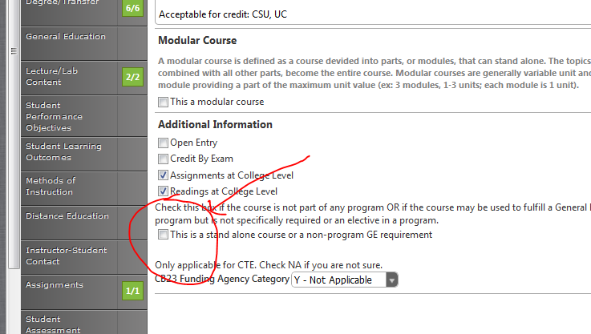

To map SLOs to PLOs, the steps are a little more involved

When folks create/update their course blocks, they need to Edit Program Courses

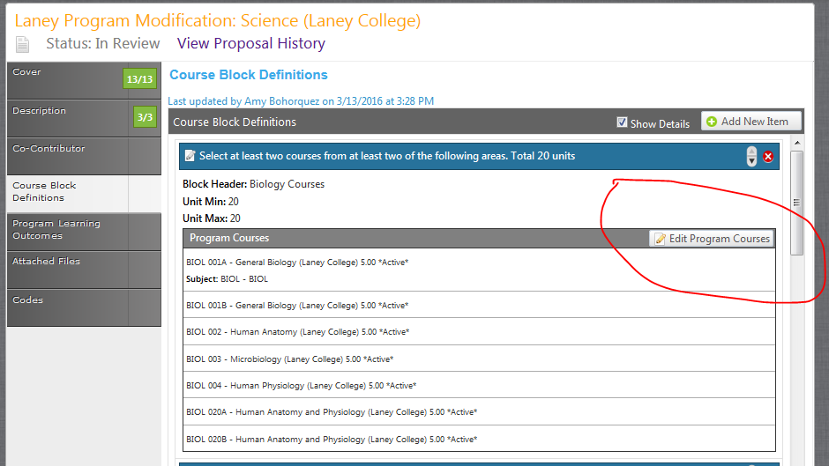

Then, they need to click “Include this course in outcome mapping” and click Update

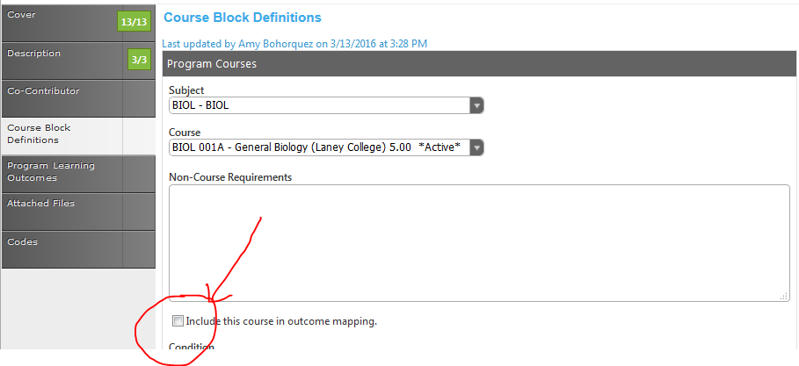

Be sure to click Done once you have chosen all the courses that you want to map to PLOs

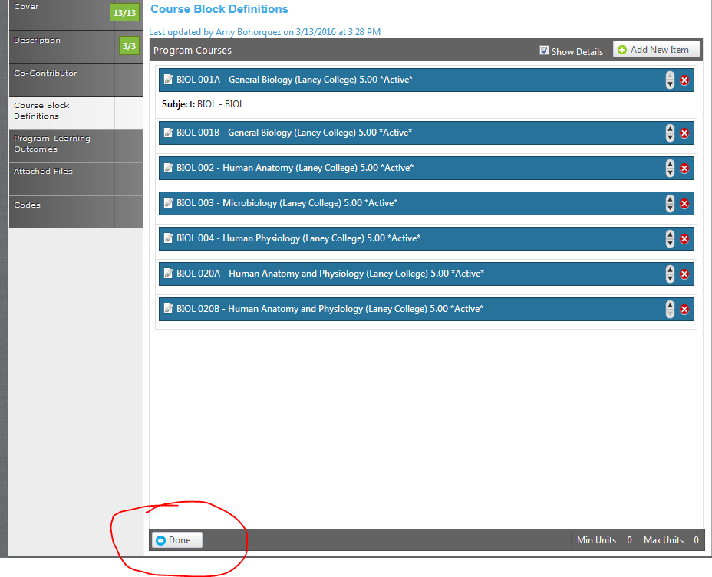

Then, choose the Program Level Outcomes – this is what it looks like once you’ve mapped it

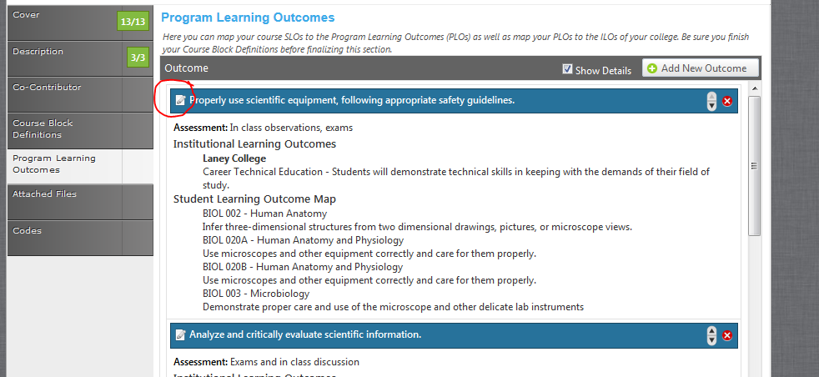

Here is how I completed the mapping, click on the pencil icon (above), then choose which college (be sure you pick your college) ILO you want the PLO to map to.

Then, scroll all the way down and the course SLOs should pop up.

If they don’t, go back to the Course Blocks to double check that you click to map. For some reason, going back seems to get the SLOs to show even if you did click it the first time

