Contents

Distance Education at Merritt College 3
Authentication of Online Students 4
Communication with Online Students 4
Course Management Strategies for Hybrid/Online Classes 5
Regular and Effective Contact 5
More Guidelines from Title V 6
Guidelines for Distance Education 8
Support Services for Faculty 10
Technology Requirements 10
What is an Online Class? 10
Hybrid/Blended vs. online 11
The Web Enhanced Course 11
Accessibility 12
Accessibility Guidelines 12
Getting started adding content 17
The first thing you need in your Moodle or LMS shell 17
More help getting started as an online student (Optional) 19
Your Welcome Letter to Students and/or Orientation Materials 19
Your online syllabus 21
A Checklist for Your Online Syllabus 23
Consider Creating a Course FAQ or Online Orientation 24
Break the Ice! 26
Online Assessment: Quizzes and Surveys 31
Online Testing as Open Testing 32
Adding Files to Moodle 34
Using Publisher Content 34
Copyright, fair use and public domain 35
Building Online Communication 40
Appendix A: Course Checklist 43
Appendix B: Finding Online Course Resources 46
Appendix C: Sample Rubric for Forum Participation 51
Appendix D: Components of an Online Syllabus 55
OEI Course Rubric (most recent version) 58
A.1 Objectives 58
A.2 Content Presentation 59
A.3 Learner Engagement 60
B.1 Communication Strategies 61
B.2 Development of Learning Community 63
B.3 Interaction Logistics 64
C.1 Expectations 65
C.2 Assessment Design 66
D.1 Supplemental Software 67

Distance Education at Merritt College

This manual provides faculty, staff and administrators at Merritt College with information about regulations and other provisions for Distance Education.

Information about Title V regulations and guidelines for Instructor/Student contact in online classes is provided.

Please take the time to review this manual for information. If more help is needed, contact your campus Distance Education Coordinator, or the Office of Instruction.

Authentication of Online Students

Federal financial aid eligibility regulations require that the District verify that the student who registers in a distance education is the same student who participates in and completes the course or program and receives the academic credit.

In order to ensure that authentication takes place as intended; faculty must utilize Peralta’s implementation of Moodle to deliver distance education courses. If faculty use a publisher’s content site faculty must require the students to access such content through a link in the campus Moodle site to ensure authentication, but the Moodle course shell must also show evidence of regular and effective contact with students.

Communication with Online Students

To ensure consistent communication with potential distance education students, faculty members teaching online courses must use their Peralta email accounts as their primary email contact.

Communication with distance learners should begin before the first class meeting.
Faculty members are encouraged to engage students before the first day of instruction. This communication should include a welcome letter, the syllabus, and course guidelines for communication. Please see the Appendix of this document for a sample DE syllabus.

Faculty members should consider modifying their syllabus to clearly address course policies, assignment submission, testing and proctoring, and support services that may be affected by the distance learning modality. Syllabi for DE courses should include a specific section that outlines how the course will be managed, how communication will be managed, and how special needs will be met.

Course Management Strategies for Hybrid/Online Classes

Faculty teaching distance education courses are responsible for the same course administrative functions as those teaching in a traditional classroom, including choosing books and curriculum, verifying course rosters, adding and dropping students, and entering grades at the prescribed times. In addition, DE faculty are responsible for creating and loading syllabi and assignments, and assuring that all features of the site are up-to-date and currently working, adhering to delivery method guidelines, and facilitating interaction among their students.

Regular and Effective Contact

A California state Title 5 requirement (Section 55211) in distance learning states that instructors must keep in contact with students on a regular and timely basis to both ensure the quality of instruction and to verify their performance and participation status (authentication). This also means that courses need to be 508 compliant (meet accessibility guidelines).

Guidelines for Section 55211
This section defines what contact must be maintained between instructor and student:

Subsection (a) stresses the responsibility of the instructor in a DE course to initiate regular contact with enrolled students to verify their participation and performance status. The use of the term “regular effective contact” in this context suggests that students should have frequent opportunities to ask questions and receive answers from the instructor of record.

How Faculty Can Ensure Regular and Effective Contact

Instructors need to make certain that there are measures for instructor-initiated and peer to peer regular effective contact incorporated into online and hybrid course design and delivery. Regular effective contact means that instructors must keep in contact with students on a consistent and timely basis to both ensure the quality of instruction and verify their performance and participation status. Lack of activity in the course indicates a lack of regular effective contact.

Examples of regular and effective contact can include forum postings, submission of assignments, group work and emails.

More Guidelines from Title V

According to Title V:
55200. Distance Education means instruction in which the instructor and student are separated by distance and interact through the assistance of communication technology. All distance education is subject to the general requirements of this chapter as well as the specific requirements of this article. In addition, instruction provided as distance education is subject to the requirements that many be imposed by the Americans with Disabilities Act and section 508 of the Rehabilitation Act of 1973 as amended.

55202. Course Quality Standards.
The same standards of course quality shall be applied to any portion of a course conducted through distance education as are applied to traditional classroom courses.

55204. Instructor Contact.
In addition to the requirements of section 55002 and any locally established requirements applicable to all courses, district governing boards shall ensure that: (a) Any portion of a course conducted through distance education includes regular effective contact between instructor and students..

55206. Separate Course Approval
If any portion of the instruction in a proposed or existing course or course section is designed to be provided through distance education in lieu of face to face interaction between instructor and students, the course shall be separately reviewed and approved according to the district’s adopted course approval procedures.

At Peralta this process is enacted by the faculty responsible for the curriculum updating an existing course with a Distance Education Addendum, via Curricunet. Faculty can seek help with this process by contacting the chair of the Curriculum committee on campus.

Guidelines for Distance Education

Definition:
Distance education is a formal interaction which uses one or more technologies to deliver instruction to students who are separated from the instructor and which supports regular and substantive interactions between the students and the instructor, either synchronously or asynchronously. Distance education often incorporates technologies such as the internet; one-way and two-way transmissions through open broadcast, closed circuit, cable, microwave, broadband lines, fiber optics, satellite, or wireless communications devices; audio conferencing; in conjunction with any of the other technologies (ACCJC, 2012).

Regular and substantive interactions includes but is not limited to:

- Early, continuing, and consistent communication from the instructor of record, including instructions for accessing the course material and opportunities for assessing whether students are accessing and understanding the course material.

- Regular contact hours established through published office hours (whether virtual or face-to-face), availability for answering questions and giving feedback that includes both synchronous and asynchronous modes.

- Timely feedback that replicates the contact of face-to-face courses, with communication between faculty and students

- Student questions answered as soon as possible, no more than 24 hours.

- Interaction between faculty and students using multiple channels, including forum discussions, email, and weekly announcements

- Use of a variety of communication modes in classes, including synchronous channels, such as chat, Skype, and CCC Confer, or other collaborative tools, such as Google docs, wikis, Facebook and Twitter

Distance Education Guidelines at Merritt Effective Beginning Spring 2014

Delivery requirements
All DE courses, either hybrid or online, must be delivered in the most recent version of Moodle adopted by the college.

Requirements for teaching DE courses:
- All course content must be in Moodle

- Moodle training is required
  - ED 1 Introduction to online pedagogy
  - ED 2 Introduction to Moodle

- Demonstration of knowledge to DE coordinator or Division Deans

- Faculty must provide evidence to the division dean that the Moodle training has been successfully completed.

Support Services for Faculty
- DE Coordinator at Merritt Alexis Alexander aalexander@peralta.edu
- District Moodle support at online@peralta.edu

Technology Requirements
Faculty members should have access to technology sufficient for managing their online courses. These include:
- Fairly recent Mac or PC (not more than three years old) with a current operating system
- Current browser (Firefox v20.0, Chrome v.24, or Internet Explorer 8.x are recommended)
- Internet connection, preferably broadband (DSL speeds)
- Moodle

What is an Online Class?
An online class is one in which 100% of all activities and resources are online, delivered through a course management system. An online class should include online orientation materials, since a face-to-face orientation cannot be required. An online course can contain synchronous and asynchronous activities.

Hybrid/Blended vs. online
Just what exactly is meant by the term “hybrid” in the context of distance learning? A variety of definitions for hybrid course delivery exist.
Many experienced online faculty have said that hybrid courses combine the best of both the online and traditional class environments by allowing instructors to choose the medium most appropriate for an activity. Properly designed hybrid courses are a great way to get students to spend more time on-task and therefore hopefully to develop a better mastery of the material. “Hybridizing” an existing traditional course is also a good first step into online teaching; an important bridge between face-to-face and online instruction.

The Web Enhanced Course
A web enhanced class is a class that takes place in the classroom, but which is supplemented by materials and resources that exist online, for example in Moodle.
The types of resources that can be placed online include:
- The course syllabus
- Handouts
- Educational videos
- Links to online resources
- Assessments such as quizzes or surveys
- Online discussion forums to promote communication and learning for students outside of the classroom
- An online “drop box” that allows students to turn in assignments online

Accessibility

Accessibility Guidelines
To ensure that students with disabilities have the same opportunity, DE courses should be designed to provide “built-in” accommodation (i.e. closed captioning, descriptive narration) and/or interface design/content layout, which is accessible to “industry standard” assistive computer technology commonly used by students with disabilities.

Specific guidelines created by the Distance Education Accessibility Taskforce are available at: Distance Education Accessibility Guidelines

Additionally, all four Peralta colleges provide Alternate Media and Assistive Technology support via the DSP office.

Since one very important aspect of any materials that you put online is the issue of accessibility, all materials in your online course must meet the requirements of the Americans with Disabilities Act and Section 508.

All of your videos must be captioned
If you include videos in your class, they must be captioned. You can find captioned videos from YouTube, TeacherTube, and lots of other places.

Any audio files must have a transcript
Audio files are a great way to provide information to students, however if you do provide audio files, you will also need to provide a “script” for the file. Creating a script can actually be helpful to you as you organize your thoughts before a presentation.
Once you have uploaded your presentation, just add the script as a PDF file link.

Don’t depend on color to make a point
Judicious use of color is a key accessibility consideration. According to the Sight & Hearing Association, more than one in 15 men is color blind. It is important to make sure that any information conveyed with color is also conveyed in some other manner.
Compare how the following graphs might look to someone with color blindness.
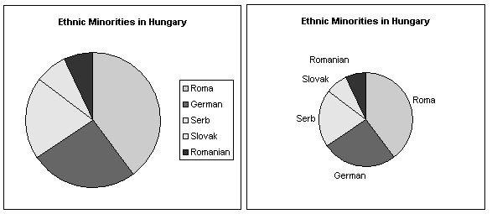
The graph on the right is much clearer (possibly even for those readers without any color blindness). Color blindness is more complex than just seeing the world in shades of gray. These examples are simplifications for purposes of illustration.

Keep the Contrast
Even when color is not the sole form of communicating information, it is still important that there be enough contrast between the text and the background. The following is difficult enough for those without visual impairments and likely impossible for people with some kinds of color blindness:
Although the examples shown here may seem trivial, they highlight problems that are easy to overlook. If you're curious to see how your materials might actually look to people with various kinds of color-blindness, you can use a tool like Vischeck which simulates various kinds of color blindness.

Make your links meaningful
If you are using links in your course material, in an HTML document, an attached MSWord document, or a PowerPoint file, it is often tempting to link just the words "click here". But compare the following:
For an example of dollar-cost averaging, click here.
Please see an example of dollar-cost averaging.
There are two problems, with this, however.
First, readers who are blind often use screen reading software to "read" pages to them, these often work by jumping from link to link. This means that links might be read without the context around them, so when a link reads "click here" it's not at all clear what that link will lead to.
The second problem concerns viewers without visual impairments. When they scan the text, the links will stand out, but will be largely meaningless, forcing the reader to stop, scan the words around the link, and then evaluate the link anew. Much more expedient would be to simply link the appropriate text as in the second example.
Another example of a best practice for using links is to transform long, meaningless links into text links, for example, let’s say this is the link to the textbook you want the student to buy
http://www.amazon.com/gp/product/1412917948/ref=s9_simh_gw_p14_d3_i5?pf_rd_ m=ATVPDKIKX0DER&pf_rd_s=centerhttp://www.amazon.com/gp/product/1412917948/ref=s9_simh_gw_p14_d3_i5?pf_rd_m=ATVPDKIKX0DER&pf_rd_s=center-2&pf_rd_r=00DZM93WMZTN2FJM8GYA&pf_rd_t=101&pf_rd_p=1389517282&pf_rd_i=5078462&pf_rd_r=00DZM93WMZTN2FJM8GYA&pf_rd_t=101&pf_rd_p=1389517282&pf_rd_i= 507846
A better link would be: You can purchase your textbook on Amazon, here is the link “Statistics for people who hate statistics.”

Make yourself a script
If you are creating a narrated audio, for example a multimedia or PowerPoint presentation, consider writing up a script beforehand. Not only does this allow for a tighter, more professional sounding presentation, but it also means that a ready "transcript" is available for posting alongside the audio.
The text needn't match what is said verbatim. As long as there is no material difference between the two, this fulfills the goals of accessibility. Incidentally, this transcript is not only useful for the hearing impaired, but can also be appreciated by students who are connecting from areas with unreliable or costly internet connections. This often includes students who are serving in military deployments.

Use Adobe PDF not Word
Adobe Acrobat (also called "portable document format" or "PDF") files are superior to MS-Word documents for most purposes in the online classroom. Although it is possible to "tag" these files for higher accessibility, this is more complicated than most faculty members are likely to feel comfortable with. However, when creating PDF files from
MS-Word documents, Acrobat will retain the "style" information from the original MSWord documents which will make the resulting PDF files more accessible. By using styles, assistive devices can better tell whether a piece of text is a header, body text, or a caption for an image, and therefore help the user determine its meaning.

Never assume that Students have PowerPoint
Not all students have access to Microsoft Office, PowerPoint files should be loaded either as Google Presentations or PDF files.

Always create an ALT tag
If you are creating HTML pages in Moodle, you should include an alternate explanation of any graphics that you include in your material. This allows the visually impaired who might be using a screen reader to speak a page out loud to have description of the graphic they may not be able to see. You will see a text box for this at the same time that you insert the graphic in the HTML editor.

Universal Design for Learning
The idea behind Universal Design is that all materials are designed with the goal of being accessible to all learners. When you design your materials with this goal in mind there is no need to revise them later to make them accessible.

Why is UDL necessary?
Individuals bring a huge variety of skills, needs, and interests to learning. Neuroscience reveals that these differences are as varied and unique as our DNA or fingerprints.
Three primary brain networks come into play:
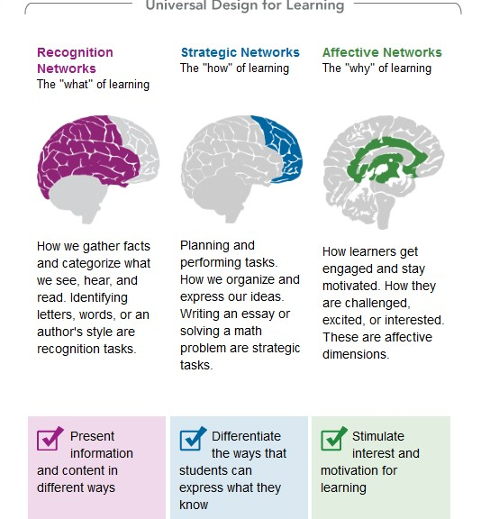

Universal Design tells us that ALL the materials we put online should appeal to the different and preferred learning styles of our students.

For example, try to avoid text only materials. Consider including a captioned video, a podcast with a transcript or an interactive tool. Think about asking students to use technology to create their assignments. Group activities are also a great way to get students using 21st Century skills in and out of the classroom.

Getting started adding content

The first thing you need in your Moodle or LMS shell
It is a best practice to include some basic information in the introductory block of your course shell. You may think that some of the following seems redundant, and it is! Putting this info in more than one place means that you are increasing the likelihood that students will find and read this information.
In the top block of your shell (block zero) please include
- Your name
- Your office hours
- The preferred ways for students to contact you
- The goals for the class (not slo’s, something more “student friendly”)
- Basic info about the class

The best thing to do is to also create some orientation materials, you can do this in a Moodle book, or simply in a Welcome page in the top block
Here is some suggested content for orientation materials
The California State Chancellor's office has recently completed some learning modules on online learning that you may find of interest.

01-Introduction to Online Learning View
02-Getting Tech Ready View
03-Organizing for Online Success View
04-Online Study Skills and Managing Time View
05-Communication Skills for Online Learning View
06-Online Reading Strategies View
07-Career Planning View
08-Educational Planning View
09-Instructional Support View
10-Personal Support View
11-Financial Planning View download zip

More help getting started as an online student (Optional)

Step 1:

Take this Readiness self-assessment questionnaire now!
This questionnaire will give you an idea whether or not you have the personality traits, learning aptitude, technical knowledge, hardware and software, and study skills for online learning.

Step 2:

Complete the Online Student Readiness tutorials
Whether this is your first time taking online classes, or you have taken a few online courses in the past; you will find that these resources are tailored to your needs and are focused on enhancing the academic and technical skills needed for success in the online learning environment.

Additional Online Learning Resources
- Online Learning: Self-Paced Introduction
- Learning to Learn Online
- How to Succeed in Online College Courses

Your Welcome Letter to Students and/or Orientation Materials
Some of the info above may also be included in a “Welcome Letter” that you email to students before the class starts.
Much of this information could be/should be included in your course syllabus as well.

The types of things you can include in that welcome letter are:
- Introduce yourself! Let students get an idea of who you are
- Give students your contact information
- Have virtual office hours? Post those here
- A brief overview of the Learning objectives for the course gives students an idea of what they will be doing in your class
- Include information about how to get started, including a link to the syllabus

Some addition items you might include:

- Course access information. How will students access your course? Make sure to give students the course URL and information on how to get tech help before class begins.

Date class begins
- Number of weeks and ending date. Got a late start or short term class? – This can be a little confusing if students don’t realize that not all classes are the same length.
- Textbook Information. If you would like students to have textbooks on the first day of class, it’s important that you provide them with all of the pertinent information (author, title, edition, ISBN number) they will need in ordering the correct text from online vendors. You may also opt for an “older” edition if your text is used primarily for reference and its content changes very little.
- Number of required synchronous meetings (if any) including when and how they will take place. If you require students to “attend” a “real-time” web facilitated, virtual meeting, provide them with the necessary information so that they can make arrangements to be “present” or opt to take the course at a future date. CCCConfer can be used for this purpose by teachers.
- Number of optional synchronous meetings (if any) including when and how they will take place. For example, you can hold “virtual” office hours so that students can reach you at a particular time. How you hold these office hours is up to you, but some ideas include being available for instant messaging (IM), chat, Skype, e-mail, and (for those who are more “old-school”) telephone! Skype is a powerful free web- conferencing tool that allows you to interact with your students using audio, video, or text and Facebook also have a video chat tool that is easy to use.
- Exam information. If students are required to take proctored exams, provide information about where, when, and how those will be taken. If your exams are online, consider at least sending a list of projected test dates.
- Technical Requirements. Explain what types of hardware, software, browser and internet access students will need to complete the work for your course. Will students need MS Word? Are you using any other type of specialized software? You should make those expectations clear so that students can evaluate whether they can meet those requirements before your class begins.

Your online syllabus

What is different about an online syllabus? Do I have to change my syllabus when I am teaching a class online?

Although the details of course requirements, expected outcomes, schedule, grading, and procedures are an important part of any course syllabus, they are perhaps even more important for an online class. Think of everything that you tell students on the first day of class, online students still need this information, and they may have trouble finding it unless you have created a syllabus that is easy to find and understand.

Even in hybrid courses—those that are taught face to face with an online component— clear directions are vital. It’s important, for instance, to explain to students how the hybrid class meetings will be scheduled. Which course activities will take place in the on-campus classroom, which in the online classroom, and what should students be working on each week?

An effective online syllabus must include:

Pedagogy:
- Contact information for the instructor
- Information about where to find things in the course
- Criteria for grading and participation (Rubrics work well for this)
- Expectations for communication, in other words what students can expect from you in terms of turnaround time and other types of instructor/student communication
- The proper sequence for accomplishing weekly activities and assignments (for example, do the exercises before taking the quiz, post a message in discussion before e-mailing the assignment)

Technology
- Technical requirements for the class (for example, what browsers work best, any special programs that are needed)
- Any contact information for technical and administrative support • What sort of file formats you will accept for assignments

A Checklist for Your Online Syllabus
Here, in summary form, is a checklist for creating your online syllabus. You don’t have to include all of these items (some may be more appropriate for your class than others), nor do you have to include them all in one document called a “syllabus.” You can distribute this information among several documents if desired or you can create an online orientation tool, such as a book in Moodle.

- Course title, instructor/s names, course number, and term information; syllabus web pages should bear creation or “last revised” dates if the term date isn’t included at the top

- Course instructor’s contact information, plus contact information for technical support

- Course description, perhaps the same as the description used for a course catalog listing, but probably more detailed; should list any prerequisites or special technical requirements for the course

- Course objectives or expected outcomes; what students can expect to learn by completion of the course

- Required texts or materials: any books or other materials, such as software, not made available in the course but required for the course and how to get those materials

- Explanation of grading criteria and components of total grade: a list of all quizzes, exams, graded assignments, and forms of class participation, with grade percentages or points; criteria for a passing grade; policies on late assignments

- Participation standard: minimum number of postings per week in discussion and any standards for quality of participation, rubrics for forum participation

- Explanation of course geography and procedures: how the online classroom is organized; how students should proceed each week for class activities; how to label assignments sent by e-mail; where to post materials in the classroom; any special instructions

- Week-by-week schedule: topics, assignments, readings, quizzes, activities, and web resources for each week, with specific dates

- Any relevant institutional policies, procedures, or resources not mentioned above

Consider Creating a Course FAQ or Online Orientation

Students in an online class need directions and a “map” to find their way around in what may be a new environment to them.

You can help!

Consider creating a course FAQ for students, this can include information about:
- How to contact you
- How to find and use the syllabus
- How to get technical help
- The layout of the course
- Communication expectations, for example how long should students expect to wait for submissions to be graded or for a response to an email
- Information about grading and how to submit assignments
- Any rubrics you use for grading
- Rules about Netiquette
- Information about forum participation and conduct
- Information about your policy on late assignments
- Any directions for special technology that you are using in the class, for example if you are using Wiki’s you would include information on what a Wiki is and how to use it in your Course FAQ’s
- A checklist that lists only readings and assignments for each week is a best practice, even if you already have this information in your syllabus
- Access to a variety of resources to cope with problems or situations that arise such as, Time Management, Managing Stress, Concentration, Motivation, Setting Goals, Group Work, Research Skills and Evaluating Internet Resources
- An explanation about the assessment methods that may be used during a course
- Guidance on how to record, cite and present references in written assignments as well as tips on how to avoid plagiarism
- Information about student support with links to Counseling and Guidance
Services, Student Health Care and the Careers Service
- Tips for being a successful student in an online/hybrid course
- Quiz to self-assess readiness to be a student in an online course
- Minimum computer hardware and software requirements
- Sources for any required plug-ins (and links)
- Links to appropriate campus library resources and services (e.g., reference librarian, electronic reserve, and online library tutorials).

Break the Ice!
One way to get students feeling more comfortable in your online course space is to create what are known as “ice breaking” activities.

These can be easily done in an online asynchronous forum. You can create a Chat Café for students to check it, post a bio or ask questions. These types of forums help to create a supportive environment and can be a great resource for students.

Why are ice breakers so important in an online course?
An ice breaker, though comprising only a small portion of the total time spent in any meetings/class/group/etc., can be of vital importance to the success of any group process. In order for your class to achieve a higher level of functioning and cohesion, the individuals in the group must get to know one another and an environment must be created in which everyone feels open to participate and share in discussion forums. Only through this discussion can the group process evolve, especially in an online course where text-based discussion may be the only form of communication. In an online course, the need to establish such an environment of open discussion where everyone can get to know one another must actively be sought in order for it to develop in a reasonable amount of time. Ice breakers help the instructor to develop this environment.

Choosing an ice breaker
When choosing an ice breaker there are 3 questions to keep in mind. First, what are your goals (instructional and group goals)? Second, who is your audience (including their reasons for being there and personal goals)? Third, is the ice breaker connected to its purpose?
The first consideration when choosing an ice breaker is the purpose of that ice breaker. Ice breakers can have many purposes. Determine what your goals are, and then you can connect the activity to those goals.

Next you have to look at your audience. If you are working with a group in which everyone already knows one another, then a get to know you exercise wouldn't serve much purpose other than to take up time. An alternative activity should then be considered.

Finally, make sure that the ice breaker you choose is actually connected to the intended purpose of the ice breaker. Not all ice-breakers work for all intended ends.

Examples of Ice Breakers

Childhood Dream. Ask the students to share their childhood dream (what they wanted to be or do when they grew up) and then ask them to reflect on how their current coursework correlates with their current aspirations.

Vacation Needs. Ask the students to respond to these questions about distance and fun in the Discussion Thread Area: A. "Since this is summer time and we would most likely rather be on vacation, tell us the farthest distance you have traveled." B. "Where would you like to go on a vacation right now if you could?" With this sharing in the online class, others may have been to some of the same places or would like to find out more from those that have gone

Interviewing. Ask the students to pair up and interview each other. The students will then report on what they discovered about each other. This type of activity can lead to strengthening student interactions in the class right from the beginning.

Special Topics. Ask the students to share their experiences with the topic being studied. Also ask them to discuss why he or she is interested in this area. For example, many special education teachers are able to describe a specific experience that led them into the field. The class will be asked if they have had similar experiences and will be encouraged to explain it to the class.

Miscomm-puter-unication. Ask the class to share their most embarrassing mishap using a computer. Share with the students your own experience, for example, replying to the wrong person in an email. This will loosen them up and cause a few to chuckle before we embark on a whole new way of thinking…using technology instead of paper and pen.

Meeting Someone. Storytelling is a wonderful way to get people to show (some of) his or her true colors. Ask the students to share about his or her favorite musician, artist, writer or actor, and then conjure a fantasy story about meeting them. In short, I would ask: Who is your favorite (fill in the blank), why do you like them and what would you say to him or her if you could meet them today?

Memory Lane. Since so many online students are so diverse in age as well as other things, such as ethnicity, it is good to close or expose the generation gaps that might exist. Ask the students to list three major world events that happened the year in which they were born, then have the other members guess the year and post a short response on whether they remembered the events or had never heard of them

Mapquest. Many online classes include a variety of students from different cultures and locations around the world. In this activity, each student is to:
Identify their location (where they live at the moment they take the course) How far is it from USA – San Mateo, CA (use a mapping site from the internet, ie.
www.mapquest.com)
Identify one interesting highlight of their location.

Tell us about yourself. How do you primarily identify yourself? (Are you a parent first, a professional 1st, a student 1st, etc.) What is your zodiac sign? Have you successfully explained your area of study to any of your family members yet?

Your Name dot Explain. Introduce yourself and tell us about how or why you have the name you have, e.g. you were named after a relative or a parent's best friend. It could be your first, middle or nickname.

Dinner. Ask students to name three people, living or dead, real or fictitious, with whom they would most like to have dinner, and why.

Creating a Social Presence:

In an online class it can more difficult for a teacher to create a “presence” and to make a connection with students. Lack of that presence can significantly diminish many things, including student motivation, retention and guidance.
Because a lot of the ways that a traditional teacher creates an effective classroom alchemy are not possible in the online environment, below are some suggestions and ideas on how to provide support and an instructor presence:
- An introductory forum for bios and introductions. There needs to be a comfortable balance between privacy and self-disclosure, but some selfrevelation on the part of the Instructor can get the ball rolling. A student should be instructed to share only what they are comfortable with.
- A short explanation about how to proceed. It is not helpful to assume the students will see the order in which they are to proceed just because the items are listed in a certain order. An online class can look like a jumble of words and links to someone who has never seen one before!
- One way to expedite the getting-to-know-you process is with a photo gallery. If a student does not feel comfortable posting their own photo, perhaps they would be comfortable posting a picture of their pet or a landscape that they like. This can also be done by encouraging students to edit their online profile in WebAccess.
- Establish a question forum for the students to ask their questions. You can also choose to encourage students to help each other in this way. Make sure that students know that they can also send a private e-mail or message for questions or concerns they do not want to share with the class.
- Consider involving students in peer review activities, or forum facilitation as they become more familiar and comfortable with the online forums.
- An instructor needs to remain accessible to students by communicating frequently throughout the discussion forums; however you do not have to answer each forum post!
- One practice for keeping students participating in the discussion forums is to attach points to participation. Requiring students to post a certain number of substantive posts over a certain period of time will keep them engaged in the discussion. If the Instructor follows the discussion and makes sure it is targeted and lively, the result will be active learning and enjoyment for the student.
- It is important to project a high-level of warmth and friendliness in all classroom interactions realizing that words and messages can be perceived differently online than in person. Capital letters are like shouting. Using a red color also seems angry or brash. Using calming colors for emphasis; blue or purple has a soothing effect for nervous students who are trying to get used to the online venue.

Online Assessment: Quizzes and Surveys

There are several schools of thought on Online Assessment. Some teachers are very concerned about cheating, or student authentication. Other teachers use online quizzes as a way to get students to review and reflect on the materials.

If you plan to use Online Quizzes as a way to assess student learning, you might want to keep the following guidelines in mind.
- If you must have testing that is more traditional, i.e not open book, you might want to look into proctored testing.
- Make your quizzes timed! Moodle allows you to set a time limit on any quiz that you create.
- When you set up your quizzes you can also determine a date range when the quiz is available, students can only access the quiz during that time frame
- Moodle allows you to “shuffle” quiz questions and answers. If you choose to shuffle answers, consider not using answers such as ‘all the above,’ ‘both a and b are true,’ etc. The randomization may cause these answers to be invalid
- Consider using a variety of question types, not use multiple choice or true/false
- Moodle also allows you to hold back feedback and results from students until the test has closed.
- Online testing is one way to determine learning, however be sure to use other methods, such as projects and papers.

Online Testing as Open Testing
The first thing that teachers often ask about online testing is how can cheating be prevented? How do you stop students from using books and other materials to answer questions?

- Bring a new mindset to online assessment.
Traditional approaches to testing don't work well online. A new mindset is
needed. That's not bad; most education experts agree that rote memory testing is not the best measure of learning in any environment.
- In online courses, treat every test as if it were "open book." Use questions that challenge students even if they use resources when forming their answers. This practice is more like our real life tests anyway.
- Publicize content, format, rules, and honor codes to students in advance.
Students are less prone to cheating if they understand what to expect on tests.
Ensure that they are appropriately prepared.
  - Provide students with study guides to help them prepare. Make sure that students understand the rules for the test, especially limitations on the resources students can use, and information about plagiarism.
  - Consider allowing students to help in creating test questions, preparing in this way for a test is a great way to get students to review.
- Ask questions that require application of knowledge.
The most important way to overcome online cheating (and realistically assess student understanding) is to use questions that require critical thinking. Essays, case studies, and other complex question types can be challenging to answer even if you are looking at the book.
- Learn the writing style of students before testing.
A great deal of written communication passes between online students and the instructor. Pay attention to the writing style of students and save samples. Online instructors report that with a little awareness, it is easy to recognize work that is not the student's own.
- Use questions that require personal input from students. Require some personal opinions from students in answers. Ask students to provide examples from their own lives. These kinds of personal details are difficult to fake.
- Don't worry too much.
Finally, online educators emphasize that online testing is more problematic in
theory than in practice. They report that the range of scores is similar for online students and classroom students. Test achievement by individual students is consistent with performance in other course assignments. Incidence of cheating is no more frequent than in face-to-face courses.
The above content is from
http://www.nccei.org/blackboard/testingadvice.html

Adding Files to Moodle
One very important thing to keep in mind is that not all students have Microsoft products (ie Word or PowerPoint) OR access to download large files.
Do not upload these types of files to Moodle
Here are some alternative methods to get these files to students
- Upload your files to Google drive, this is accessible to all students and as a big plus can also be accessed on a phone or other mobile device, which is the #1 way students access your online course content
- Create PDFs of your content

Using Publisher Content
If you plan to use publisher content in your course, you must include clear and concise instructions for your students on how to access this content. In your course orientation you should clearly explain to students how you will use a publisher site. Clear directions (perhaps with screen shots or other visuals) for accessing the publisher site are also critical

What is publisher content?
Textbook publishers are increasingly likely to offer electronic resources to accompany their textbooks. These could be as simple as banks of test questions, but might also include e-Packs or even complete courses hosted on the publisher’s website with their own activities, practice exercises, testing resources and grade-books.

How can I tell what content is available for my text?
The best way to determine if extra content is available for your textbook is to check the publisher’s website. Textbook company representatives are also happy to talk with you about your options, and make frequent visits to the on-campus office buildings.

How do I get access to publisher content?
The fastest way to get access to publisher content is to contact your local publisher’s representative. They usually respond quickly. They can supply a username and password so you can view available content.
The other option is to work through the publisher’s website. This usually takes longer and involves submitting an application with some verification of your status as an instructor.

How do I decide whether to use publisher content?
Questions to consider include:
- Is the publisher material better for students than what I could develop myself in the time I have available?
- Does publisher content augment my own material in useful ways?
- Does the material match the outcomes for my course?
- Do the materials look like they would be relatively easy for students to access and use?
- Does the publisher provide instructor tutorials? Technical support for students?

I’m mostly interested in the publisher’s test bank. How do I get the questions into my Moodle course?
Most publishers have questions that can be imported into a Moodle format. You can contact online@peralta.edu for help importing test banks.

Copyright, fair use and public domain

What is copyright?
The Copyright Act of 1976 is currently the basis for all rules of copyright in the United States, although it has gone through quite a few amendments since the initial enactment on January 1, 1978, and will probably continue to do so. Anyone can access the act online to learn about the rights of copyright holders, what constitutes fair use and to find out about some ways to determine if and when works enter the public domain.

In general, copyright is a form of protection for the authors of “original works of authorship,” and provides protection for the following:
- Literary Works
- Musical works, including any accompanying words
- Dramatic works, including any accompanying music
- Pantomimes and choreographic works
- Pictorial, graphic, and sculptural works
- Motion pictures and other audiovisual works
- Sound recordings
- Architectural works (“Libraries & Copyright | I Love Libraries,” 2012) Section 106 of the 1976 Copyright Act generally gives the owner of copyright the exclusive right to do and to authorize others to do the following:
- To create copies of their own work
- To produce derivatives of their work
- To see copies of their work
- If the materials that they have created are dramatic works, they have the right to perform the work publicly
- To publicly display their own work
In terms of educational use, the doctrine of fair use, which is outlined in section 107 of the 1976 Copyright Act, allows wide latitude for teachers, who can use many types of materials in the classroom. The basic guidelines of fair use of copyrighted materials frame the fair use of materials as being for the “purpose of criticism, comment, news reporting, teaching, scholarship, and research”(“U.S. Copyright Office - Fair Use,” 2012)

How does copyright and fair use apply in the area of distance education? When the copyright act of 1976 was authored, the transmission of materials was understood and defined in fairly limited ways. Section 110(1) of the copyright act allows teachers to use all sorts of copyrighted materials in the face to face classroom and Section 110(2) allow the broadcasting of non-dramatic works as long as certain restrictions are met. One restriction in particular, that reception of the materials must be in a classroom or other place devoted to instruction, causes problems in terms of distance learning. Online materials today can be transmitted in a secure environment that is limited to students who are authenticated users, which is different that the type of transmission that was envisioned by legislators in 1976.

In 1999 Congressional hearings were held to discuss how to amend Section 110(2) with emphasis on areas of clarifying the concept of transmission, and defining mediated instruction. Sadly, the end result was not a final clarification, although experts in many areas were allowed to give their opinions and. In 2002, with the signing of the Teach Act, there are more resources for teachers to look to, as they develop or plan to use materials in their online classes.

In terms of “fair use” there are specific rules or considerations that apply, including:
- How the materials is being used, and is it for nonprofit educational purposes
- The nature of the copyrighted work
- How much of the original work is used
- The effect of the use upon the potential market for, or value of, the copyrighted work (“U.S. Copyright Office - Fair Use,” 2012)
Teachers may receive advice from their colleagues or institutions. If they don’t know for sure if they are violating provisions of fair use by offering materials online, they should ask or do some research. There is no doubt that the lack of clarity in this area probably leads to instructors limiting the nature of their online offerings or to them in fact violating copyright without knowing it due to ignorance of the law.

Derivative Works and Materials in the Public Domain in the Online Environment
A lot of the materials that are created by online instructors could be called “derivative” since online content is often modular and composed of a mixture of original and resourced materials. Unfortunately, for teachers anyway, derivative works must still follow the rules for copyright and distribution. The only case in which this does not apply is in the use of materials that have moved into the public domain for various reasons, usually based on the age of the materials or the date of the author’s death.
In more recent times, instructors and instructional designers have brought a focus on the use of reusable educational objects, and resource sites such a Merlot offer these in many different disciplines. There are many different places where educators can go online to find materials, which are created and combined to create:
“shareable content objects” (SCO) that can be used as an independent learning asset, separated from the presentation of the learning itself…for example, a course reading, a narrative bit of text written by the instructor explaining an idea, a course lecture, an interactive “widget”, an assignment, a mastery question or a series of mastery questions, or all or part of a quiz might each be considered a learning asset. The individual learning assets, in theory, can be used flexibly in a variety of presentation models, such as in a course web site, in an online book, or in an online game, in a semi-flexible manner. Online repositories such as MERLOT and more recent entries into the market such as SOPHIA and the much-touted Khan Academy are, arguably, based upon this premise: that individual, discrete lessons can be used flexibly and nimbly as an integrated part of a broader curriculum in a variety of ways. (Higdon, McNamara, & McKay, 2012.)
The development of these types of objects, used by more and more educators, has exploded the development of derivative materials. Unfortunately using open source materials combined in this way, which include copyrighted materials, does not excuse the re-user in the case of violation of copyright and educators need to keep that in mind.
There are some other issues with materials in the public domain, for example, some materials may have the original work in the public domain, but derivative works created from that content may in fact have some sort of copyright. According to Jassin (2012) “One helpful rule-of-thumb is that all works published in the United States before 1923 are in the public domain in the United States. In addition to pre-1923 works, there are also millions of other works that have fallen into the public domain for either (a) failure to renew; or (b) failure to affix a proper notice”. Repositories of these works can easily be located online.

Building Online Communication

Moodle provides you with a Forum Tool that allow you to create asynchronous discussion space for your students

Forum activities can serve a variety of purposes and can be used to meet a wide range of instructional objectives. Forums should be used to meet specific course objectives and should be aligned with course content.
The benefits of using an online forum for your class are numerous. Some key advantages include:
- Builds connections and class community by promoting discussion on course topics and more informal discussion
- Contributes to the development of cognitive, critical thinking, and writing skills
- Allows time for thoughtful, in-depth reflection on course topics. Much like traditional writing exercises, students have more time to think about, research, and compose their thoughts before contributing to the discussion.
- Facilitates exploratory learning by allowing students to review and respond to the work of others and approach learning in diverse ways
- Empowers students to express themselves. For students with different learning styles, an online discussion board can be a venue where they feel more comfortable contributing to group discussions. With positive reinforcement from interactions on the discussion board, an increase in in-class participation may also occur
- Discuss key concepts to allow students to learn from one another and share ideas. When students submit an assignment directly to a teacher, this sharing of ideas is lost.
- Reflection - Reflective activities require students to share a synthesis of the learning experience, or to describe how a situation or experience has personal value to them. These kinds of activities should allow for honest and open responses.
- Consensus Building - Consensus building activities require students to work together to create a product or to come to an agreement on some topic.
- Student Leadership: the effective use of discussion forums can encourage student leadership by giving them a voice in the classroom

Best Practices
Becoming informed about best practices will help make you and your students’ experience with the discussion board a rewarding experience and one that contributes effectively to learning. Here are some quick tips:
- Establish and communicate forum ground rules. What are your expectations for writing styles in the online forum? Are students expected to adhere to general rules of netiquette or does anything go? Include an introductory post that outlines your expectations for students will benefit you and your students.
- Determine and communicate how you will evaluate students’ participation. Students must know how their contributions will be assessed in order to make effective responses; otherwise, they may misunderstand your directions or become unsure of what is expected of them – leading to a frustrating and ineffective learning experience.
- What are your guidelines for giving students credit for forum participation? Do they need to post a certain number of times? How often? Any specific length? Is there information they should include or reference? What are your specific evaluation criteria?
- Encourage students to contact you if they don’t understand the assignment or are having technical difficulties with the board.
- Providing a rubric for students on forum posting is a good place to start (A
sample rubric can be found in Appendix C.
- Engage your students by asking good questions to get discussions going. Use open-ended questions and questions that challenge thinking. In-depth guidelines for writing good discussion prompts are included in the Additional Resources section below.
- To encourage informal interaction and connection amongst your students, create an area in your discussion board for personal introductions and discussions. Your students may learn more about their peers than they would in the classroom — opening new doors of connection and community.

Appendix A: Course Checklist

This course checklist covers many different areas that are important to creating a successful online course. This checklist is a combination of various online checklists and covers most aspects that you need to have an accessible and well designed course.

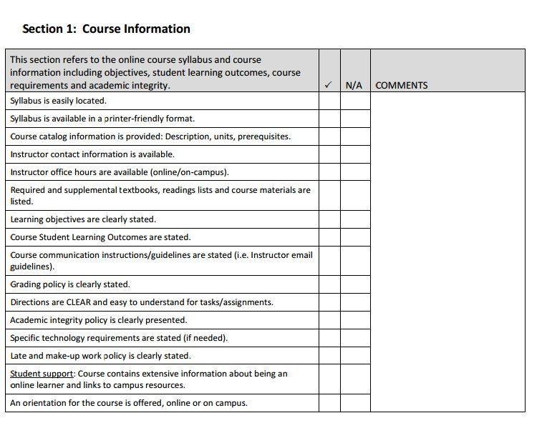
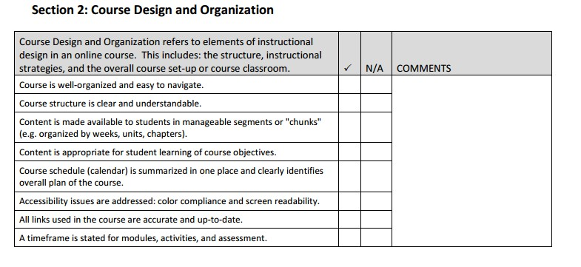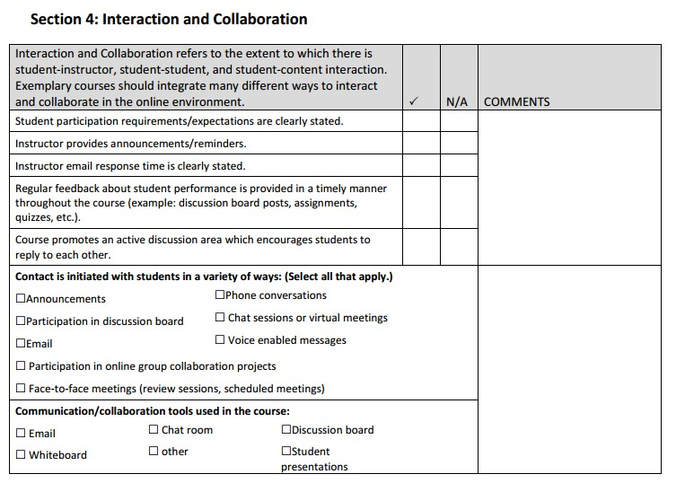

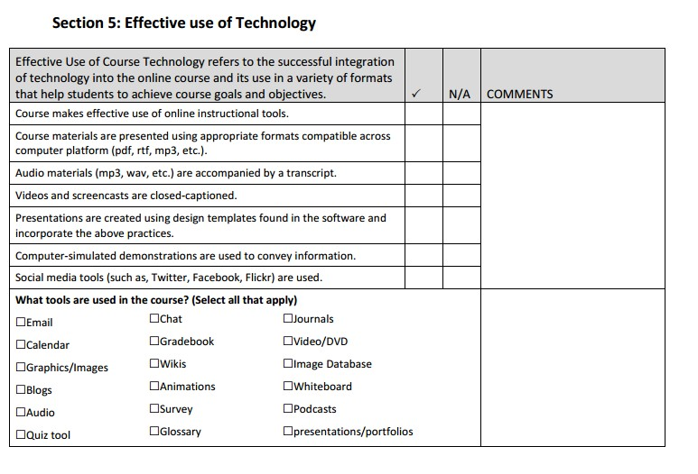

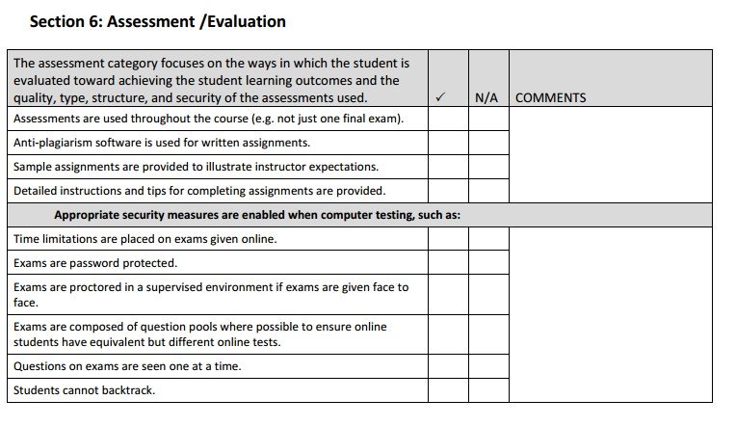

Appendix B: Finding Online Course Resources

Below you'll find links to some of the best sources for shared educational content, lectures, video, images, academic journals and reference sources. Start here to find open licensed material to build or enhance your course.

Online Video Lectures and Course Materials — Open Yale Courses
Open Yale Courses provides free and open access to a selection of introductory courses taught by distinguished teachers and scholars at Yale University. The aim of the project is to expand access to educational materials for all who wish to learn.
All lectures were recorded in the Yale College classroom and are available in video, audio, and text transcript formats
Free Online Course Materials | MIT OpenCourseWare
MIT OpenCourseWare (OCW) is a web-based publication of virtually all MIT course content. OCW is open and available to the world and is a permanent MIT activity.
Coursera https://www.coursera.org/
Courses in a wide range of topics, spanning the Humanities, Medicine, Biology, Social Sciences, Mathematics, Business, Computer Science, and many others.

College Open Textbooks
Organized by subject, with various open licenses.
http://www.collegeopentextbooks.org

Open Educational Resources
Searchable repository organized by grade level, subject, type of content and format http://www.oercommons.org/

Open Stax
Peer-reviewed college textbooks online.
https://openstaxcollege.org/books

Global Textbook Project
Open document format for textbooks in business, computing, education, health, sciences and social sciences http://globaltext.terry.uga.edu/books

Open Course Ware search
Includes course content from nearly a dozen institutions, including MIT, Yale, UMass and Notre Dame http://www.ocwsearch.com/

Merlot
Searchable repository of educational content, organized by subject, grade level, type of content and format.
http://www.merlot.org/merlot/index.htm

Hippocampus
Digital content organized by subject. Includes a lot of streaming content.
http://www.hippocampus.org/

Wikibooks
http://www.wikibooks.org/

Flat World Knowledge
free textbooks, searchable by subject http://www.flatworldknowledge.com/

Academic Earth
http://academicearth.org/

The Orange Grove
Florida’s digital repository for educational content http://florida.theorangegrove.org

YouTube http://www.youtube.com http://www.youtube.com/education

Vimeo
Shared videos. Includes non-educational content as well. http://vimeo.com/

Ted
Video links to lectures by notable experts in science, global issues, technology, business and design http://www.ted.com/

Creative Commons
Find images with open licenses http://search.creativecommons.org/

Slideshare
Power points searchable by tag terms or a search bar. http://www.slideshare.net/

Directory of Open Access Journals http://www.doaj.org/

Directory of Open Access Books http://www.doabooks.org

Public Library of Science research articles in the sciences http://www.plos.org/

Scholarpedia
Open access encyclopedia, curated by subject experts http://www.scholarpedia.org/

Wikimedia Commons
Freely usable media files
http://commons.wikipedia.org/wiki/Main_Page

Khan Academy http://www.khanacademy.org/
Our library of videos covers K-12 math, science topics such as biology, chemistry, and physics, and even reaches into the humanities with playlists on finance and history. Each video is a digestible chunk, approximately 10 minutes long, and especially purposed for viewing on the computer.

"I teach the way that I wish I was taught. The lectures are coming from me, an actual human being who is fascinated by the world around him."
—Sal
Next Vista for Learning http://www.nextvista.org/
All videos in the regular collections of NextVista.org are for a student audience, highlighting the creativity of students and teachers around the world. Our three principal collections are: Seeing Service, Global Views and Light Bulbs
We also have a large collection of careers videos to help middle and high school students better understand and connect to their future possibilities. If you are interested in projects which use these videos or which would encourage your students to make and contribute such videos, please contact us.

Udacity http://www.udacity.com/
Udacity is a totally new kind of learning experience. You learn by solving challenging problems and pursuing udacious projects with world-renowned university instructors
(not by watching long, boring lectures). Keep Reading

Appendix C: Sample Rubric for Forum Participation

This is an example of the kind of information you might post for your students about their online discussion participation

Your Forum Participation
Each week we will have at least one discussion forum. You must post THREE times in each forum to get the maximum number of points for your participation. Each substantive and complete post is worth 25 points.

As the instructor, I will facilitate student discussions but I will not address every single post. In most cases, I might share a related idea, intervene when the discussion goes off-track, or tie student comments together to help deepen student learning.
Consequently, I will not directly answer questions in the discussion area unless they are addressed to me. I will check the discussions daily during the week, and occasionally on the weekends.
Some characteristics I consider to be part of excellent discussion contributions are outlined below. I will consider these characteristics when assessing the quality and level of student participation.
- Submit initial post(s) early in the week, and subsequent responses to the posts of other learners at timely intervals throughout the duration of the session. The goal is to have a dynamic discussion around the topic that lasts throughout the entire session.
- Posts and responses should be thorough and thoughtful. Just posting an "I agree" or "Good ideas" will not be considered adequate. Support statements with examples, experiences, or references. Be brief — keep each post and response to one or two short paragraphs. Keep in mind that fellow learners will be reading and responding to you, too.
- Make certain that all posts and responses address the question, problem, or situation as presented for discussion. This does not mean you should not extend the topic, but do not stray from the topic.
- Discussions occur when there is dialogue; therefore, you need to build upon the posts and responses of other learners to create discussion threads. Make sure to revisit the discussion forum and respond (if necessary) to what other learners have posted to your initial responses.
- When relevant, add to the discussion by including prior knowledge, work experiences, references, web sites, resources, etc. (giving credit when appropriate).
- Contributions to the discussions (posts and responses) should be complete and free of grammatical or structural errors.

What do I mean by a substantive post?
The following are some ideas to set the stage for substantive participation for the development of your critical thinking skills:
- Ensure that the posting contributes to the overall discussion thread that is being developed. Your response must contain some reference back to the original discussion question. Stay on track by always referring back to that original discussion question.
- Try to use your posting to add value to the discussion. This is more effective than simply responding to meet a requirement.
- Check to see that the posting expands on the main theme (in the discussion question, or assignment posting).
- Make sure your posting is at least 50-150 words.

Other Ideas for Participation

- Share a related experience.
- Comment on others' experiences.
- Ask students questions about their ideas/experiences.
- Consider an idea being discussed, and offer a different perspective on it.
- Describe an interesting idea from the week's reading, and explain what insights you gained from it.
- Ask the group a question about the week's reading.
- Disagree (respectfully, of course) with a point that someone else has made.
- Discuss a related issue on which you would like some feedback.
- Describe how you have applied the recent course concepts to your personal/professional life.
- Share another resource you have used as you explored the course topics.

Criteria | Unsatisfactory | Satisfactory | Exemplary
Quantity and  Timeliness | Does not submit at least one post early in the session and/or does not submit at least two responses to other learners at various times during the session. | Submits at least one thoughtful post early in the session, and at least two responses to other learners at various times during the session. | Submits two or more thoughtful posts early in the session, and more than two responses to other learners at various times during the session.
Demonstrates knowledge and understanding of content and applicability to professional practice | Post(s) and responses show little evidence of knowledge and understanding of course content and applicability to professional practice. | Post(s) and responses show evidence of knowledge and understanding of course content and applicability to professional practice. | Post(s) and responses show evidence of knowledge and understanding of course content and applicability to professional practice and include other resources that extend the learning of the community.
Generates learning within the community | Posts do not attempt to elicit responses and reflections from other learners and/or responses do not | Posts attempt to elicit responses and reflections from other learners and responses build | Posts elicit responses and reflections from other learners and responses build upon and integrate
 | build upon the ideas of other learners to take the discussion deeper. | upon the ideas of other learners to take the discussion deeper. | multiple views from other learners to take the discussion deeper.

Appendix D: Components of an Online Syllabus

The online course syllabus must require no verbal explanation. It must stand alone and serve as a guide for the student.

Online Syllabus Components

- Welcome to Course • Course Information
- Faculty information
- Course Goals/Objectives
- Faculty/student roles
- Expectations
- Time commitment
- Library information
- Resources
- Required text & materials
- Technical Contacts & Requirements
- Assignments
- Due dates
- Evaluation (Assessment)

Comparison of Online and Classroom Syllabi:

Differences
- Faculty/Student time commitment is much more online
- Instructor availability is different...Weekends? Nights? Holidays?

Example:
Even though this is a 100% online course it does not mean that you cannot visit with me during my “live” office hours. Please feel free to drop by or make an appointment if you have any questions regarding the course content. You can also call during my office hours and I’d be happy to speak with you over the phone.

Example:
Please feel free to email me directly with questions of a personal nature, grading questions, advising help or with any other issues that are not appropriate for the rest of the class to read. I check my email regularly and will respond to all emails within 24 hours during the work week. Please note that I am not available on weekends but will respond to weekend email messages on Monday.

Course pacing must be stated

Example:
As an 8 week class, this will be an extremely fast paced course and students should be prepared to spend a minimum of 8 hours a week on reading and on course assignments. While you may feel that I’m throwing a lot of information at you on a weekly basis remember that in a traditional 8 week “live” course you would be coming to class for 4 hours and then spending an additional 4 hours (at least) outside of class on assignments and reading. In our online course environment my expectation is that you will be spending those 4 “class hours” on your own working on the concepts that you would usually get in a live lecture. Please be sure to budget your time accordingly!

When are assignments due? What about forum postings? Due dates must state time zone

Example:
Our class “weeks” will be from Thursday-Thursday. Weekly homework assignments must be uploaded no later than 5pm each Thursday. If you have not posted and/or responded to the weekly discussion board question by that time you will be marked as absent for the week.

Review the Course Schedule for an overview of our weekly schedule and the dates of each week. New assignments and discussion board questions will become available 5pm each Thursday. Specific due dates for assignments are listed in the schedule an d can also be found in the course calendar.

- Assignments are submitted differently
- Links can be placed within syllabus
- Syllabus must explicitly define:
  - Instructor’s role: Facilitator, evaluator
  - Student’s role: Active learner, peer reviewer, facilitator
- Responsibilities and Expectations must be stated

Example:
You will be counted as “present” for a class week if you participate in that week’s Discussion Board question. If you do not post to the proper discussion board forum during the class week you will not be counted as attending class that week.

Grading

Basis for Student Grading
How will students be evaluated, what percentage is assigned to each method, are make-up exams allowed, what penalties are charged for late work if late work is accepted, what constitutes attendance in the class, how should students turn in their work? This seems self-evident but it is imperative that grading criteria and course expectations are communicated clearly to students. Otherwise you’ll find that your assumptions may not conform to the expectations of your students

Policies
There are a variety of policies that you could potentially include. It’s helpful to state them on your syllabus because you can always refer to them if needed. Feel free to reword/rework as appropriate!

Civility Policy

Confidentiality Policy

Plagiarism Policy

Faculty Information

- Photo
- Contact Information
- E-mail (include personal e-mail address line)
- Telephone (Office, Cell Phone)
- Hours for Synchronous and Asynchronous activities
- Specifically state available or unavailable days/times

OEI Course Rubric (most recent version)

A.1 Objectives
Distinguished to  Exemplary (5-6) | Satisfactory to  Accomplished (3-4) | Promising (2) | Incomplete (1)
- Objectives are made available in a variety of areas in the course (within the syllabus and each individual learning unit or module)  - Objectives are clearly written at the appropriate level and reflect desired outcomes  - Objectives are written in measurable outcomes (students know what they are expected to be able to do) | - Objectives are located within the course syllabus or the individual learning units  - Objectives are written to reflect desired learning outcomes, although not all are written as measurable outcomes  - Students understand of what is expected of them | - Objectives are not easily located within the course  - Objectives are not written at the appropriate level to match the desired outcomes  - Objectives are not clearly written in measurable learning outcomes  - Students may be unsure of what they are expected to be able to do | - Objectives are not easily located within the course  - Some are missing and others poorly written  - The level does not match the desired learning outcomes

A.2 Content Presentation
Distinguished to  Exemplary (5-6) | Satisfactory to  Accomplished (3-4) | Promising (2) | Incomplete (1)
- Content is made available or “chunked” in manageable segments (i.e., presented in distinct learning units or modules)  - Navigation is intuitive and content flows in a logical progression  - Content is presented using a variety of appropriate mechanisms (content modules, single pages, links to external resources, and/or multimedia, etc.)  - CMS tools are used to reduce the labor-intensity of learning (e.g., providing links to needed resources where they will be used in the course, integrating publisher resources that are tailored to the course materials, and providing streamlined access to supplementary materials)  - Clearly labeled tutorial materials that explain how to navigate the CMS and the specific course are included | - Content is made available or “chunked” in manageable segments (i.e., presented in distinct learning units or modules)  - Navigation is somewhat intuitive, but some “exploring” is required to determine the flow of content  - Content is presented using a variety of mechanisms (content modules, single pages, links to external resources, RSS Feeds, print material)  - CMS tools are made available to assist students, but could be organized or arranged for even greater usefulness  - Clearly labeled tutorial materials that explain how to navigate the CMS and the specific course are included | - Some content segments are overly large (or possibly too small) for the specified objectives  - Navigation is only occasionally intuitive, thus the flow of content is sometimes not easily determined  - The design does not avail of the content presentation tools (content modules, single pages, links)  - Only a few tools (of those available within the CMS) are used in a way that streamlines access to materials and activities for students  - Tutorial materials that explain how to navigate the CMS and/or the specific course may be evident, but not easily found | - Content is not “chunked” into manageable segments;  - Navigation is not intuitive and the flow of content is unclear  - The design does not avail of the content presentation tools (content modules, single pages, links)  - Tools that could reduce the labor- intensity of online instruction are not utilized  - Tutorial materials explaining how to navigate the CMS or the specific course may be included but are difficult to find, lack detail, are not well organized, or are incomplete

A.3 Learner Engagement
Distinguished to  Exemplary (5-6) | Satisfactory to  Accomplished (3-4) | Promising (2) | Incomplete (1)
- It is clear how the instructional strategies will enable students to reach course objectives  - Course design includes guidance for learners to work with content in meaningful ways  - Individualized learning opportunities, remedial activities, or resources for advanced learning activities are provided  - Tools available within the course management system (CMS) are used to facilitate learning by engaging students with course content  - Technologies are used creatively in ways that transcend traditional, teacher-centered instruction  - Learners have the opportunity to give anonymous feedback to the instructor regarding course design and course content both during course delivery and after course completion | - Instructional strategies are designed to help students to reach course objectives, although this relationship may not be obvious to learners  - Guidance is provided, but could be improved with greater detail or depth  - Individualized learning opportunities (such as remediation) may be available on a limited basis  - Tools available within the CMS could be utilized more (or more creatively) to engage learners with course content  - Technologies within the course are used in many cases merely to replicate traditional face-to-face instruction  - Learners have the opportunity to give anonymous feedback to the instructor regarding course design and/or course content, but only after course completion | - It is not clear how the instructional strategies will help learners achieve course objectives  - Guidance in using content materials may only be provided on a limited basis  - Individualized learning opportunities are not provided, although there may be supplementary content resources available  - Tools available within the CMS are not used to their full extent or not used when it would be appropriate to do so  - Technologies within the CMS are used primarily by instructors and not students (“students as recipients of content” model)  - Learners have the opportunity to give feedback to the instructor regarding course design or course content, but only after course completion, or the feedback is not anonymous | - Instructional strategies do not provide students with skills needed to achieve course objectives  - Content is provided but it is not clear what students are expected to do with it  - No supplementary resources or activities are provided for remediation or advanced study  - Technologies used within the CMS do not engage students with learning  - Students are not expected to use technologies available within the CMS  - Learners do not have the opportunity to give feedback to the instructor regarding course design or course content

B.1 Communication Strategies
Distinguished to  Exemplary (5-6) | Satisfactory to  Accomplished (3-4) | Promising (2) | Incomplete (1)
- Contact information for the instructor is easy to find and includes multiple forms of communication (for example, e-mail, phone, chat, etc.)  - Expected response time for email replies (or other communication tool) is included  - The instructor’s role within the course is explained (for example, instructor participation in discussions and activities, role—if any—in tech support, etc.)  - The instructor’s methods of collecting and returning work are clearly explained  - There are plentiful opportunities for interaction, as appropriate  - Communication strategies promote critical thinking or other higher order thinking aligned with learning objectives  - Communication activities benefit from timely interactions and facilitate “rapid response” communication (i.e., students gain practice discussing course content extemporaneously without looking up basic, declarative information) | - Contact information for the instructor is included and contact information includes more than one type of communication tool  - Expected response time for email replies is included  - Instructor’s role within the course is clearly spelled out to students  - The instructor’s methods of collecting and returning work are clearly explained  - Several communication are included to reinforce the desired learning outcomes  - Communications sometimes require reflection or other higher order thinking  - Interactions are meaningful but may not take full advantage of the real-time presence of instructor and/or peers | - Contact information for the instructor is provided but not easy to find and includes only one way to reach the instructor  - Information concerning response time for email replies is not included  - Little or no information is given regarding the instructor’s role in the course  - The instructor’s methods of collecting and returning work are evident but not clearly explained.  - Communication strategies are included, however, they may not consistently reinforce desired learning outcomes  - Communications are focused primarily on lower levels of thinking (e.g., summarizing, describing, interpreting, etc.)  - Interactions are used mostly for instructor explanation or clarification of content, or other instructor-focused activities | - Contact information for the instructor is sketchy, at best  - Information concerning response time for email replies is not included  - Information regarding the instructor’s role in the course is not included  - Instructor’s methods of collecting and returning work are confusing or non-existent.  - Little to no attention has been devoted to communication strategies  - Interaction activities that are included do not invoke critical thinking, reinforce learning, or take advantage of the specific strengths of the communication tools used

B.2 Development of Learning Community
Distinguished to  Exemplary (5-6) | Satisfactory to  Accomplished (3-4) | Promising (2) | Incomplete (1)
- Instructors have a plan for initiating contact prior to or at the beginning of class and at regular intervals during the course  - Communication activities are designed to help build a sense of community among learners  - Student-to-student interactions are required as part of the course. Students are encouraged to initiate communication with the instructor  - Collaboration activities (if included) reinforce course content and learning outcomes, while building workplace-useful skills such as teamwork, cooperation, negotiation, and consensus-building | - Communication activities may help learners build a sense of community, but do not appear to be designed with this in mind  - Some student-to-student interaction is built into the course  - Students interact with the instructor, although primarily as a result of instructor-initiated contact  - Collaboration activities (if included) support some team-building skills, but may not purposefully integrate these elements | - Effort has been devoted to fostering a sense of community in the course, but only minimally.  - More focus is needed on designing activities and a course climate that foster student-to-student interactions as well as student-to-instructor interactions. | - Little to no attention has been devoted to building a sense of community in this course.

B.3 Interaction Logistics
Distinguished to  Exemplary (5-6) | Satisfactory to  Accomplished (3-4) | Promising (2) | Incomplete (1)
- Guidelines explaining required levels of participation (i.e., quantity of interactions) are provided  - Expectations regarding the quality of communications (e.g., what constitutes a “good” answer) are clearly defined  - A rubric or equivalent grading document is included to explain how participation will be evaluated  - The instructor plans to participate actively in communication activities, including providing feedback to students  - The instructor plans to use communication tools effectively to provide course updates, reminders, special announcements, etc. | - Expectations of student participation in communication activities are given, but would benefit from more detail  - Expectations regarding the quality of communications are included, but may lack detail or illustrative examples  - Minimal information may be provided regarding grading criteria for communications activities  - The instructor is occasionally involved in communication activities  - The instructor sometimes takes advantage of LMS tools to post announcements, reminders, etc. | - Instructor expectations of student interactions are not made clear  - Little information is provided regarding what constitutes a “good” response or post  - Students are not given a clear set of criteria for how communications activities will be graded  - The instructor appears to be largely absent from communication activities  - Few announcements, reminders, or other updates are provided | - Few or no guidelines are provided to students regarding the desired quantity or quality of communications/ interactions within the course  - The instructor does not participate in communications activities with students  - The instructor does not provide announcements, reminders, or other updates.

C.1 Expectations
Distinguished to  Exemplary (5-6) | Satisfactory to  Accomplished (3-4) | Promising (2) | Incomplete (1)
- Assessments match the objectives  - Learners are directed to the appropriate objective(s) for each assessment  - Rubrics and/or descriptive criteria for desired outcomes are provided (models of “good work” may be shown, for example)  - Instructions are written clearly and with exemplary detail to ensure understanding | - Assessments match the objectives  - Rubrics or descriptive criteria for desired outcomes are included for some assessment activities  - Instructions are written clearly, with sufficient detail included | - Students are assessed on the topics described in the objectives  - There may be some explanation of how assessments will be scored/ graded, however, instructions lack detail that would help students understand how to successfully complete the assessments | - Assessments bear little resemblance to objectives  - Expectations or grading criteria are not provided  - Instructions are limited or absent

C.2 Assessment Design
Distinguished to  Exemplary (5-6) | Satisfactory to  Accomplished (3-4) | Promising (2) | Incomplete (1)
- Assessment activities have “face validity” (i.e., they appear to match the curriculum and are explained using appropriate reading level and vocabulary)  - Higher order thinking is required (e.g., analysis, problem-solving, etc.)  - Assessments are designed to mimic authentic environments to facilitate transfer  - Assessment activities occur frequently throughout the duration of the course, and the instructor provides meaningful feedback in a timely manner  - Multiple types of assessments are used (research project, objective test, discussions, etc.)  - Opportunities for student self-assessment are plentiful, and provide feedback that allows students to seek additional help when necessary. | - Assessment activities have “face validity” (i.e., they appear to match the curriculum)  - Some activities involve higher order thinking  - Assessment activities may focus on tasks similar to real-world application of skills  - Multiple assessments are included; at least three different types of assessments are used  - Opportunities for student self-assessment are present, and provide feedback that allows students to seek additional help | - It is not clear whether the assessment activities actually measure the desired skill  - The majority of assessments require only low-level thinking (memorization, for example)  - Assessment activities typically do not include tasks that are relevant beyond the scope of this course  - Two types of assessments are included, at a minimum.  - Opportunities for student self-assessment are present, but it may not be evident to the student how they should use the results | - Assessment activities appear to lack validity due to bias, lack of clarity in questions or tasks, or because students are evaluated on performance unrelated to the stated objectives  - No higher-order thinking skills are required to complete assessment activities  - There is little or no evidence of authenticity built into assessments  - Assessments are too few and far apart for the course content  - Students are not provided activities or resources for self-assessment.

D.1 Supplemental Software
(if required - it is permissible to award this criterion a 6 if the course does not require software beyond the CMS and browser)
Distinguished to  Exemplary (5-6) | Satisfactory to  Accomplished (3-4) | Promising (2) | Incomplete (1)
- Clear explanations of optional and/or required software including any additional costs are provided within the course  - Software required to use course materials is listed with links to where it can be captured and installed  - Links are located within the course where learners will use the software (i.e., near the materials requiring its use) | - Clear explanations of optional and/or required software (in addition to the CMS) are provided within the course  - Software required to use course materials is listed but links to where it can be captured and installed are not found near where it will be used | - Software (in addition to the CMS) required to use course materials is mentioned, but not explained  - Links to where it can be captured and installed are provided, although they may not be conveniently located | - The need for additional software required to use course materials may be mentioned  - Links to software may be missing or incomplete

