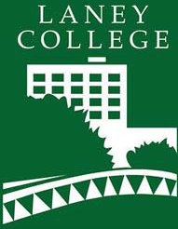 |  | Laney College  Distance Education Newsletter
News & Updates | OCTOBER 2019
Are you on Twitter?  Follow your Distance Ed Coordinator:  @chelseam  cohen for updates and other tibits related to online education! |  | Laney’s First Annual CanInnovate Party!  CanInnovate was a free online conference last Friday, October 25th. Laney College hosted one of the 65 viewing rooms across the state. Nearly 5,000 educators tuned in to presentations focused on California Community College Canvas users.  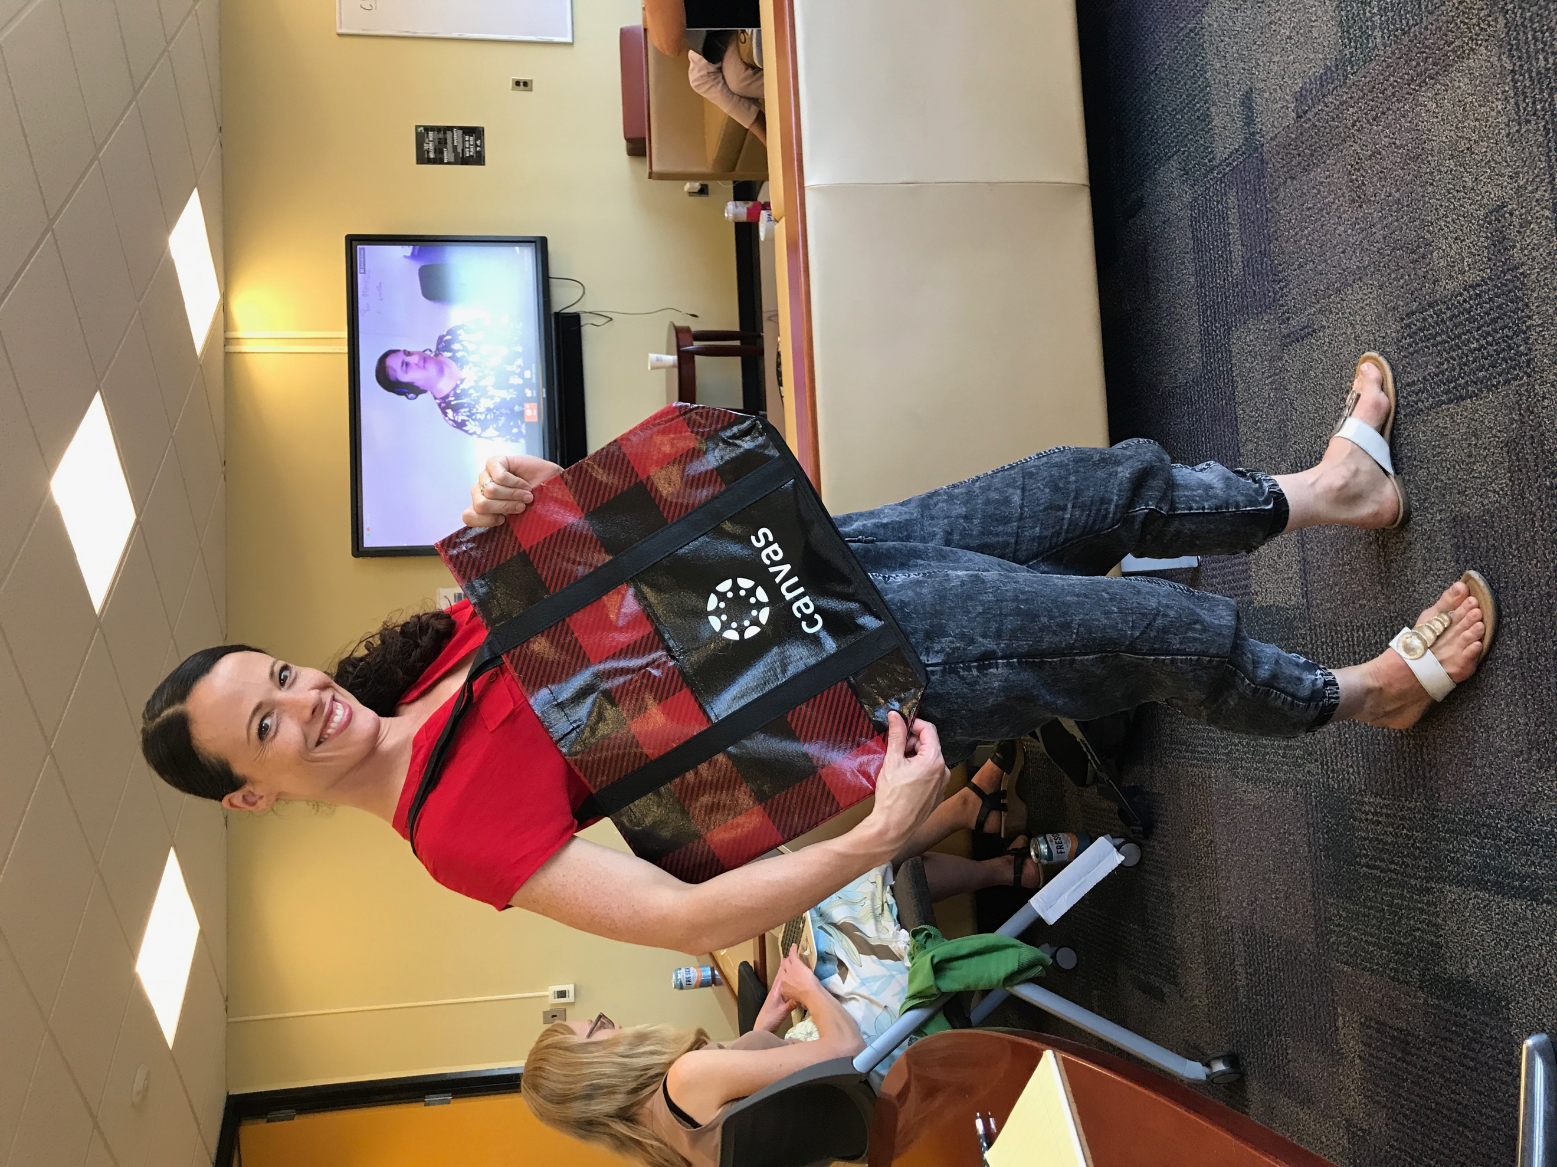  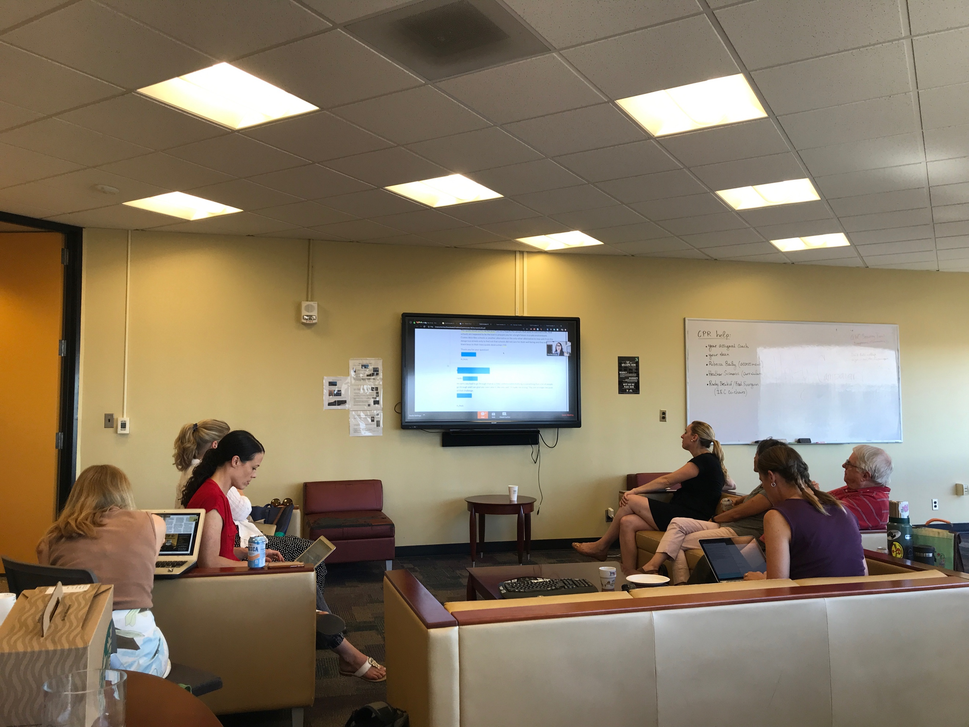  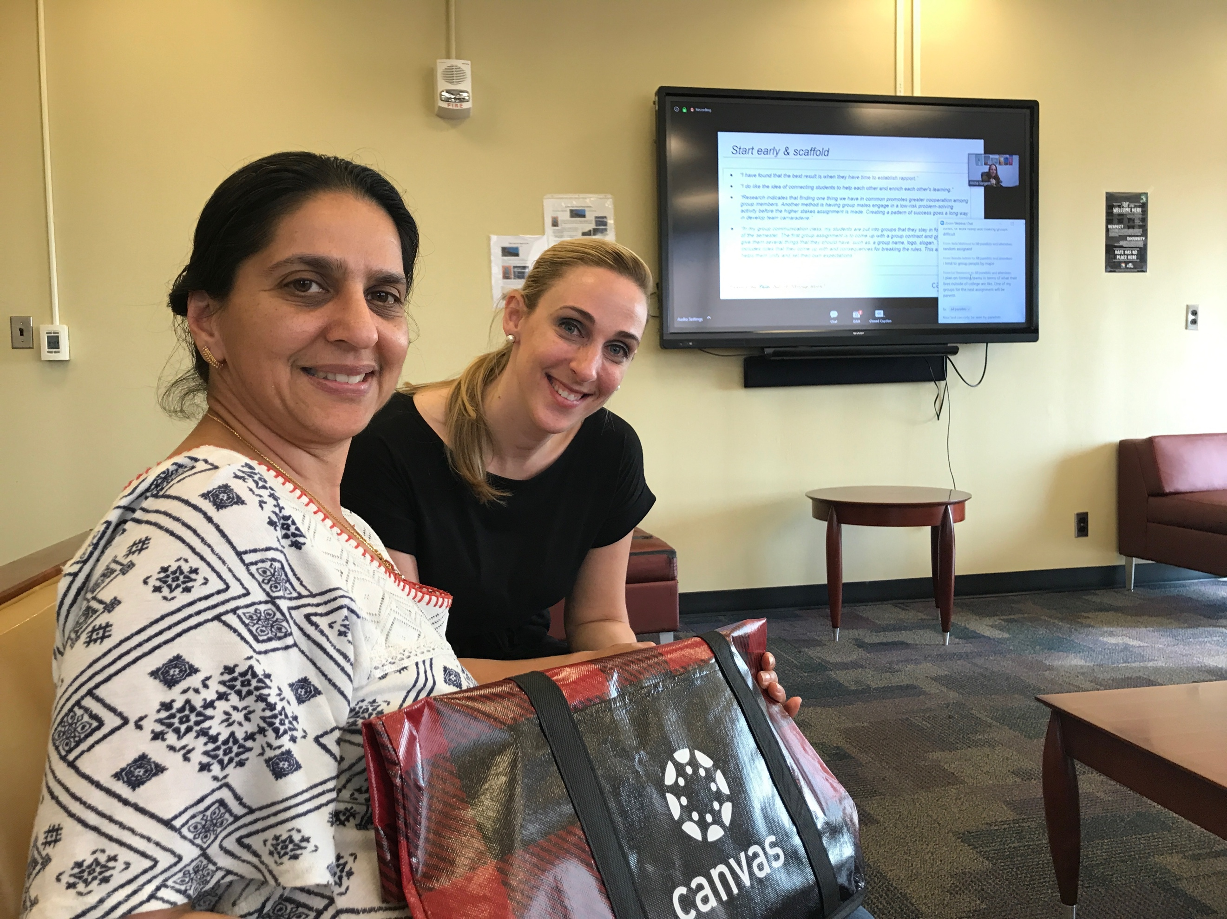  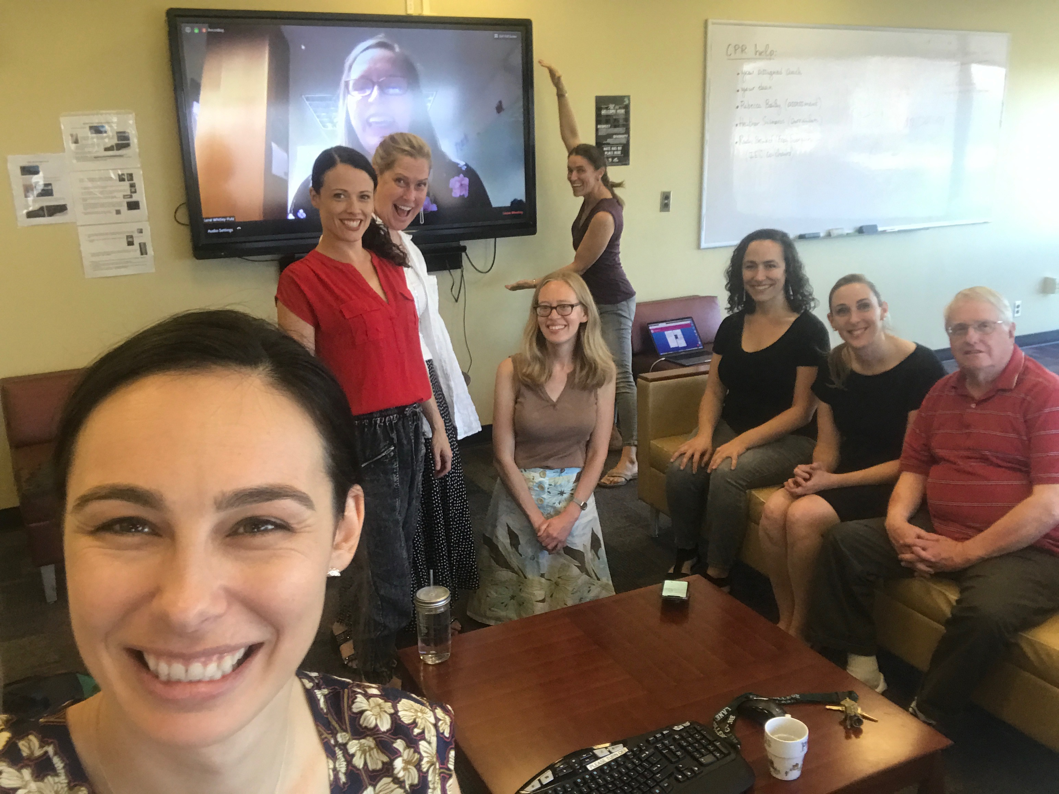  Highlights and Takeaways  Laney and COA professors passionate about online education came together to watch presentations, discuss new ideas and post our thoughts on a shared Padlet. Here are a few of our takeaways from the day:  - Keynote Speaker Kona Jones (Director of Online Learning, Richland Community College) reported that within the last 12 months, 87.4% of students reported feeling overwhelmed by all they had to do. Her full keynote slides are here: Integrating Compassion into your Teaching.  - Michelle Pacansky-Brock, Faculty Mentor, CVC-OEI, shared an easy way to get to know your online students at the beginning of the semester: Student Info Form.  - Your collegues Inger Stark, Adrienne Oliver and I discussed how to foster connection and belonging online using Twitter and Hip-hop Pedagogy elements. Here are our slides.  - Maritez Apigo, English Professor, Contra Costa College, showcased how she uses “Book Clubs” in small group discussions to generate greater interaction than the usual, "Post-Once-Reply-Twice" forums. See the video she shares with her students here.  If you missed it, not to worry. All sessions were recorded and will be posted later this week here: https://onlinenetworkofeducators.org/caninnovate19/. You can also read comments from educators across the state on Twitter here: #CanInnovate19 and @ONE  Upcoming Distance Education Professional Development  Interested in learning more about teaching online? Email ccohen@peralta.edu to schedule an appointment with Chelsea. Her Distance Ed office hours are Tuesdays from 2-3pm in ConferZoom.  There are three more workshops left this semester:  - Have Fun with Video: Thursday, October 31st, 12-1pm  - What is the Peralta Equity Rubric? Friday, November 15th 12-1pm  - Spice Up Your Online Discussions: Friday, December 6th 12-1pm (note: date change)  Workshops will be held in Chelsea’s Zoom Room: https://cccconfer.zoom.us/my/ccohen

