Hi All,

Our first …-DAS-…Report of 2019 delivers the same generally bad news but in a more upbeat tone and plenty of multimedia links! (DAS is terrible but maybe it’s “The Room”-type terrible?)

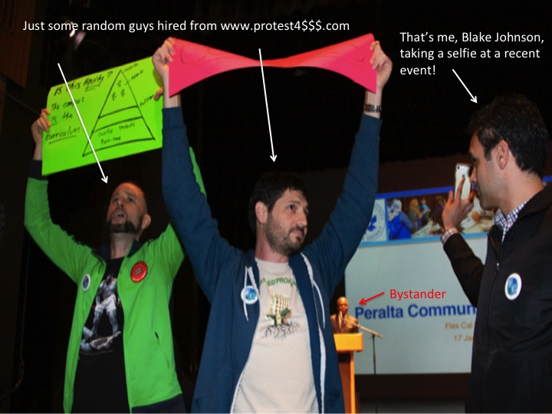

The PBC/PGC “Special” Accreditation Meetings on 12/14
These meetings were a bemusing, positive tone!, mess and the farcical nature of the non-process regarding coming up with an “Action Improvement Plan” while involving as few people at the Colleges as possible caught up to the administrative team involved (basically VCs, College Presidents, and a hodgepodge of functionaries—a couple of DAS faculty included) and the AIP was voted down by the “Planning and Budgeting Council” (in which faculty and staff had a majority) before that vote was completely ignored and the plan, including a proposal for a further $12 million in cuts disproportionately from the Colleges, was subsequently approved by the inaptly titled “Participatory Governance Council” (in which VCs and College Presidents had a majority) because “we have no choice” (always an encouraging phrase!). Subsequently the “AIP,” basically a District plea for more time and the equivalent of a “Look over there! What’s that!?, was signed off by the Trustee designee and sent off to Marin where all things better left off ignored go.

What’s Happened Since?
Surprisingly little! And maybe that’s for the best?

The District and Colleges were formally notified that our “we don’t have it now can you give us 5 months” plea was accepted by the ACCJC and that we’re expected to send an update by March 1st (this will basically be “we’re planning to do something!”) and a “final” 5 year plan on May 1st (this will be “this is what we’re pretending our likely substantially different administrative teams will be doing in 2+ years”).

At the January 25th PBC and PGC “Meetings” (it’s unclear whether they were supposed to be separate or merged meetings—we’re following a “seat of the pants” planning process here at Peralta right now (“seat of the planning?”)—pretty much nothing was accomplished other than the non-representative working group model that led to the December mess was deemed “good” enough for the District (“Peralta enough?”) to continue and we’ll have 2 groups now that are charged with: 1) Enrollment Management and 2) Finance.

The enrollment management group will be presenting the College “plans” and we’ll probably pretend that there’s a District plan/process to do a collective “strategic” plan in the near future. “You never know.”

The finance group is complicated by our visitors from FCMAT and our ongoing inability to know what our finances actually are (deep epistemological questions happening at the District…) or what our mission really is beyond pretending we exist to serve student—pretty clear that can’t be it based on what we actually do.

As of the morning of Friday, February 1st it appeared that an hour into the Finance group’s 1st official meeting since December 14 (so 7 weeks…) they might have identified someone to chair the meeting (Elijah?).

So, Where Are We Now?
Nowhere, really. But that’s not new and might even be a virtue right now. Leaning into the contradictions…

No meaningful planning or process has taken place since December 14th (or really since long before that) and we’ve been at the point of the movie where the montage starts as our hero starts doing things to an 80s soundtrack for the last 7 weeks but instead we’re doing this still.

And What is DAS Up To?
DAS is doing what DAS does; which is to say nothing. At the “special” meeting on January 29th we heard an update from the interim VC of IT Minh Lam that ONEPeralta is now in the advanced stages of talking about restarting the planning for redoing ONEPeralta pending further discussion and planning. So be on the lookout for some exciting discussion about planning soon! (That was hour 1)

Following the robust discussion about further robust discussion, DAS moved into a robust discussion following up on our prior robust discussions about the pretense we’re making regarding holding District accountability: the no-confidence/censure vote. That went nowhere but did seem to include a lively pep talk from our President.

So, What’s Next?
I’m going to spend the remaining term I have as the Laney DAS Representative—there is no way I am subjecting myself again to this year—seeking to radically revise, read completely alter, the DAS Constitution in an effort to promote amongst DAS all the things I’ve been trying to promote at the Colleges and District: transparency, accountability, representation, engagement and in general the minimum I wish we expected of ourselves and the institutions in which we’re complicit in enabling their ongoing dysfunction.

I don’t expect to be successful—things are the way they are for a reason and faculty are ultimately the foundation for all of this dysfunction—but as should be apparent at this point there’s not a lot of productive alternatives when my major DAS-related accomplishment of January will be that I’ve managed to turn my internal screaming into this report…and some fun links.

So I’ll do my best tilting at the latest windmill and anyone else is welcome to join…

