Chapter 1.

Introduction

The District and its Service Area

About the District. Founded in 1964, the Peralta Community College District (PCCD) is a collaborative community of colleges comprised of Berkeley City College (BCC), College of Alameda (COA), and Laney and Merritt colleges in Alameda County, California. The four Peralta Colleges provide a dynamic multicultural learning environment offering accessible, high-quality educational programs and services, including two-year degrees, certificates and university transfer programs, to students from the San Francisco Bay Area. According to the 2000 Census, PCCD’s primary service area had over 615,000 residents. The District has a reputation for developing effective approaches to serve the varied educational and career preparation interests and needs of its vibrant community. The District in general serves over 25,000 students a semester while the majority of whom (68%) are part time. PCCD’s student population is very diverse and mirrors the surrounding community. Roughly 28% are Hispanic/Latino, 24% Asian American, 20% African American, 17% white (non-Hispanic) and remaining as displayed in Chart X below.

Chart X.
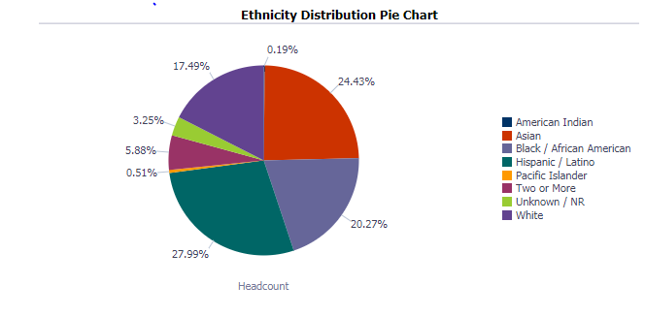

The district’s total full-time equivalent student (FTES) over the last ten years dropped from its peak, 24,252 in AY 2009/10 to 20,307 in AY 2017/18; it was a 16.2% decline (Chart X).

Chart X
Total PCCD FTES, Ten Year Trend
between AY 2008/09 and AY 2017/18

Source: CCCCO Data Mart

PCCD’s Major Service Area. The four PCCD colleges are easily accessible for current and potential students from the Bay Area. While both BCC and Laney are half a block away from a Bay Area Rapid Transit (BART) station, COA and Merritt are only one AC Transit bus ride away from downtown Oakland. While offering similar courses for their students to fulfill general education requirements, the four colleges offer unique academic and career programs for PCCD students to pursue their different professional pathways. The close proximity of the four PCCD colleges leads to a high rate of “student swirl”; 53% of students within the district attend more than one of the four PCCD colleges, 23% attend two or more PCCD colleges within the same semester.
The Bay Area has been experiencing an exponential economic growth for more than one decade. While the San Francisco Bay Area is considered to be the global hub of various growing industry, the East Bay is one of the hubs for renewable energy nationwide and one of the biggest adopters of and markets for solar technology in California. Alameda County is at the heart of the East Bay Green Corridor. The Bay Area Council Economic Institute predicts that the Bay Area labor market will continue to outperform the rest of the state and the nation. Business Insider, in April 2018, ranked two Northern California metros — San Francisco-Oakland-Hayward and San Jose-Sunnyvale-Santa Clara — as the places with the best economy in the country. According to the San Francisco Area Economic Summary, January 31, 2019, the unemployment rates in both San Francisco area (2.7) and Alameda County (3.0) are lower than the national rate of 3.9. Furthermore, the Bay Area Economic Institute announced in July 2018, if the Bay Area were its own country, its economy would rank 19th in the world. At better than four percent economic growth, the Bay Area economy doubles the national average.
Community College Enrollment and the Economy. Community college enrollment and the regional economy tend to have a reverse relationship. While celebrating the country’s recent economic growth being the nation’s second longest, according to Bloomberg, along with many other Bay Area multi-college districts, PCCD has been struggling with enrollments in recent years (Table X). Facing declining enrollment, the District has had to employ a mixture of allowable strategies, stabilization and borrowing, just to meet the base. For example, resident credit FTES in Table X below shown that 15/16 included fall 15, spring and summer 2016; 16/17 only included fall 2016 and spring 2017, while 17/18 included summer and fall 2017 and spring 2018. (to be confirmed)

 | Annual 2015-2016 | Annual 2016-2017 | Annual 2017-2018 | Credit FTES | Credit FTES
 | Credit FTES | Credit FTES | Credit FTES | 2015/16 and 2016/17 % Chg | 2016/17 and 2017/18 % Chg
Peralta CCD | 19,409.34 | 15,624.75 | 18,684.53 | -19.50% | 19.58%
Source: CCCCO Recal Apportionment Attendance Report (these are likely to change these to the recall numbers)

During the same three-year period, credit FTES of most of the Bay Area districts also experienced dynamic changes, as suggested in Table X below.

Table X
Bay Area Community College District Three-Year Credit FTES Trends,
in Comparison with CCCCO

 | 15/16 & 16/17 % Chg | 16/17 & 17/18 % Chg.
Chabot-Las Positas CCD | 2.38% | 0.41%
Contra Costa CCD | -1.48% | -0.01%
Foothill CCD | -3.06% | -6.95%
Los Rios CCD | -3.29% | -0.30%
Marin CCD | -2.09% | -2.72%
Ohlone CCD | 2.06% | -7.42%
Peralta CCD | -5.89% | -0.12%
San Francisco CCD | -11.31% | 17.38%
San Jose CCD | 0.06% | 4.79%
San Mateo CCD | 0.42% | -2.04%
West Valley CCD | -8.59% | -6.08%
State of California | -0.26% | -0.11%

Source: CCCCO Data Mart

PCCD’s Proactive Enrollment Strategies. In spite of this reality, PCCD is engaged in a constant analysis and activities to reverse the declining enrollment trend. The following tables are explained in depth in the District and college Enrollment Management Plans. (add hyperlinks)

Insert SEM crosswalk or if it’s too big then let’s make a brief sample of the chart activities and then link to the full chart.

Importantly, in this era of declining enrollment, there are key areas of growth that have assisted in negating the full impact of the decline. These growth areas include, but are not limited to, dual enrollment, CDCP noncredit and online instruction. These and other areas continue to be the focus for growth, especially in light of the Student Centered Funding Formula which pays the enhanced rate ($5,474 per FTES) for dual enrollment and CDCP noncredit.

Dual enrollment: Initiated prior to this legislation, the number of dual enrollment students has increased from 250 in fall 2015 to 1,709 in fall, 2018. For the fiscal year 2018-2019, the State used 2017-2018 data. This resulted in 1,093 dual enrollment FTES, adding over $6 million dollars to PCCD allocation.

Online instruction: The percentage of students taking online instruction increased from 19% (2011-2012) to 30% in 2016-2017. This includes an increase of 6% who were students taking online instruction for the first time and 17% who were outside of the PCCD service area. Notably, FTES for distance education courses has increased to almost 20% of the district FTES total, counteracting a significant decline in FTES for traditional courses.

CDCP noncredit: A focus on CDCP noncredit was initiated in PCCD when the State began offering full apportionment in 2014 (SB 860). To date the number of CDCP noncredit certificates has grown from 0 in 2014 to 11 in the fall of 2018, with an additional 18 CDCP certificates in the approval process locally and at the State. As noted in the PCCD Strategic Enrollment Management Plan, the expected revenues in the Basic Allocation of the SCFF from these efforts is projected as follows:

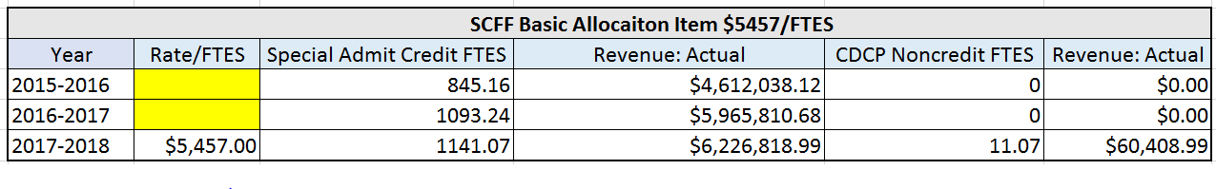

PCCD intends to support these growth areas through strategies such as the following:
- Increase the number of CDCP noncredit program partnerships – As stated in its recent Noncredit Plan for Development (add hyperlink), Peralta will expand existing partnerships with Community Based Organizations and work in collaboration with adult schools in its service area.

- Increase distance education course offerings across the district – By providing more online and hybrid course options, especially in noncredit and dual enrollment areas, Peralta will support responsible growth that helps students complete programs, credentials, and certificates, and that addresses local workforce needs.
- Increase online student retention and success rates to the same levels as the retention and success rates for students in face-to-face classes – It is not enough to increase enrollments in online courses. Peralta recognizes the change in funding emphasis—from enrollment to completion—and is taking the necessary steps to address achievement gaps for specific groups of online learners across the district. By doing so there is a potential multi-year ability to retain 1,699 students. As Distance Education continues to expand this becomes even more important and in light of the SCFF the impact is further enhanced fiscally in that increased retention, persistence and completion.

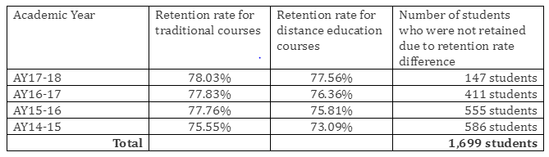

District Shared Governance Structure

Shared governance is central to the PCCD decision making process and key to all financial planning. This process is called the Planning and Budget Integration Model (PBIM). The PBIM utilizes a participatory governance model for operational planning and resource allocation that integrates the four key elements of the strategic planning cycle districtwide:

• Planning
• Budgeting
• Resource allocation
• Evaluation

PBIM relies upon its strategic planning processes as the foundation for integrating planning and budgeting. Strategic planning includes the District Strategic Plan and planning for Academic Affairs, Student Services, Facilities, Information Technology, Human Resources, Enrollment Management, and Fiscal Resources. The colleges, working in partnership with the District Service Centers, have the primary responsibility for developing educational and resource plans that meet the needs of students.

PBIM Committees. PBIM communities include Academic Affairs and Student Services Committee, Enrollment Management Committee, Technology Committee, and Facility Committee. Among the primary PBIM committees, three districtwide committees assume the major responsibility for analyzing enrollment and financial issues, developing strategies to take on the challenges, and coordinating with the four colleges for implementation.

District Participatory Governance Council (PGC). To enhance districtwide communication and decision-making process, PCCD has recently established a District Participatory Governance Council (PGC) that serves as the primary districtwide advisory review body pertaining to major participatory governance issues affecting the Peralta Community College District and assures the broad dissemination of information to constituent groups. All District PBIM Committees report to the District Participatory Governance Council. Specifically, the District Participatory Governance Council will:
- Advise the Chancellor on matters referred by the respective Colleges and/or other standing Councils or Committees;
- Advise the Chancellor on matters relating to the development or revision of Board Policy/District Administrative Procedures;
- Review and make recommendations regarding the ongoing implementation of and ongoing assessment of the District’s Strategic Goals and Institutional Objectives;
- Advise the Chancellor on district-wide operational targets and goals to achieve the District’s Strategic Goals and Institutional Objectives;
- Review and make recommendations regarding PCCD’s integrated improvement plans to achieve the District’s Strategic Goals and Institutional Objectives;
- Review and make recommendations regarding the progress and effectiveness of PCCD’s integrated improvement plans;
- Assure collaboration among the Colleges to address and maintain Accreditation Standards;
- Identify district-wide issues for discussion and follow-up, and make referrals to other PBIM Committees;
- Review and update, as needed, delineation of functions between the District Service Centers and the four Colleges;
- Review and make recommendations regarding advocacy of community college issues at the local, state, and national levels; and,
- Monitor and evaluate the overall effectiveness of PBIM.
District Planning and Budgeting Council (PBC). PBC serves as the primary participatory governance body for the Peralta Colleges, and is responsible for overseeing districtwide planning activities. PBC provides guidance and input in the annual budget planning process, including recommendations of districtwide budgeting assumptions. It is also charged with the development, recommendation and monitoring of the Five-Year Integrated Financial Plan – the first iteration of a long-term financial plan.

PBC receives and reviews recommendations that have been forwarded from the PBIM committees and makes final recommendations to the District Participatory Governance Council. Recommendations include educational and resource priorities, Board Policies and Administrative Procedures, and new initiatives. PBC will continue to:

- Affirm consistency with strategic and educational plans;
- Recommend a coordinated, district-wide planning approach;
- Recommend a prioritization of plans across subject areas and the four Colleges;
- Identify funding approaches to support priorities;
- Provide oversight on the implementation of the Strategic Plan.
- Track recommendations and determine whether the recommendations are implemented including any modifications, or if the recommendations are not implemented, the reasons for not being implemented;
- Ensure accountability in district-wide planning by determining whether the agreed upon steps in the process were followed; and,
- Make recommendations to the District Participatory Governance Council and to the Chancellor for alternative uses of unrestricted revenue.

District Academic Affairs and Student Services Committee (DAASSC). The DAASSC serves to coordinate district-wide instructional goals and student support services to promote student success, sustain academic quality, and to continuously evaluate and make improvements. This committee ensures the broad dissemination of information to constituent groups. DAASSC makes recommendations to the Planning and Budgeting Council (PBC) to:

- Review issues and make recommendations pertaining to academic affairs and student services across the four Colleges.
- Seek collaborative solutions that use resources across the Colleges and District Service Centers;
- Ensure consistency among College requests;
- Coordinate and monitor the effectiveness of academic affairs and student services policies and procedures;
- Stay current on legislative and regulatory proposals and new funding streams that may impact College and district-wide programs;
- Use a systems approach to ensure optimal capacity and to avoid redundancy of effort; and,
- Help to establish new services, as needed, among the Colleges pertaining to instruction and student services.

Including resident, non-resident, credit, and non-credit FTES.
Although a great local economy may offer PCCD students plenty of opportunities for employment, as well as upward mobility, national data has shown that there is a reverse relationship between economy and community college enrollment, indicated by Community College Review, January 2019; Inside Higher Ed, June 2018; United States Census, June 2018, EvoLLLurtion, February 2019; along with many other sources of information. A 2015 article in Insider Higher Ed took one step further indicating that as a general rule of thumb, community college enrollment tends to decline by about 2.5 percent for every 1 percent drop in the unemployment rate. It is primarily due to the fact that those adult learners aged 25 or older would leave college and go back to the work force when economy is blooming and jobs are available, whereas they go back to school when employment opportunities disappearing. This statement may be supported by the age representation shift of PCCD students. PCCD student age data indicate that adult students (age 25 or older) represented 51% of the total PCCD student body back in 2009/10 – PCCD’s enrollment peak; that year was also the tail end of the housing bobble when jobs were scarce. However, in 2017/18 when the job market was thriving, the district student body only comprised of 44% of adult students. This means, in between these two years, PCCD only lost 2,194 or 7.2% students aged 24 or younger, but 9,680 or 30.2% adult students.
Include resident and non-resident credit FTES.

