2021-2022 Annual Program Review (APR) Questions
Administrative
- Below are the questions in META for your Annual Program Review.
- Several Questions have last year’s responses/information inserted in text boxes. This is provided for you to review and edit the information to reflect currency, relevancy, and accuracy for the current program review you are filling out.
- Prompts are highlighted in grey where last year’s information will show.
- LAST – it is recommended to print out/save your Program Review from last year and use as a reference for this year’s Program Review. Instructions on how to get save a copy of last year’s program review is at the bottom of this document.
TAB NAME | ITEMS/FIELDS IN TAB
Mission Statement/Strategic Goals | Mission Statement  1. Mission Statements should include the following criteria/questions to ask in the development of your Mission Statement:  - Department/Area Mission Statement aligns with college Mission Statement  - Department/Area Mission Statement is student-centered  - How does the department define success in terms of the students you serve?  - How do you support the programs and services at the college to help them build or achieve student success?  Below is the Mission Statement for your department/unit from the 2020-2021 Program Review. Review it for inclusion of the above items. You may keep your Mission Statement or edit it below.  <<An editable text box will show the departments/units mission statement from last year’s program review>>  Strategic Goals  2. Strategic Goals are things the department/area needs to do in order to accomplish their Mission Statement. Strategic goals should:  - Be aligned with Campus Strategic goals and aligned with department mission statement  - Define what needs to be done to accomplish the Mission Statement and/or  - Define what needs to be done better to accomplish the Mission Statement  Below are the Program Strategic Goals for your department/unit from the 2020-2021 Program Review. Review them for inclusion of the above items. For each Strategic Goal, identify the current “Goal Status”. If you would like to add a new Strategic Goal, click on “Add Item” and fill out all the fields. Be sure to SAVE your new Strategic Goal.  <<All previous strategic goals will be inserted here for you to review/edit/update>>  Faculty and/or Staff  3. Below are the personnel for your department/unit from the 2020-2021 Program Review. Review the information for accuracy. Update as needed.  <<Each box will show information that was inputted last year and be able to be edited >>  Full Time Part Time Student Worker Instructional Aid Other  Facility Usage  4. Describe the current utilization of facilities, including labs and other space. Below is the facility list for your department/unit from the 2020-2021 Program Review. Review the information for currency and accuracy. Update as needed.  <<An editable text box will show information inputted last year and be able to be edited>>
Program Overview | Dashboard Data link here  1. Using the dashboard, review and reflect upon the data for your program. Describe any significant changes and discuss what the changes mean to your program. Consider whether performance gaps exist for disproportionality impacted students. Focus upon the most recent year and/or the years since your last comprehensive program review. Cite data points from the dashboard to support your answer  2. Describe the outcomes and accomplishments from previous year’s funded resource allocation request.
Assessment | Assessment  1.Progress  Describe the department/unit progress on assessment of Student Learning Outcomes (SLOs), Service Area Outcomes (SAOs), and/or Administrative Unit Outcomes (AUOs) since the last Comprehensive Program Review (CPR) or Annual Program Review (APR), including:  - If you are instructional and offer degrees/certificates, please describe the department progress on Program Learning Outcomes (PLOs)  - If you have an established assessment plan from a previous CPR, have you followed the plan? Please explain any changes to the plan that may have occurred.  2.SLOs/SAOs/AUOs: Learning, Improvements, Changes  This assessment information will be used to support resource requests.  Please address the following with brief explanations:  - What were the important things your department/unit learned from assessment?  - Did action plans result in better student learning or unit improvements?  - Did assessment results lead to changes in curriculum or processes?  3.PLOs: Learning, Improvements, Changes (Instructional and Instructional.CTE, & SS w/Instruction only)  This assessment information will be used to support resource requests.  Please address the following with brief explanations:  - What were the important things your department learned from PLO assessment?  - Did PLO action plans result in better student learning?  Did PLO assessment results lead to changes in curriculum?
Resource Request | Resource Request  Below is the resource request list for your department/unit from the 2020-2021 Program Review. Review the resource request(s) for currency and accuracy. For each Resource Request, click on the pencil to the left and identify the current “Resource Request Status” (bottom of the questions).  <<Last year’s full list will show and all items are editable to review/edit/update>>  If you would like to add a new Resource Request, click “Add Item” and fill out all the fields. Be sure to SAVE your new Resource Request.  <<The resource request info below is the same, but is reflecting that the “library” option is removed--- Updated to reflect IEC determination that “Library” resource request was not appropriate in PR. Therefore, Library choice was removed>>  1. Resource Request Options to choose from:  - Personnel  - Professional Development  - Technology  - Facilities  - Equipment  - Other  If choose “Personnel”, subcategory drop down options:  - Classified Staff  - Student Worker  - Part-time Faculty  - Full-time Faculty  If choose “Professional Development”, subcategory drop down options:  - Department-wide PD needed  - Individual/Personal PD needed  If choose “Technology”, subcategory drop down options:  - Software  - Hardware  If choose “Facilities”, subcategory drop down options:  - Classrooms  - Offices  - Labs  - Facility Improvement  - Other  If choose “Equipment, subcategory drop down options:  - New equipment  - Equipment Repair  - Upgrade of current equipment  If choose, “Other”, text box opens to write request in  1. Which of your programs strategic goals will this personnel request address?  2. How will this resource request help you address the identified strategic goal(s)?  3. What funding category are you requesting this come from?  - SSP  - Equity  - Perkins  - Grant  - Instructional Equipment & Library Materials  - Other Funding Category  4A. For CTE curriculum, if this equipment request is supporting a new program or class, has your industry advisory committee approved the curriculum?  For Instructional curriculum, if this equipment request is supporting a new program or class(es), have you provided evidence and need for the new curriculum in the Curriculum tab on this Program Review?  4B. Has the curriculum been written for the new class(es) or program?  5. Total Cost  6. “Resource Request Status”  dropdown choices:  - New Resource Request  - In-Progress  - Completed  - No Longer Applicable  - Give a brief update of Status

Instructions to save a copy of the 20-21 Program Review:
- Click on the piece of paper to the right of the Program Review
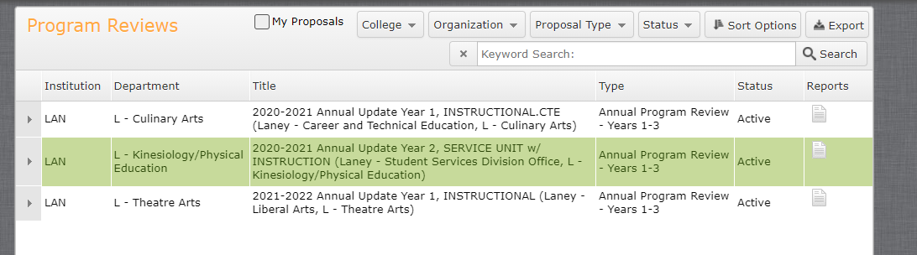

- Click on “All Fields”
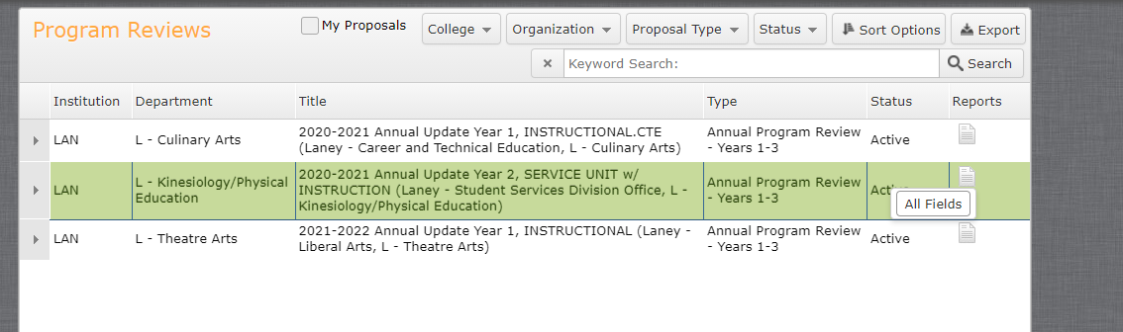

- A new webpage tab will open up with the Full Program Review.

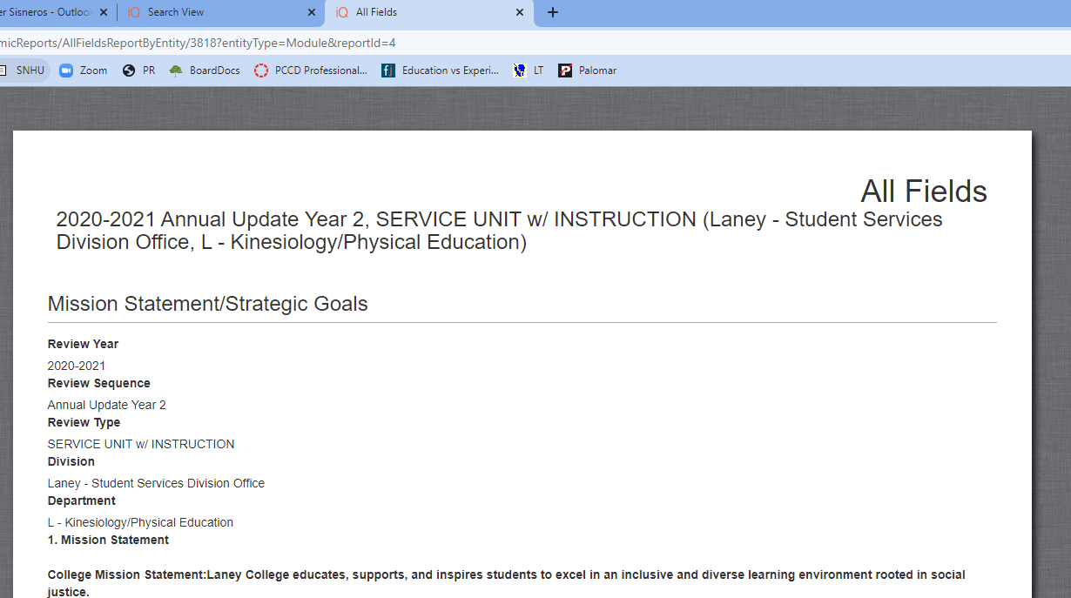

- Copy and paste all the information into a word document save it or
- Save the webpage.

