2021-2022 Comprehensive Program Review (CPR) Questions
Administrative
- Below are the questions in META for your Comprehensive Program Review.
- Several Questions have last year’s responses/information inserted in text boxes. This is provided for you to review and edit the information to reflect currency, relevancy, and accuracy for the current program review you are filling out.
- Prompts are highlighted in grey where last year’s information will show.
- LAST – it is recommended to print out/save your Program Review from last year and use as a reference for this year’s Program Review. Instructions on how to save a copy of last year’s program review is at the bottom of this document.
TAB NAME | ITEMS/FIELDS IN TAB
Mission Statement/Strategic Goals | Mission Statement  1. Mission Statements should include the following criteria/questions to ask in the development of your Mission Statement:  - Department/Area Mission Statement aligns with college Mission Statement  - Department/Area Mission Statement is student-centered  - How does the department define success in terms of the students you serve?  - How do you support the programs and services at the college to help them build or achieve student success?  Below is the Mission Statement for your department/unit from the 2020-2021 Program Review. Review it for inclusion of the above items. You may keep your Mission Statement or edit it below.  <<An editable text box will show the departments/units mission statement from last year’s program review>>  Strategic Goals  2. Strategic Goals are things the department/area needs to do in order to accomplish their Mission Statement. Strategic goals should:  - Be aligned with Campus Strategic goals and aligned with department mission statement  - Define what needs to be done to accomplish the Mission Statement and/or  - Define what needs to be done better to accomplish the Mission Statement  Below are the Program Strategic Goals for your department/unit from the 2020-2021 Program Review. Review them for inclusion of the above items. For each Strategic Goal, identify the current “Goal Status”. If you would like to add a new Strategic Goal, click on “Add Item” and fill out all the fields. Be sure to SAVE your new Strategic Goal.  <<All previous strategic goals will be inserted here for you to review/edit/update>>  Faculty and/or Staff  3. Below are the personnel for your department/unit from the 2020-2021 Program Review. Review the information for accuracy. Update as needed.  <<Each box will show information that was inputted last year and be able to be edited >>  Full Time Part Time Student Worker Instructional Aid Other  Facility Usage  4. Describe the current utilization of facilities, including labs and other space. Below is the facility list for your department/unit from the 2020-2021 Program Review. Review the information for currency and accuracy. Update as needed.  <<An editable text box will show information inputted last year and be able to be edited>>
Assessment & Accomplishments | Assessment  Administrative Unit Outcomes (AUOs) are specific, measurable statements concerning the fundamental functions of the unit, and the resulting services provided to clients. Assessment of AUOs should lead to action plans that, when implemented, are intended to lead to continued quality improvement in the services provided.  Planning  Indicate your unit’s assessment plan below, by stating your unit’s AUOs (up to three) and when you plan to assess them:  Process  Best practices for assessment include aligning your AUOs to the college mission and ILOs, planning, collaboration, and designating unit leads for specific tasks.  2. How well does your unit collaborate on assessment, rate 1 – 5 (5 being the ideal)  3. How frequently does your unit meet to discuss assessment  4. If any improvements are needed to your assessment process, please describe.  Use of Assessment Results and Action Plans  5. What were the most important things your unit learned from assessment of AUOs? If implementation of your action plans resulted in improved outcomes and/or changes in process, briefly explain. How has assessment informed planning and goal setting in your unit?  Support  6. What support does your unit need from administrators and assessment coordinators to continue to make progress in assessment of outcomes and implementation of action plans? Check all that apply:  Help with creating an assessment plan  Help with strategizing how to make assessment work for your unit  Overall understanding of assessment  Training on how to input data in META  Other
Resource Request | Resource Request  Below is the resource request list for your department/unit from the 2020-2021 Program Review. Review the resource request(s) for currency and accuracy. For each Resource Request, click on the pencil to the left and identify the current “Resource Request Status” (bottom of the questions).  <<Last year’s full list will show and all items are editable to review/edit/update>>  If you would like to add a new Resource Request, click “Add Item” and fill out all the fields. Be sure to SAVE your new Resource Request.  <<The resource request info below is the same, but is reflecting that the “library” option is removed--- Updated to reflect IEC determination that “Library” resource request was not appropriate in PR. Therefore, Library choice was removed>>  1. Resource Request Options to choose from:  - Personnel  - Professional Development  - Technology  - Facilities  - Equipment  - Other  If choose “Personnel”, subcategory drop down options:  - Classified Staff  - Student Worker  - Part-time Faculty  - Full-time Faculty  If choose “Professional Development”, subcategory drop down options:  - Department-wide PD needed  - Individual/Personal PD needed  If choose “Technology”, subcategory drop down options:  - Software  - Hardware  If choose “Facilities”, subcategory drop down options:  - Classrooms  - Offices  - Labs  - Facility Improvement  - Other  If choose “Equipment, subcategory drop down options:  - New equipment  - Equipment Repair  - Upgrade of current equipment  If choose, “Other”, text box opens to write request in  1. Which of your programs strategic goals will this personnel request address?  2. How will this resource request help you address the identified strategic goal(s)?  3. What funding category are you requesting this come from?  - SSP  - Equity  - Perkins  - Grant  - Instructional Equipment & Library Materials  - Other Funding Category  4A. For CTE curriculum, if this equipment request is supporting a new program or class, has your industry advisory committee approved the curriculum?  For Instructional curriculum, if this equipment request is supporting a new program or class(es), have you provided evidence and need for the new curriculum in the Curriculum tab on this Program Review?  4B. Has the curriculum been written for the new class(es) or program?  5. Total Cost  6. “Resource Request Status”  dropdown choices:  - New Resource Request  - In-Progress  - Completed  - No Longer Applicable  - Give a brief update of Status

Instructions to save a copy of the 20-21 Program Review:
- Click on the piece of paper to the right of the Program Review
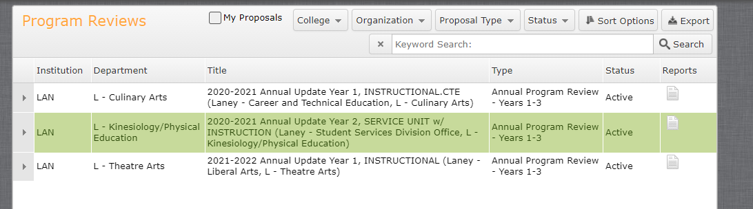

- Click on “All Fields”
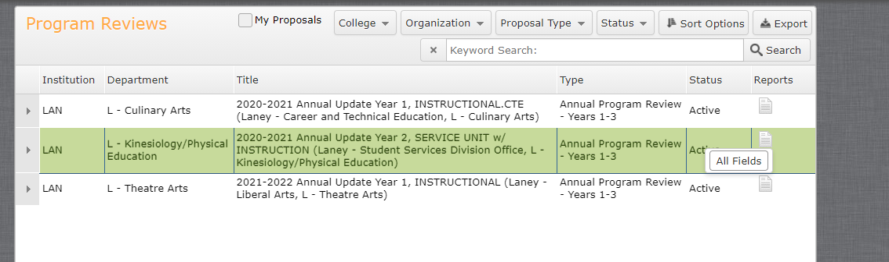

- A new webpage tab will open up with the Full Program Review.

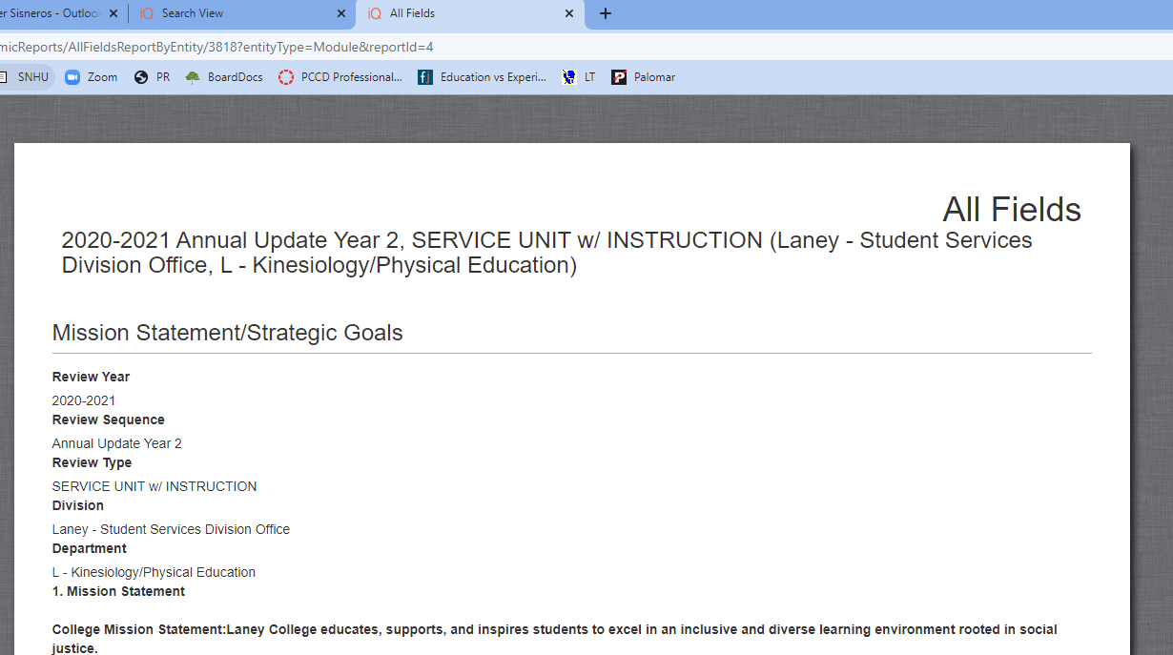

- Copy and paste all the information into a word document save it or
- Save the webpage.

