2021-2022 Comprehensive Program Review (CPR) Questions
Special Programs.Student Services
- Below are the questions in META for your Comprehensive Program Review.
- Several Questions have last year’s responses/information inserted in text boxes. This is provided for you to review and edit the information to reflect currency, relevancy, and accuracy for the current program review you are filling out.
- Prompts are highlighted in grey where last year’s information will show.
- LAST – it is recommended to print out/save your Program Review from last year and use as a reference for this year’s Program Review. Instructions on how to save a copy of last year’s program review is at the bottom of this document.
TAB NAME | ITEMS/FIELDS IN TAB
Mission Statement/Strategic Goals | Mission Statement  1. Mission Statements should include the following criteria/questions to ask in the development of your Mission Statement:  - Department/Area Mission Statement aligns with college Mission Statement  - Department/Area Mission Statement is student-centered  - How does the department define success in terms of the students you serve?  - How do you support the programs and services at the college to help them build or achieve student success?  Below is the Mission Statement for your department/unit from the 2020-2021 Program Review. Review it for inclusion of the above items. You may keep your Mission Statement or edit it below.  <<An editable text box will show the departments/units mission statement from last year’s program review>>  Strategic Goals  2. Strategic Goals are things the department/area needs to do in order to accomplish their Mission Statement. Strategic goals should:  - Be aligned with Campus Strategic goals and aligned with department mission statement  - Define what needs to be done to accomplish the Mission Statement and/or  - Define what needs to be done better to accomplish the Mission Statement  Below are the Program Strategic Goals for your department/unit from the 2020-2021 Program Review. Review them for inclusion of the above items. For each Strategic Goal, identify the current “Goal Status”. If you would like to add a new Strategic Goal, click on “Add Item” and fill out all the fields. Be sure to SAVE your new Strategic Goal.  <<All previous strategic goals will be inserted here for you to review/edit/update>>  Faculty and/or Staff  3. Below are the personnel for your department/unit from the 2020-2021 Program Review. Review the information for accuracy. Update as needed.  <<Each box will show information that was inputted last year and be able to be edited >>  Full Time Part Time Student Worker Instructional Aid Other  Facility Usage  4. Describe the current utilization of facilities, including labs and other space. Below is the facility list for your department/unit from the 2020-2021 Program Review. Review the information for currency and accuracy. Update as needed.  <<An editable text box will show information inputted last year and be able to be edited>>
Students Served | Students Served  1. Detail the services provided by your program/service area. Below are the services provided for your department from the 2020-2021 Program Review. Review the information for currency and accuracy. Update as needed.  <<An editable text box will show information inputted last year and be able to be edited>>  2. Reflect on collaboration and engagement with other programs/service areas that have contributed towards student success and meeting program goals.  3. Review and reflect your program’s data using the Student Services Dashboard. Describe any significant changes and discuss what the changes mean to your program.  4. Detail the completion rates for your program and comment upon it. Do performance gaps exist in the completion rates for disproportionately impacted students, including African-American, Hispanic/Latino, Filipinos/Pacific Islanders, Foster youth, Veterans, and students with disabilities or other groups not listed here? Note: groups whose completion rate is 3% or less than the College completion rate reflect a disproportionate impact.  5. If differences exist, please detail the differences and describe the activities your program is making to address the differences. How will your program evaluate the effectiveness of these activities?
Assessment | Assessment  Student Learning Outcomes (SLOs) and Program Learning Outcomes (PLOs) are specific, measurable statements of knowledge, skills, abilities, or attitudes students should be able to demonstrate when they complete a course or program. Assessment of SLOs and PLOs should lead to action plans that, when implemented, are intended to lead to continued quality improvement in courses and programs.  Planning  If you have not created an assessment plan, click on the link to download the template. Fill it out according to the instructions in the template and upload it to this program review. If you have already turned in an assessment plan with a previous Program Review, do your assessments listed above show that you have been following the plan? Please explain any changes to the plan that may have occurred, such as changes in SLOs/PLOs.  Process  Best practices for assessment include planning, collaboration, and designating department leads for specific courses or tasks.  Describe how your department works together on assessment and any improvements you plan to make to your process.  Results and Action Plans (SLOs)  What were the most important things your department learned from assessment of SLOs? If implementation of your action plans resulted in better student learning and/or changes in curriculum, briefly explain.  Results and Action Plans (PLOs)  What were the most important things your department learned from assessment of PLOs? If implementation of your action plans resulted in better student learning and/or changes in curriculum, briefly explain.  College Level Participation (multidisciplinary programs)  If your department is included in a multidisciplinary program, describe your participation in the assessment of that program. Explain what you learned from the assessment of the program that was applicable to your own discipline.  College Level Participation (ILOs)  Describe your department’s participation in the assessment of Institutional Learning Outcomes (ILOs). Examples include completion of mapping SLOs/PLOs to ILOs, participation in campus ILO surveys, and/or use of the ILO common rubrics.  Support  What support does your department need from administrators, assessment coordinators and/or Laney’s Learning Assessment Committee (LAC) to continue to make progress in assessment of outcomes and implementation of action plans? Check all that apply:  Help with creating an assessment plan  Help with strategizing how to make assessment work for your department  Training on how to input data in  More full time faculty to help with assessment work  Funding to support part time faculty assessment work  Other
Degrees & Certificates | Degrees & Certificates  Data Dashboard links here  1. What has the discipline, department, or program done to improve the number of degrees and certificates awarded? Include the number of degrees and certificates awarded by year, for the past three years.  2. Over the next 3 years, will you be focusing on increasing the number of degrees and certificates awarded?  3. What is planned for the next 3 years to increase the number of certificates and degrees awarded?
Engagement | Engagement  1. Discuss how faculty and staff have engaged in institutional efforts such as committee’s presentations and departmental activities. Please list the committees that full-time faculty participate in.  2. Discuss how faculty and staff have engaged in community activities partnerships and/or collaborations.  3. Discuss how adjunct faculty members are included in departmental training discussions and decision-making.
Resource Request | Resource Request  Below is the resource request list for your department/unit from the 2020-2021 Program Review. Review the resource request(s) for currency and accuracy. For each Resource Request, click on the pencil to the left and identify the current “Resource Request Status” (bottom of the questions).  <<Last year’s full list will show and all items are editable to review/edit/update>>  If you would like to add a new Resource Request, click “Add Item” and fill out all the fields. Be sure to SAVE your new Resource Request.  <<The resource request info below is the same, but is reflecting that the “library” option is removed--- Updated to reflect IEC determination that “Library” resource request was not appropriate in PR. Therefore, Library choice was removed>>  1. Resource Request Options to choose from:  - Personnel  - Professional Development  - Technology  - Facilities  - Equipment  - Other  If choose “Personnel”, subcategory drop down options:  - Classified Staff  - Student Worker  - Part-time Faculty  - Full-time Faculty  If choose “Professional Development”, subcategory drop down options:  - Department-wide PD needed  - Individual/Personal PD needed  If choose “Technology”, subcategory drop down options:  - Software  - Hardware  If choose “Facilities”, subcategory drop down options:  - Classrooms  - Offices  - Labs  - Facility Improvement  - Other  If choose “Equipment, subcategory drop down options:  - New equipment  - Equipment Repair  - Upgrade of current equipment  If choose, “Other”, text box opens to write request in  1. Which of your programs strategic goals will this personnel request address?  2. How will this resource request help you address the identified strategic goal(s)?  3. What funding category are you requesting this come from?  - SSP  - Equity  - Perkins  - Grant  - Instructional Equipment & Library Materials  - Other Funding Category  4A. For CTE curriculum, if this equipment request is supporting a new program or class, has your industry advisory committee approved the curriculum?  For Instructional curriculum, if this equipment request is supporting a new program or class(es), have you provided evidence and need for the new curriculum in the Curriculum tab on this Program Review?  4B. Has the curriculum been written for the new class(es) or program?  5. Total Cost  6. “Resource Request Status”  dropdown choices:  - New Resource Request  - In-Progress  - Completed  - No Longer Applicable  - Give a brief update of Status

Instructions to save a copy of the 20-21 Program Review:
- Click on the piece of paper to the right of the Program Review
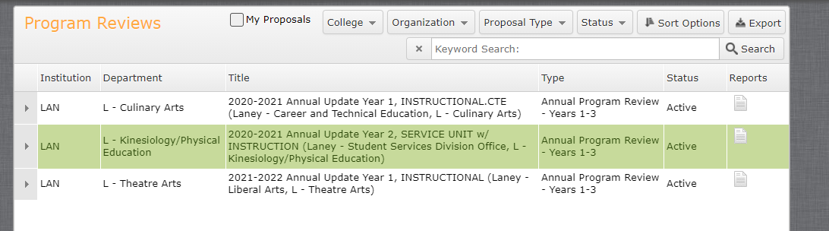

- Click on “All Fields”
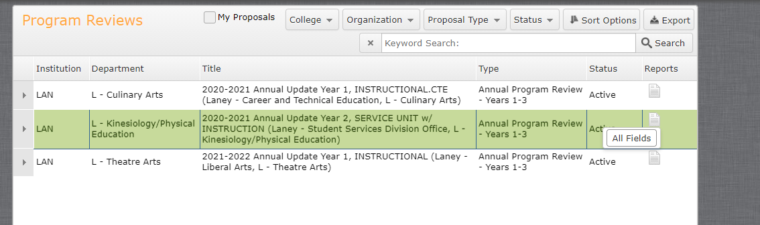

- A new webpage tab will open up with the Full Program Review.

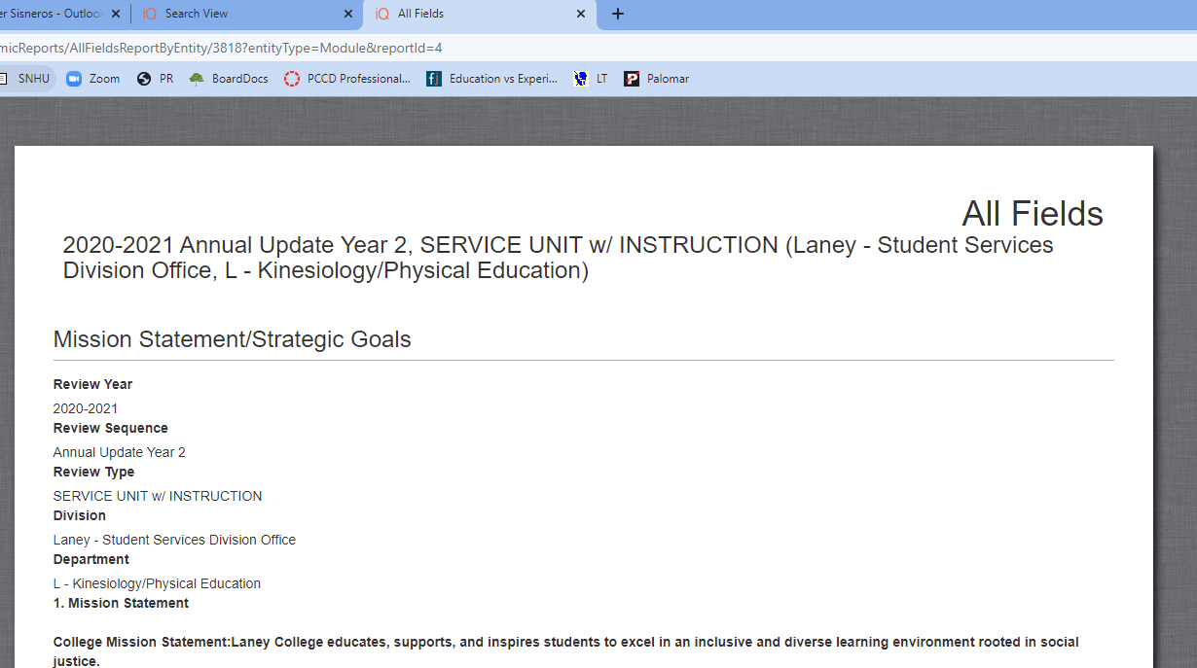

- Copy and paste all the information into a word document save it or
- Save the webpage.

