A glossary of what tops things off
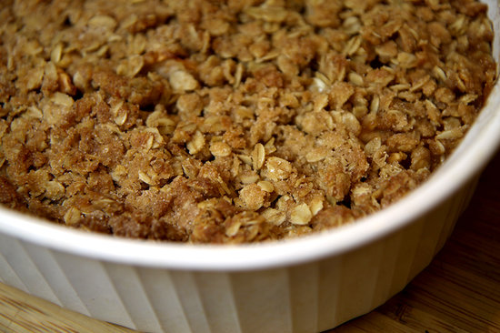
Sometimes it’s the topping that distinguishes one style of baked fruit dish from another. Here’s a rundown of what defines each style of these endlessly versatile dishes.

Crisp
One of the most common fruit desserts, the crisp boasts a topping made primarily from oats and nuts. Nearly any seasonal fruit works well. Though crisps are often interchangeable, this dessert traditionally has more going on in the topping than the crumble does, and, as the name suggests, it gets a little crispier when baked.
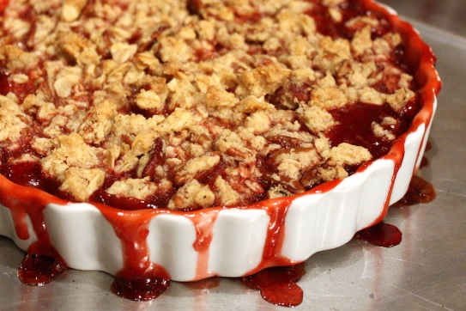
Crumble
Not to be confused with a crisp (though they often are), this dessert has a simple streusel topping—essentially butter, flour, sugar and a little seasoning –that is sprinkled over the fruit of choice. When baked, the crumbled topping hardens and browns, while simultaneously melting into the fruit underneath.

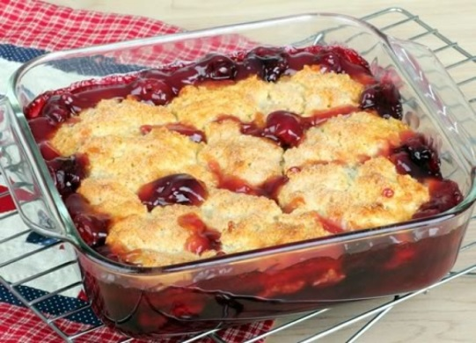
Cobbler
A baked deep-dish dessert with the dough on top rather than the bottom. The topping is normally a sweet cream or buttermilk biscuit, while the fruit—even savory fillings like winter squash can work. In some versions, the biscuit dough is rolled and cut into circles to place on the fruit, allowing some of the filling to peek through; in others, the dough is spread across the surface, hiding the fruit beneath.
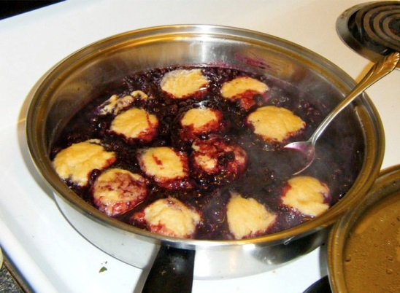
Grunt or slump
Essentially a steamed cobbler, this fruit-and-dough combination is cooked on the stove as opposed to being baked. The dough—which resembles a dumpling batter—is dropped in spoonfuls over simmering fruit. As for the name? It can be either a grunt or slump, depending on where you live; the origins are said to trace back to different parts of New England. Some say the dish makes a grunting sound on the stove as it steams and bubbles, others claim that the dessert has a slumped appearance when spooned onto a plate.
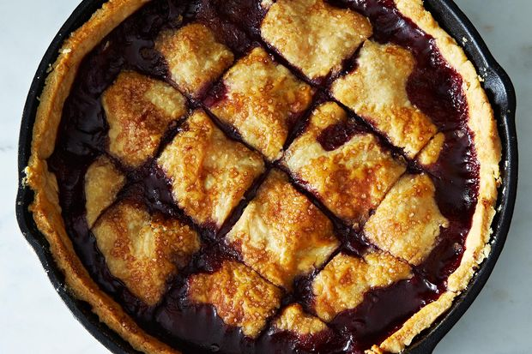
Pandowdy
Said to be named for its homely appearance, this deep-dish dessert starts with a base of almost any fruit. Toppings can range from rolled-out pie or pastry dough to biscuit, but the catch is that about halfway through baking, the topping is broken up into pieces and pushed down into the cooked fruit, allowing some of the juices to bubble up and over the dough.
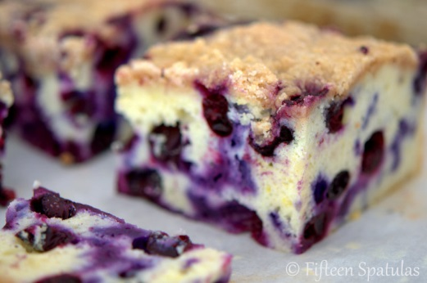
Buckle
Baked as a one-layer cake, this dessert is normally made by floating berries into batter, then sprinkling streusel crumbles on top. When it comes out of the oven, the cake has a buckled look—hence the name. With a loose, almost pudding-like batter, this has a very moist crumb, and works just as well for brunch as for dessert.
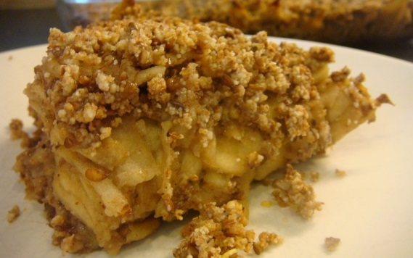
Brown Betty
This layered dessert is all about crumb—breadcrumbs, that is. The fruit of choice—most often apples or pears—is placed in alternating layers with buttered toasted crumbs, which either soften along with the fruit or harden up on top of the dessert of the dessert. Leftover cake or pastry crumbs would work, too.

