AMATYC Contest (Spring 2013) SOLUTIONS
- [D] $25+25-12=38$
- [D] It should be between $8.1-1.4=6.7$ and $8.1+1.4=9.5$. So it's 8.
- [E] 2nd eqn - 1st eqn gives $3ex+3ey=3e$, so $y=1-x$. Substitute into 1st eqn, $x=-1$, so $y=2$.
- [C] Factor each of the five to see.
- [B] The $x$-intercepts are $-\frac{b}{2}$ and $\frac{6}{m}$ , respective. Thus $-\frac{b}{2}=\frac{6}{m}$, and so $mb+12=0$.
- [B] $\frac{1}{a}≤ \frac{1}{b}$ , so $\frac{2}{b}≥\frac{1}{a}+\frac{1}{b}=\frac{1}{n}$ , thus $b≤2n$. For each $n$ listed, try all such $b$ to see if it works.
- [B] For $k=1,⋯,12$, do a prime factorization of $2013-k^{3}$. (Well, you probably need a graphing calculator with factoring functionality!) Keep only those cases where all primes of the form $4k+3$ appear an even number of times (including 0 times). So only three cases are kept: (1) $2013-2^{3}=5⋅401$, (2) $2013-4^{3}=1949$, and (3) $2013-{10}^{3}=1013$. For case (1), $b^{2}+c^{2}=2013-2^{3}=5⋅401=(2+i)(2-i)(20+i)(20-i)$, so, up to complex conjugation and multiplication by $±1$, $±i$ , $b+ci$ is either $\left(2+i\right)\left(20+i\right)=39+22i$ or $\left(2+i\right)\left(20-i\right)=41+18i$. But we are told that $b$ is a multiple of 5, so neither one works. Next try, (2), so $1949={10}^{2}+{43}^{2}$ (i.e. $(10+43i)(10-43i)$.) This works, for then $a=4, b=10, c=43$. (Remark: The solution relies on knowledge in Gaussian integers.)
- [A] $A^{2} | 3^{2}⋅5^{2}⋅7⋅{11}^{2}$, so $A^{2} | 3^{2}⋅5^{2}⋅{11}^{2}$, thus $A | 3⋅5⋅11$. If $A$ has two or three prime factors, $MTYC$ would have three or one prime factors (counting multiplicity), impossible. So $A=3, 5, 11$. Try $A=11$, then $MTYC=3⋅3⋅5⋅5⋅7$, which can be $3⋅5⋅7⋅15$. So we get $3+5+7+15=30$.
- [B] 139 is a prime, so it must be that $P\left(0\right)=1$, $P\left(3\right)=139$. Thus $P\left(x\right)=ax^{3}+bx^{2}+cx+1$, with $27a+9b+3c=138$. The prime factorization of 689 is $13⋅53$. So $P\left(1\right)=13$, $P\left(2\right)=53$, i.e. $a+b+c=12$ and $8a+4b+2c=52$. Solve the system of three linear equations in $a,b,c$ to get $a=3, b=5, c=4$, thus $P\left(x\right)=3x^{3}+5x^{2}+4x+1$, and so $P\left(-1\right)=-1$.
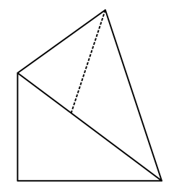
- [6.175] $\cos{t}=\cos\left(\frac{πt}{180}\right)$, so $\cos{t}-\cos\left(\frac{πt}{180}\right)=0$, i.e. $-2\sin\left[\frac{1}{2}\left(1+\frac{π}{180}\right)t\right]\sin\left[\frac{1}{2}\left(1-\frac{π}{180}\right)t\right]=0$. Thus the smallest positive $t$ is $\frac{π}{\frac{1}{2}\left(1+\frac{π}{180}\right)}≈6.175$.
$$A$$
$$B$$
$$C$$
$$D$$
$$E$$
- [A] $CDB$ is a right triangle, with $BC=6$, $CD=8$, so $BD=10$. Since $\overline{AE}$ bisects the angle $∠BAD$, we have $EB:ED=AB:AD=6:10=3:5$. Thus
$BE=\frac{3}{3+5}⋅BD=\frac{3}{8}⋅10=\frac{15}{4}$.
- [C] Solve each of the four systems $\left\{\begin{aligned}\frac{x}{2}+\frac{y}{4}=1 \\ \frac{x}{4}+\frac{y}{6}=1\end{aligned}\right.$ $\left\{\begin{aligned}\frac{x}{2}+\frac{y}{4}=1 \\ \frac{x}{6}+\frac{y}{4}=1\end{aligned}\right.$ $\left\{\begin{aligned}\frac{x}{4}+\frac{y}{2}=1 \\ \frac{x}{6}+\frac{y}{4}=1\end{aligned}\right.$ $\left\{\begin{aligned}\frac{x}{4}+\frac{y}{2}=1 \\ \frac{x}{4}+\frac{y}{6}=1\end{aligned}\right.$ for $x, y$ and calculate $3x+y$. (More quickly, solve the first two systems, then swap each ordered $x, y$ pair to get a new pair, resulting in four pairs.) We get $\left(-4, 12\right), \left(0, 4\right), \left(12, -4\right), (4, 0)$, so $3x+y=0, 4, 32, 12$.
- [B] With $k+1$ trips, the first lasting for $a$ days. Thus $\frac{1}{2}\left(k+1\right)\left(a+a+2k\right)=366$,
thus $\left(k+1\right)\left(a+k\right)=6⋅61$, so $k+1=6, a+k=61$. The trips lasted 56, 58, 60, 62, 64, 66 days.
- [Erroneous] The complement of a string $S$ is the string $S'$ such that $S+S'=111111$. Thus $(S^{'})'=S$. Note that $S^{'}≠S$. The reversal of $S$ is denoted by $S^{∘}$. Thus ${\left(S^{∘}\right)}^{∘}=S$. Note that ${\left(S^{'}\right)}^{∘}=(S^{∘})'$. There are $2^{6}=64$ strings, forming 32 disjoint sets, each being of the form $\{S, S^{'}\}$. Taking the reversals of elements of such a set $\{S, S^{'}\}$, one gets another set of this kind: $\{S^{∘}, {\left(S^{∘}\right)}^{'}\}$. A set $\{S, S^{'}\}$ is called self-reverse if $\left\{S^{∘}, {\left(S^{∘}\right)}^{'}\right\}=\{S, S'\}$. (E.g. $S=100110$, we have $\left\{011001, 100110\right\}=\{100110, 011001\}$; or for $S=100001$, we have $\left\{100001, 011110\right\}=\{100001, 011110\}$.) We are to choose exactly one string from each of the 32 disjoint sets of the form $\{S, S^{'}\}$, just making sure that, if $\left\{S^{∘}, {\left(S^{∘}\right)}^{'}\right\}≠\{S, S'\}$, the one chosen from $\left\{S^{∘}, {\left(S^{∘}\right)}^{'}\right\}$ should be different from the reversal of the one chosen from $\{S, S'\}$. In the end, we get one string from each of the 32 sets. The answer should be 32.

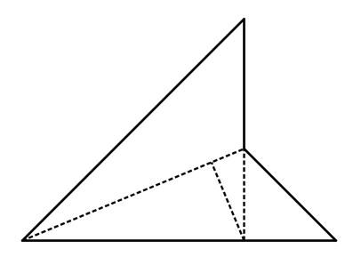
- [E] $PR=8\sqrt{2}$, so $PA=\left(8\sqrt{2}\right)\cos\left({22.5}^{∘}\right)$, and $RA=\left(8\sqrt{2}\right)\sin\left({22.5}^{∘}\right)$. So

$$P$$
$$Q$$
$$R$$
$$S$$
$$A$$
$$B$$
$PQ=PA+RA=\left(8\sqrt{2}\right)(\cos\left({22.5}^{∘}\right)+\sin\left({22.5}^{∘}\right)$. The area of $PQRS$ is
$2\left(\frac{1}{2}PQ⋅RA\right)={\left(8\sqrt{2}\right)}^{2}\left(\cos\left({22.5}^{∘}\right)+\sin\left({22.5}^{∘}\right)\right)\sin{({22.5}^{∘})}$
$=64⋅2\left(\frac{1}{2}\sin\left({45}^{∘}\right)+\frac{1}{2}\left(1-\cos\left({45}^{∘}\right)\right)\right)=64$
- [C] If you have a graphing calculator with "table" functionality, you may let $x=b$, $y=a=\sqrt{2+2x^{2}}$, list $x, y$ table, with $x$ starting 1, incrementing +1 each time. You would get the answer rather quickly: $x=41, y=58$, so $a-b=y-x=58-41=17$.
- [B] Enumerate all such 5-digit numbers: If 1is on the far left, then 2 has three places to go, for each we ask where the rest can go. This results in only 14253, 13524. If1 goes to the 2nd place from the left, we get only 31425, 31524, 41352. So far we have 5. Along with their reversals, we have 10. Now let 1 be at the middle, and suppose 2 is on the far left. We get only 24135 and 24153. Along with their reversals, we have 4. Altogether we have $10+4=14$. The answer is $\frac{14}{5!}=\frac{14}{120}=\frac{7}{60}$.

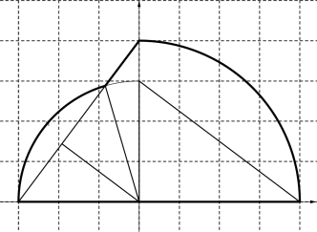
- [B] $ΔOAB$ is rotated to $ΔOCD$. The arc $BD$ (of radius 3) intersects the segment $CD$ at $E$. The arc $AC$, the segment $CE$, the arc $ED$, and the segment $DA$ together enclose the region of interest. Let $F$ be the midpoint of $\overline{DE}$ and let $θ=∠DOF$, so $\cos{θ}=\frac{4}{5}$. Then $∠DOE$ is $2θ$,
$$B$$
$$F$$
$$O$$
$$D$$
$$E$$
$$C$$
$$A$$
$\cos{(2θ)}=2\cos^{2}{θ}-1=2{\left(\frac{4}{5}\right)}^{2}-1=\frac{7}{25}$ . So $\sin{(2θ)}=\frac{24}{25}$. The area of the region bounded by the arc $DE$ and the segment $DE$ is
$\frac{1}{2}3^{2}\left(2θ\right)-\frac{1}{2}3^{2}\sin{(2θ)}=\frac{9}{2}\left(\sin^{-1}\left(\frac{24}{25}\right)-\frac{24}{25}\right)≈1.471509979$. The area of the region of interest is thus $\frac{1}{4}π4^{2}+\frac{1}{2}3⋅4+1.471509979≈20.04$
- [D] $\left(m, n\right)=\left(25, 84\right), \left(15, 54\right), \left(13, 30\right), \left(17, 60\right), \left(20, 96\right), \left(10, 24\right), (5, 6)$.
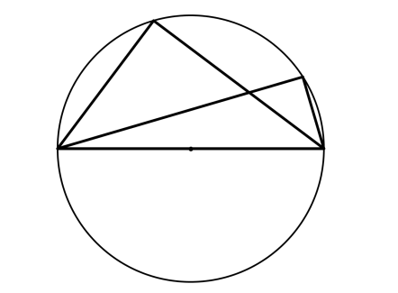
- [D] Let $E$ be where $\overline{AC}$ and $\overline{BD}$ meet. We have $CD=50$, $AD=14$, thus $AC=48$ by the Pythagorean Theorem. Likewise $BD=40$, $BC=30$. Let $ΔACD$ also denote the area of $ΔACD$, etc. So we have $ΔACD=\frac{1}{2}⋅14⋅48=336$, $ΔBCD=\frac{1}{2}⋅40⋅30=600$. Let $ΔECD=x$. Then we have the ratio $\frac{ΔAED}{ΔBEC}=\frac{336-x}{600-x}$. But $ΔAED\sim ΔBEC$, so $\frac{ΔAED}{ΔBEC}={\left(\frac{AD}{BC}\right)}^{2}={\left(\frac{14}{30}\right)}^{2}={\left(\frac{7}{15}\right)}^{2}$. So $\frac{336-x}{600-x}=\frac{49}{225}$. Solve to get $x=262.5$. Thus the answer is $336+600-262.5=673.5$.

$$C$$
$$D$$
$$A$$
$$B$$
$$E$$

