PROFESSIONAL DEVELOPMENT NEWSLETTER
November 2014 LANEY COLLEGE

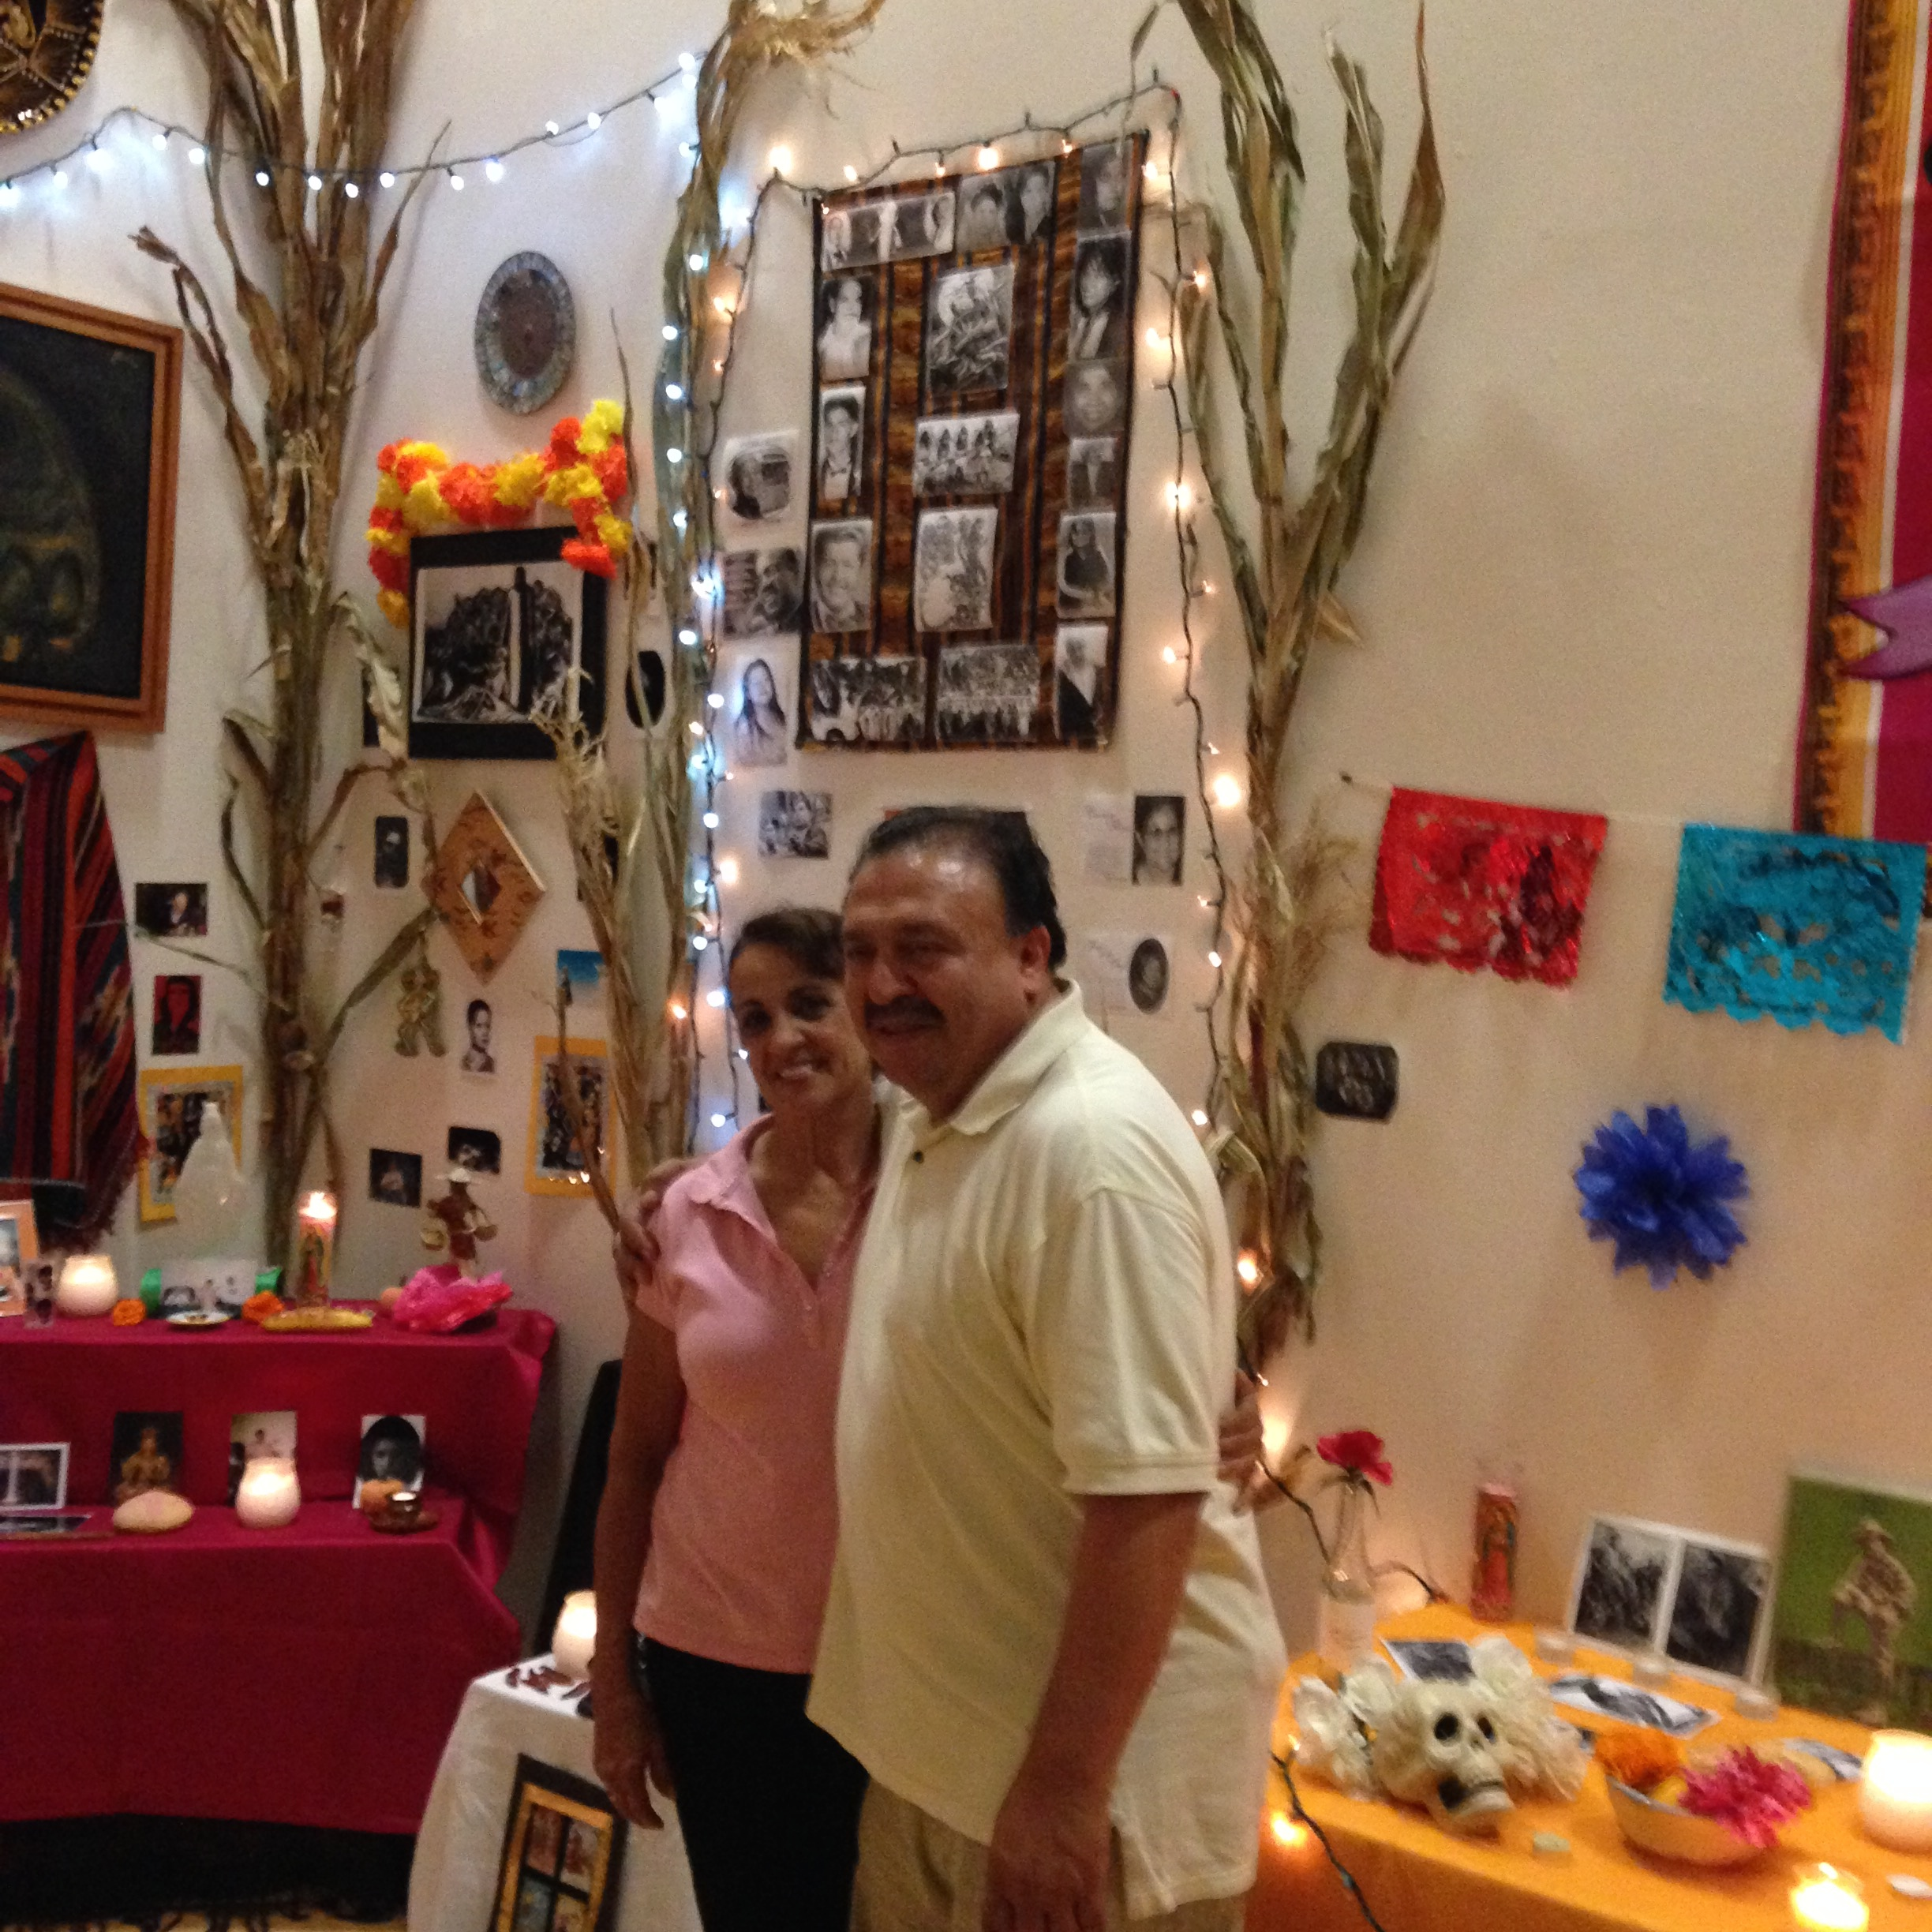
From Dias de los Muertos Gallery Exhibit

Apply for Funds! $1000 per faculty member per year is available. Take the opportunity! New rules allow
all faculty to apply.

- On Nov. 20th in T450 at NOON there will be a workshop on how to fill out prof. dev. forms with Kathy Tran of the Business Office. Please come!

- Budget: The professional development committee has about $60,000 to spend for the remainder of the year. The committee voted to give co-chairs Sonja Franeta and Kathleen Pappert .2 release time each for their extra time and Kathy Tran a $2500.00 stipend for her work as bookkeeper. Sabbaticals will be awarded in Spring 2015 for the following year.

http://www.laney.edu/wp/professionaldevelopment

This year at our spring flex days, we would like to feature faculty and faculty success. We have some amazing achievements and talents among our faculty. Please let us know if you would like to present at Professional Development Days January 14-16 2015 or another time.

- Some of our plans:
Leadership training for trainers by former faculty member and Deborah Pruitt of Group Alchemy, with workshops over a semester’s time;
- Feature faculty achievements at flex day;
- Spread the news about professional development activities on campus and off.

Our meetings are every second and fourth Wednesday at 4pm in T450. Please send us your suggestions. Meetings remaining in Fall 2014:
Nov. 12, Dec. 10.

Committee Members: Sonja Franeta and Kathleen Pappert, co-chairs, Chris Weidenbach, Agustin Rodriguez, Alena Jacks-Young, Chungwai Chum, Deans Mildred Lewis, Denise Richardson and Phoumy Sayavong. Kathy Tran, bookkeeper.

