CLUB CHARTERING PACKET
FOR
THE ASSOCIATED STUDENTS OF LANEY COLLEGE

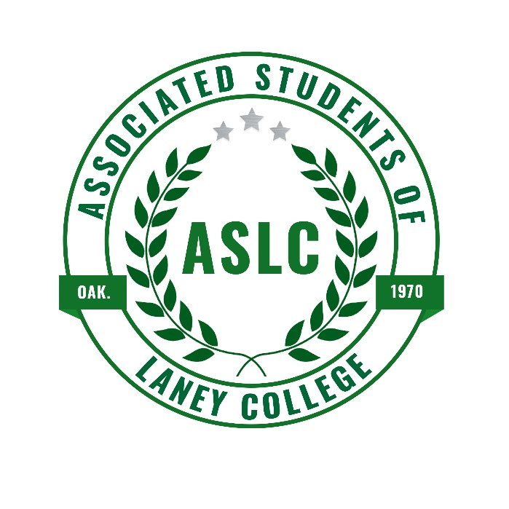
IMPORTANT DATES:

ASLC GENERAL MEETINGS: Via Zoom, time & date TBA

CLUB CHARTERING PROCEDURES

- Return completed package to the Office of Student Activities and Campus Life via email at emoreno@peralta.edu.

- You will be notified via email to attend an Associated Students scheduled meeting in order for your proposed club to be officially chartered.

CLUB APPLICATION

SEMESTER OF ACTIVATION: ☐ Fall ☐ Spring YEAR:________
NAME OF CLUB:______________________________________
CLUB EMAIL (REQUIRED):___________________________________
BRIEF DESCRIPTION OF CLUB (Please include objective):
___________________________________________________________________________________________________________________________________________________________________________________________________________________________________________________________________________________________________________________________________________________________________________________________________________________________________________________________________________________________________________________________________________________________________________________________________________________________________________________________________________________________________________________________________________________________________________

MEETING INFORMATION:
Meeting day(s): | Location/Room Number: | Time(s):

CLUB OFFICER & ADVISOR INFORMATION

CLUB PRESIDENT:
PRINT NAME: |  |  | PHONE:
E-MAIL: |  |  | SIGNATURE:

CLUB ADVISOR (Staff or Faculty):
PRINT NAME: |  |  | PHONE:
E-MAIL: |  |  | DEPARTMENT:

INTER-CLUB COUNCIL REPRESENTIVE:
PRINT NAME: |  |  | PHONE:
E-MAIL: |  |  | SIGNATURE:

(PLEASE PRINT OFFICER POSITION NAME):
PRINT NAME: |  |  | PHONE:
E-MAIL: |  |  | SIGNATURE:

(PLEASE PRINT OFFICER POSITION NAME):
PRINT NAME: |  |  | PHONE:
E-MAIL: |  |  | SIGNATURE:

(PLEASE PRINT OFFICER POSITION NAME):
PRINT NAME: |  |  | PHONE:
E-MAIL: |  |  | SIGNATURE:

(PLEASE PRINT OFFICER POSITION NAME):
PRINT NAME: |  |  | PHONE:
E-MAIL: |  |  | SIGNATURE:

CLUB MEMBER ROSTER SHEET
The page serves as a list of members in your club. Please note that all members must be Peralta College students; a minimum of 10 students is required.

Student Name (Please print) | Student ID Number | Email Address

*Please attach a separate sheet, if additional names need to be added
CONSTITUTION GUIDELINES

Your club’s constitution should be complete and supply enough information to meet the needs of the club. Below are guidelines that should be considered in the preparation of your constitution.
- Name and purpose of club

- Membership
- Who may become a member
- How to become a member

- Officers
- Duties
- When elected
- How elected
- Term of office
- Filling vacancies

- Meetings
- How often and how called
- Location and time

- Quorum (number of members needed to be present to constitute a valid meeting)

- How to amend constitution

- By-laws (if any) should contain:
- Additional information about
- Meetings
- Officers and duties
- Statement of
- Standing committees and their duties
- Obligation of members
- Order of business
- Parliamentary procedures and authority
- Amendments

CONSTITUTION SAMPLE

IMPORTANT: Use this template for your constitution and customize it for your club.
You must include the required text in your constitution. If you do not, you club charter request may not be approved.

Name of club

Section I. The name of the club.

What is your club’s purpose?

Section I. Briefly describe the purpose and objective of your organization.
Section II. What is hoped to be accomplished by the club?

Membership

Section I. Describe who is eligible for membership?
Section II. Are there any restrictions on students (e.g., GPA, class standing, etc.)?

[REQUIRED MEMBERSHIP LANGUAGE]

Only currently registered students, faculty, and staff may be active members in a registered student organization. Only active members may vote or hold office.

[REQUIRED ANTI-HAZING STATEMENT]

We will not haze according to California State Law; we will not restrict membership based upon race, color, national origin, religion, sex, physical and mental disability, medical condition, ancestry, marital status, age, sexual orientation, citizenship or status as a covered veteran (special disabled veteran, Vietnam-era veteran or any other veteran who served on active duty during a war or in a campaign or expedition for which a campaign badge has been authorized).

Recording
Section l. Who will be in charge of handling your budget? Will you create monthly reports?

Officers/Elections

Section I. List the officers by title (e.g., President) or define the leadership structure if another system is used (e.g., spokesperson by consensus).
Section II. List eligibility requirements.
Section III. Describe the process and required majority of votes by which your officers will be elected.
Section IV. What time of year will selection occur?
Section V. Stipulate term of office.
Section VI. How will officers be removed or replaced?

Meetings

Section I. How often will the group meet? Where will you meet?
Section II. Will there be a call for special emergency meetings?
Section III. How will you notify people of emergency meetings?

Article VI – Constitutional Amendments
Section I. Who can propose an amendment?
Section II. How are they proposed?
Section III. How will you notify active members that an amendment is going to be voted upon?
Section IV. Incorporate into your constitution that an amendment will need a 2/3 majority vote from your active membership in order to pass.

*Please Note: Because amendments change the structure of the group it is important to have 2/3 approval from the members at large.

[REQUIRED AMENDMENT CLAUSE]

All amendments, additions or deletions must be filed with the Student Life Office within one week of adoption.

RESPONSIBILITIES OF CLUB ADVISORS

In order to provide a common framework in which all clubs can operate with a maximum of student enthusiasm and interest and within reason, advisor participation, we are holding all club advisors of clubs responsible for the following:
- Club advisor is required to attend all club related events, practices, and meetings.
- Each club is required to file minutes of every meeting with SACL. Club advisor should insure that the students fulfill this and other responsibilities.
- Club advisor should be knowledgeable of all financial transactions of the club.
- Club advisor is responsible for supervising the use of the college equipment and facilities during any club activity.
- Club advisor should have some knowledge of the Ralph Brown Act and parliamentary Procedures. (This information is available upon request)
- Club advisor is also expected to file travel forms for all off campus activities.
Before agreeing to be a Club Advisor for a club, you should have an opportunity to read the student’s petition to organize so that you may be acquainted with the purposes, objectives, and membership of the proposed club.
A Club Advisor can only serve as an advisor for one club at a time.
______________________________________________________________________________
FACULTY/STAFF ADVISOR AGREEMENT
I agree to act as advisor of (Name of club) __________________________________________ during the current academic year, provided that the request for the club to be chartered is granted.

_____________________________ ________________
Club Advisor’s Name Date

___________________________
Club Advisor’s Signature

AGREEMENT OF THE CLUB REPRESENTATIVE

Name of Club:__________________________________________________________________
- As a chartered club of the ASLC, we agree that no less than two (2) representatives from our club will actively assist and participate in all ASLC events.
- As a charted club of ASLC, we agree that executive officers (President, Vice President. Treasurer, Secretary) must have a cumulative GPA of 2.0 and shall be enrolled in at least 5 units at Laney College while serving in an executive position.
- We will attend every regular Inter Club Council (ICC) meeting and will appoint one (1) voting delegate and one (1) alternate delegate to vote at these meetings.
- We will adhere to the ICC and ASLC constitutions and the Laney College and Peralta Community College District Code of Conduct.
- We will remove our fliers promptly after events or may forfeit having privilege of posting fliers on campus. Posting guidelines are included in the Event Proposal Packet after chartering is complete.
- As a chartered club of ASLC, we agree that we will have no less than two (2) events per semester.
By signing this document, I have read this document and we the undersigned club agree to all terms prescribed to remain a club in good standing on the campus of Laney College.

__________________________ ___________________________ __________________
Name of Club Representative Signature of Club Representative Date

______________________ ________________________ __________________
Name of Club President Signature of Club President Date

Date completed package received by SACL: __________________

*Please note: You will be notified via email to attend an Associated Students scheduled meeting in order for your proposed club to be officially chartered. This is the final step in the chartering process.
Please return completed Club Chartering Packet to:
Student Activities and Campus Life via email at emoreno@peralta.edu

