NetTutor is an online tutoring service that provides live or asynchronous tutoring support to students 24/7/365. This service has been available to all Canvas instructors starting Spring 2018.

NetTutor is disabled by default in your course. You can make it available to your students by going to your course -> Settings (in the left navigation bar) -> Click on ‘Navigation’ ->
Enable ‘NetTutor-Free Online Tutoring.’

Once you have activated the system, a ‘Free Online Tutoring’ navigation item is visible on the left-hand side. When students click the link, they are taken directly to the NetTutor page where they can receive tutoring in their respective subject area.

Here are the detailed instructions on enabling the NetTutor service in your course:

- Go to your course home page.
- Click on ‘Settings’ in the left-side navigation.

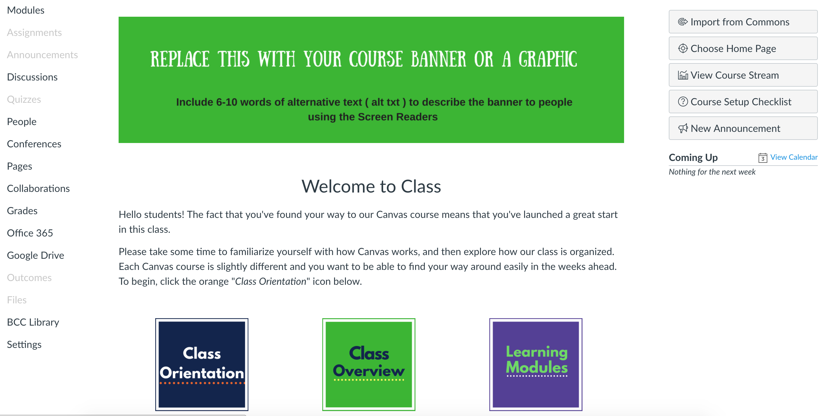

- Click on ‘Navigation’ tab.

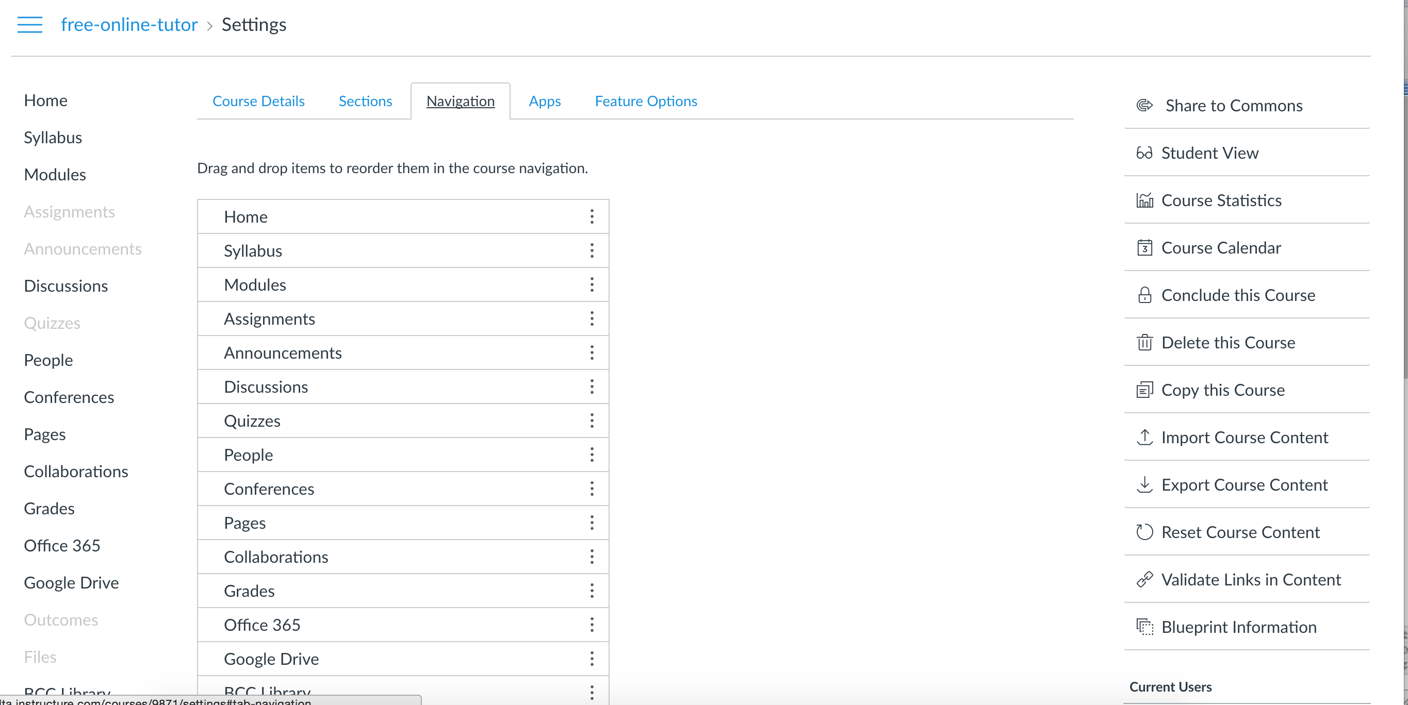

- Scroll down to find ‘NetTutor – Free Online Tutoring’ in the list and
- Either drag and drop it in the active list
- Alternatively, click next to the ‘NetTutor – Free Online Tutoring’ and click ‘Enable.’

- Click ‘Save,’ and you are done! You can see ‘Free Online Tutoring’ in the left-side navigation list.

