How to set up student E-mail
Step 1
This is the login page for Outlook.
- Type in your Passport User ID and add @cc.peralta.edu for Windows Live ID.
- The password is the same as your passport password on first login.
Note: Your username and password are ALL LOWER CASE.

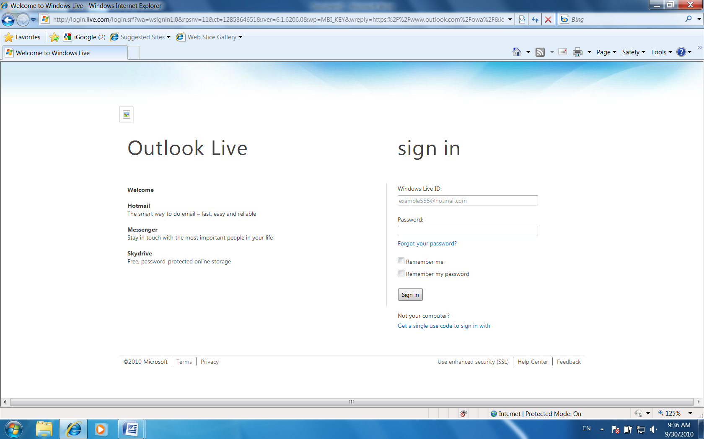

Step 2
Provide account information
- Put in your login and password.
- Select a question.
- Type the answer to the question you selected.
- Clicking “submit”
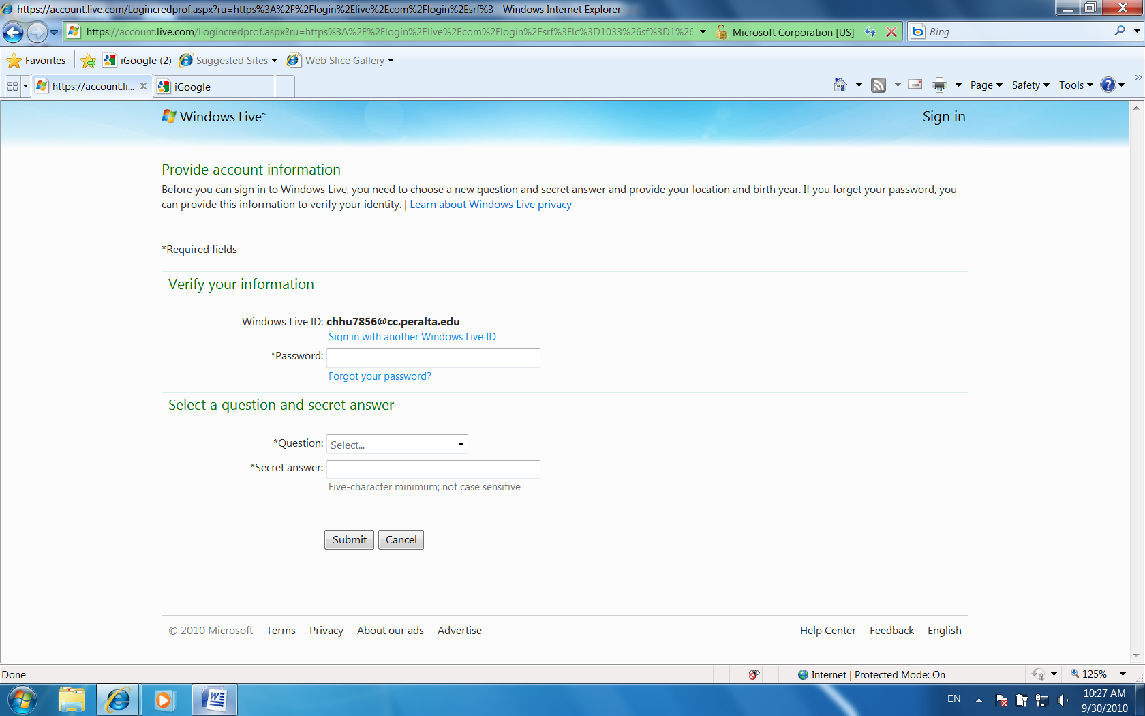

Step 3
Continue to provide the information
- Put in your birth year.
- Select country/region (united states).
- Click “I accept”.

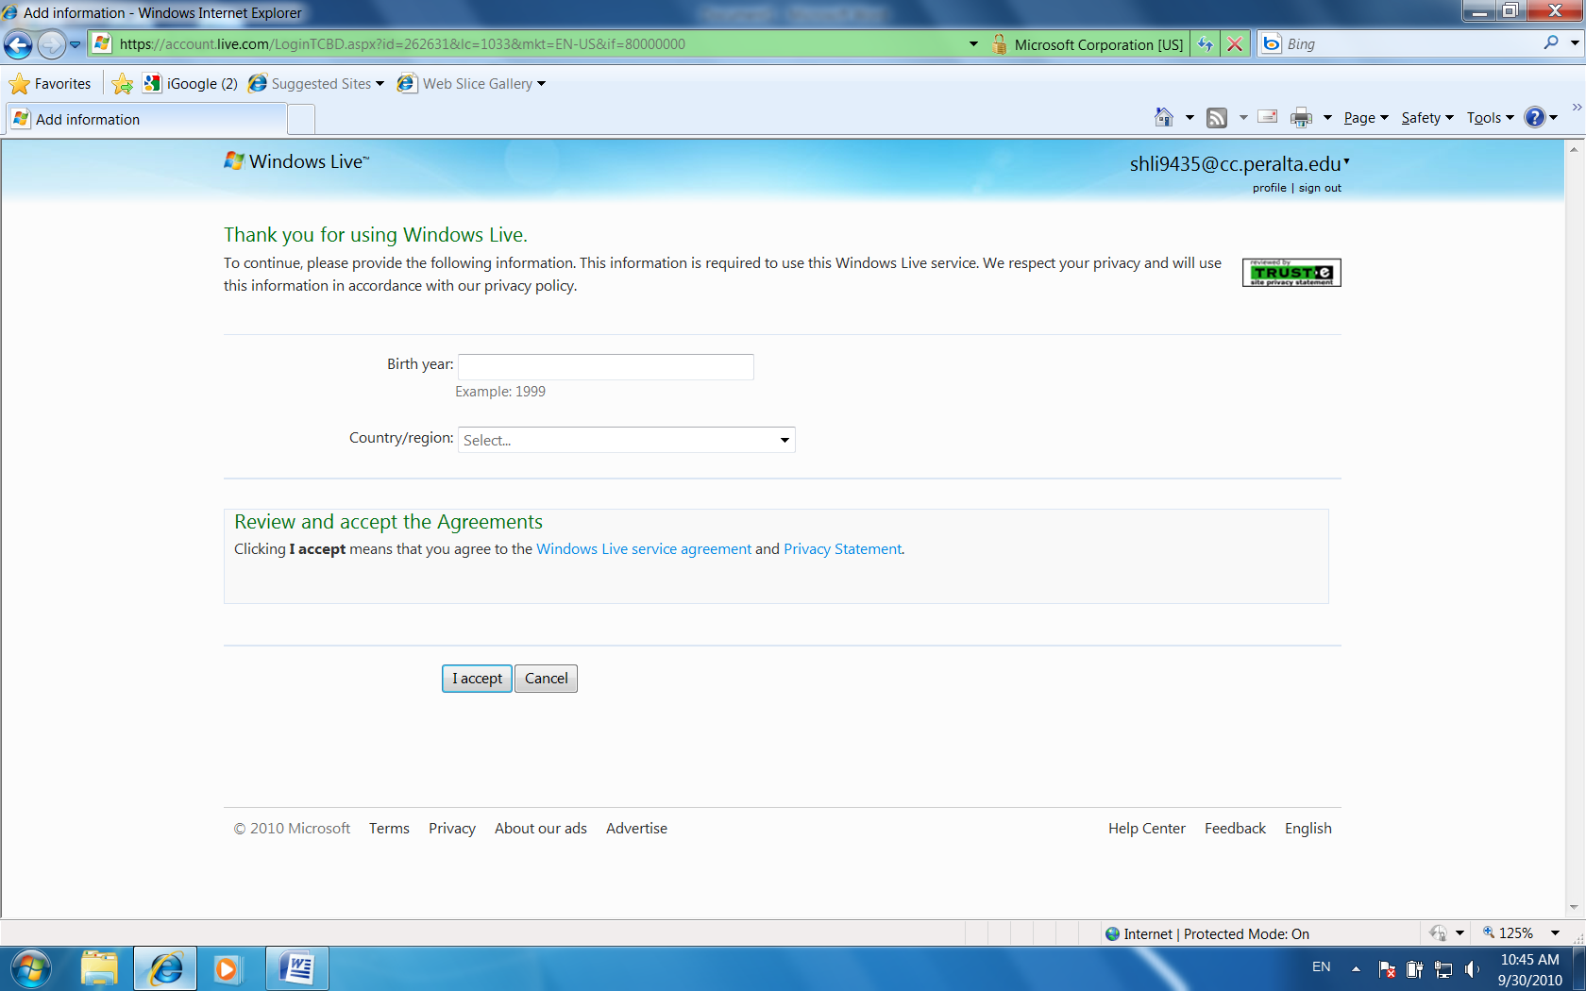

Step 4
Outlook Web App
- Choose the language you want to use.
- Select a time zone (Pacific Time US & Canada).
- Click “ok”

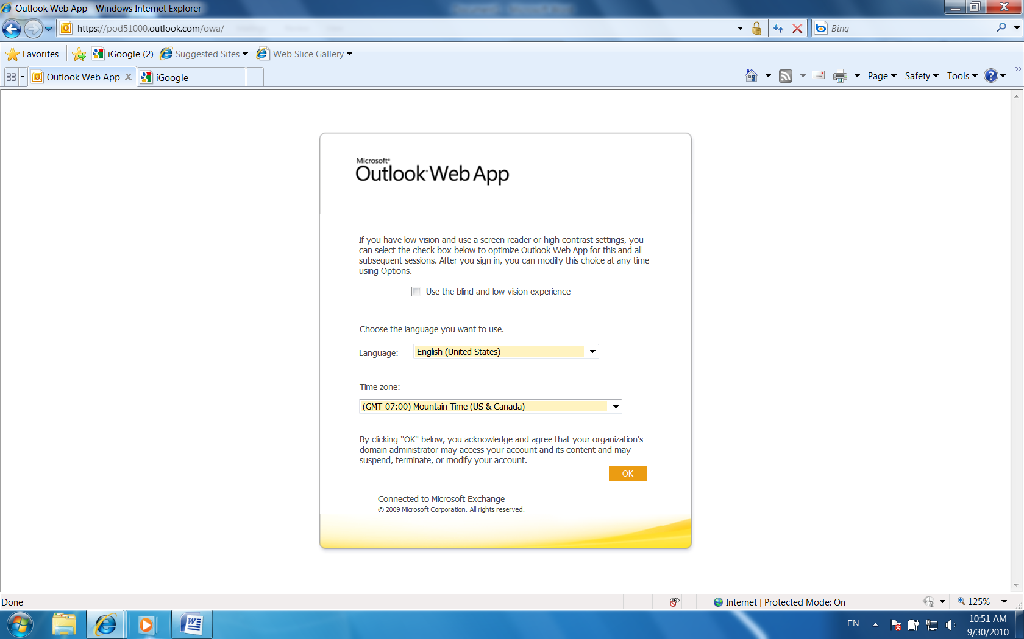

Step 4
Congratulations!
Your student E-mail has been set up!

