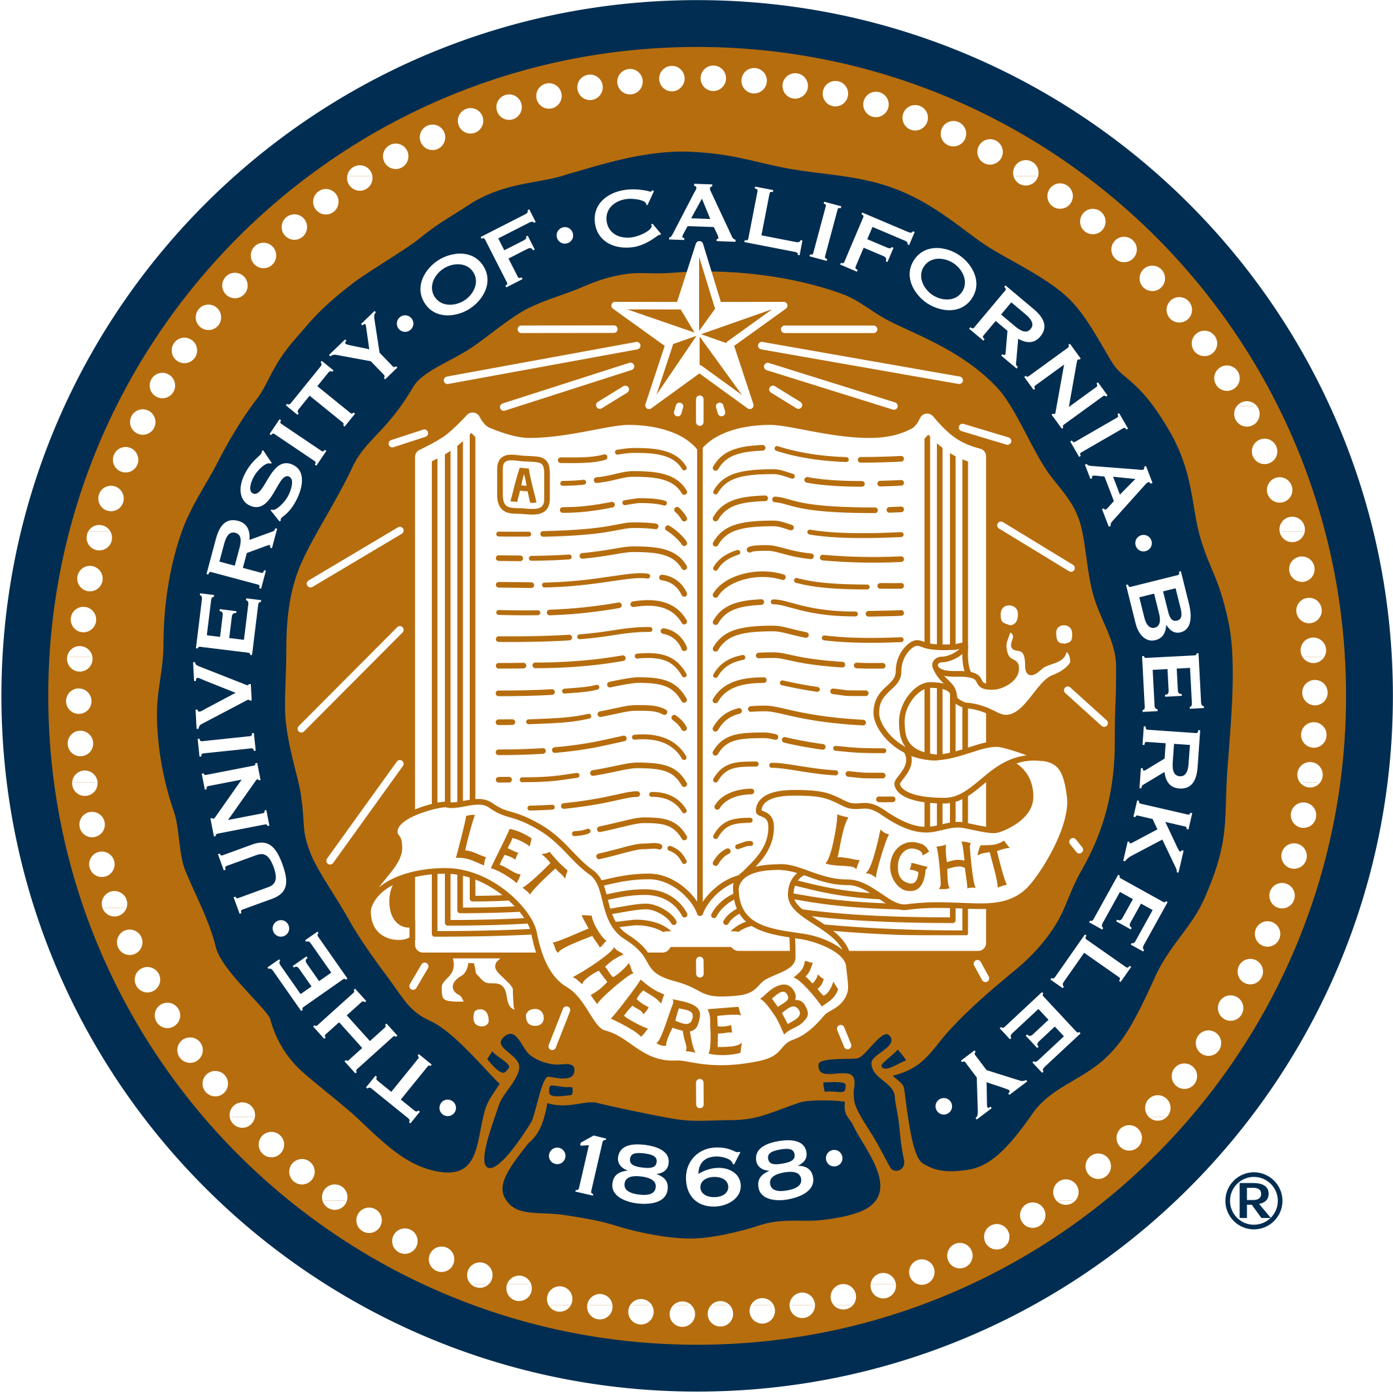Interested in transferring to a 4-year university in a science major?
Want a $7400 scholarship to prepare at UC Berkeley?

Come to Laney College information session!!!
The Environmental Leadership Pathway (ELP)
Date: Tuesday, October 18th

Time: 12noon to 12:50pm
Location: Building F ROOM 170A

ELP is a one year program sponsored by UC Berkeley and the National Science Foundation to prepare 25 Bay Area community college students to successfully transfer to and thrive at competitive universities in science majors. Classes, training and research are conducted at the UC Berkeley campus.
The program includes:
1. UC Berkeley course in Environmental Science Case Studies (3 units) – Spring
2. 8 week paid summer internship in a UC Berkeley Lab – Summer
3. UC Berkeley course in Teaching Environmental Science (4 units) – Fall

This program seeks students with excellent GPAs from underrepresented communities and with financial need that are interested in science majors.

CHECK US OUT AT OUR WEBSITE AND APPLY TO THE PROGRAM!

http://nature.berkeley.edu/cnrelp

