KERSTIN FIRMIN

WILD LIFE REFUGE
Photography and Illustration

This is my love letter to Lake Merritt, my refuge. During the current shelter-in-place crisis, access to nature and open, public spaces is more critical than ever. Even as we self-isolate to protect public health, our physical and mental health depends on fresh air and safe space to breathe.

There are many inequities in access to outdoor space. Private outdoor space frequently remains the privilege of property owners, residents of newer luxury apartments and suburban apartment complexes. A recent study also showed that areas with higher income and education were found to have significantly better access to public open space. That is why urban public open spaces like the Lake Merritt Wildlife Refuge are so critical.

If you feel stuck indoors, without easy access to nature, I am sharing these photos and coloring pages for you. Download the coloring book pages and share them with kids of all ages around you.

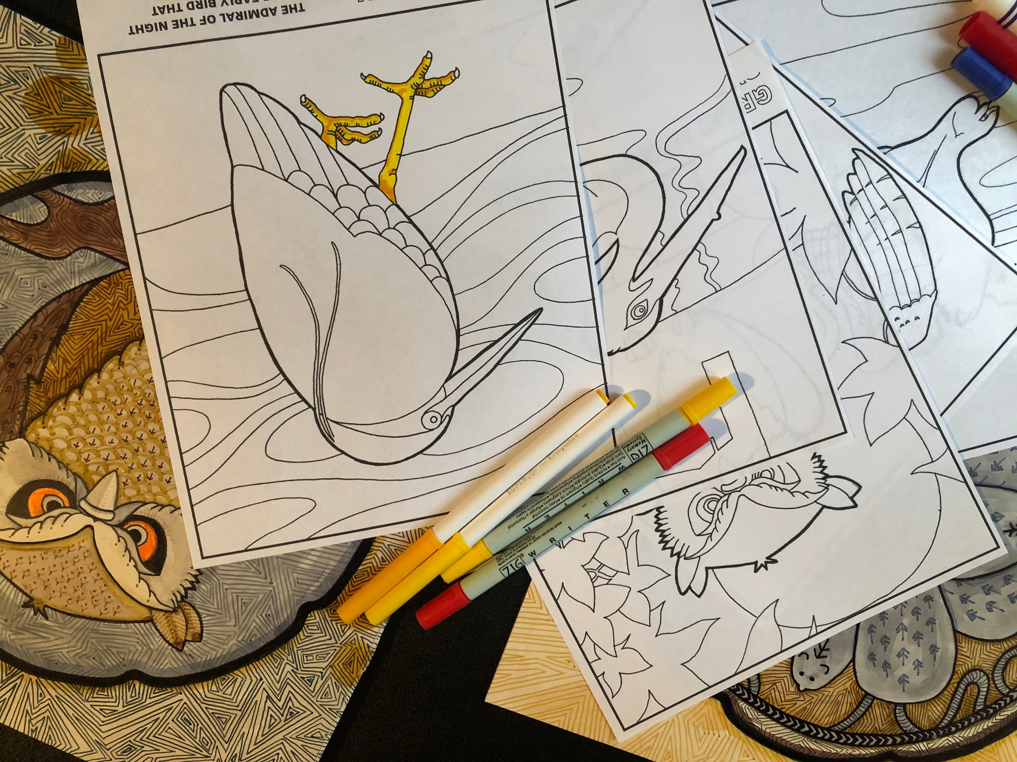

https://www.gih.org/views-from-the-field/the-urgent-need-for-nature-during-and-after-covid-19/
https://www.citylab.com/equity/2019/03/inequality-parks-and-green-space-income-race-research/585166/

