Step by step instructions to input assessment data into Meta
(screenshots apply to all Peralta colleges)

- Log in to Meta. peralta.curricunet.com
If you forgot your password, click the link below the password box.
If you do not have an account, contact Rebecca Bailey and Heather Sisneros.

- Click “Create Proposal” on the top right. 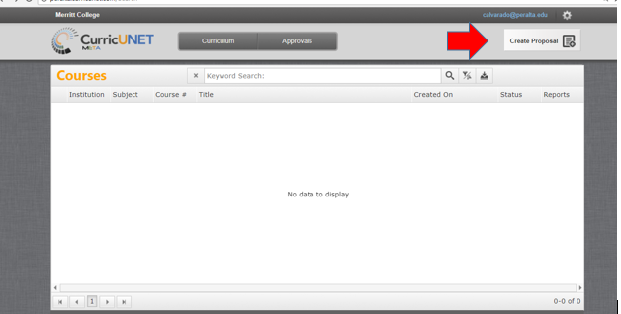

- Using dropdown menu for “Proposal Type”, scroll down to “Assessments” and choose “Laney Assessment 1 - SLO Assessment”. Click “next”. (note: do not hit enter key)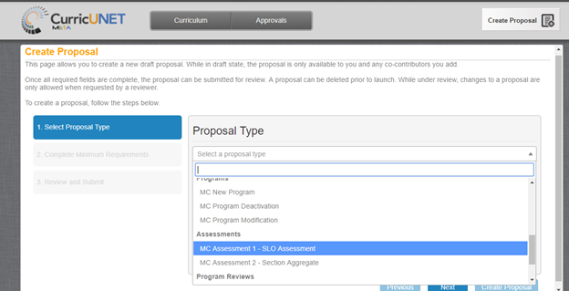

- Choose your Division and Department from dropdown menus. Create a title for your assessment, using the following naming conventions. If you are one instructor entering data for your course, use example “a,” and you can include just one of your class codes. If you are entering an aggregate of data for multiple sections with multiple instructors, use example “b,” and indicate “AGG” in the title, plus one of the course codes. It is important that titles of assessments are never duplicated, so the codes keep each title unique.

  - DEPT COURSE CLASSCODE SLO# SEMESTER YEAR, for example:
      - BIOL 2 23456 SLO1 Spring 2017
      - CIS 34 45678 SLO2 Fall 2017
      - MATH 208 32334 SLO3 Summer 2017
  - DEPT COURSE AGG CLASSCODE SLO# SEMESTER YEAR, for example:
      - BIOL 4 AGG 23456 SLO3 Fall 2017
      - KIN 150 AGG 54321 SLO2 Spring 2018
      - WELD 53 AGG 34567 SLO1 Fall 2018

- Confirm that you want to “Create Proposal” by clicking on button (do not hit enter).

- You will now be on the “Main” tab of your assessment. Complete this tab by choosing pre-populated options from the dropdown menus, or typing in numbers, as appropriate. Choose a “Co-Contributor” if you would like someone else to have access to this assessment. For example, there may be multiple instructors for a course with many sections. Only the originator and co-contributor(s) will be able to see and edit the proposal while it is still in draft form. 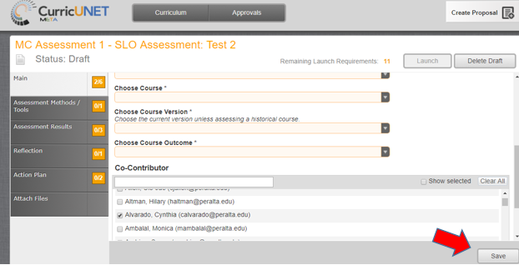

- Once this tab is completed, click “Save” at the bottom. If you forget to complete this step, or you don’t see the “Save” button, Meta will prompt you before you leave the tab, asking “There are unsaved changes. Do you want to save them?”

- Click on the tab “Assessment Methods/Tools.” NOTE: If you click a checkbox, and then change your mind, save your work before you unclick a box. Then unclick the box and resave. There is a temporary glitch in the system that makes this necessary.
  - In this section you will identify the method you are using to assess the SLO. Choose from the pre-populated list, or choose “other.” When you click a checkbox, a text box appears for you to describe the method in detail.

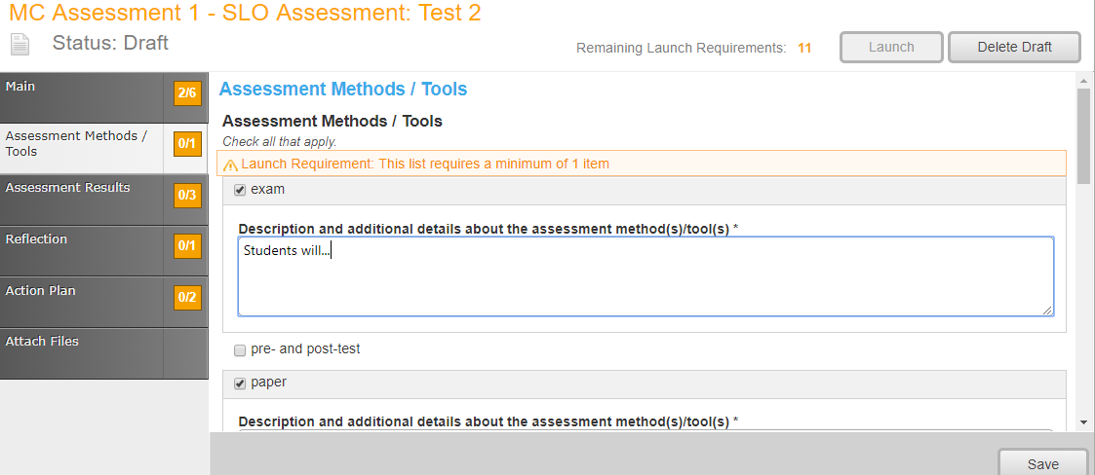

  - Detail your “Success Criteria.” In this area, describe your measurement criteria. Rubrics are an excellent way to do this and can be attached just below the text box. Identify the level of success for students and for the outcome, for example, “80% of the students must earn 80% of the points in order to meet the outcome.”

- Click on the tab “Assessment Results.” Identify the course delivery method. Complete your Results and Analysis and Learning Gaps.

- Click on the tab “Reflection.” Results from previous Action Plans will be populated if data is available, and you will discuss the efficacy of these past action plans. In most cases, until we have more data in the system, you should say n/a.

- Click on the tab “Action Plan.” Here you will detail your action plans based on results from the current assessment. You must choose at least one action at the course level. You may also choose actions beyond the course level, but this is not required. Text boxes will request additional detail. At the bottom of the page, identify the next time this SLO will be assessed.

- The final tab allows for attachment of any additional supporting files. While attachments are not required by the system, typically you would have a few attachments, including a rubric, exam, etc.

- Once all sections are complete, click “Launch” in the upper right hand corner. You will not be able to launch until all launch requirements are complete. Orange boxes indicate the tab is incomplete, while green boxes indicate the tab is completed. If you want to leave it as draft, you can access at another time by logging in, then click on “Curriculum” along the top, scroll down to “Assessments”. Your drafts will appear. Click on the draft to enter and make changes or launch once complete. You can delete a draft, if necessary, by clicking “Delete Draft” next to the “Launch” button.

