Meta Assessment Module

Step by step instructions to input assessment data into Meta
(screenshots apply to all Peralta colleges)

- Log in to Meta. peralta.curricunet.com
  - Type in your full email address (including the @peralta.edu) and password.
- If you forgot your password, click the link below the password box.
- If you tried the forgot password link, and see a “user not found” message, contact your college Assessment Coordinator to get an account.

- Click “Create Proposal” on the top right.

- Using dropdown menu for “Proposal Type”, scroll down to “Assessments” and choose “Laney Assessment 1 - SLO Assessment”. Click “next”. (note: do not hit enter key)

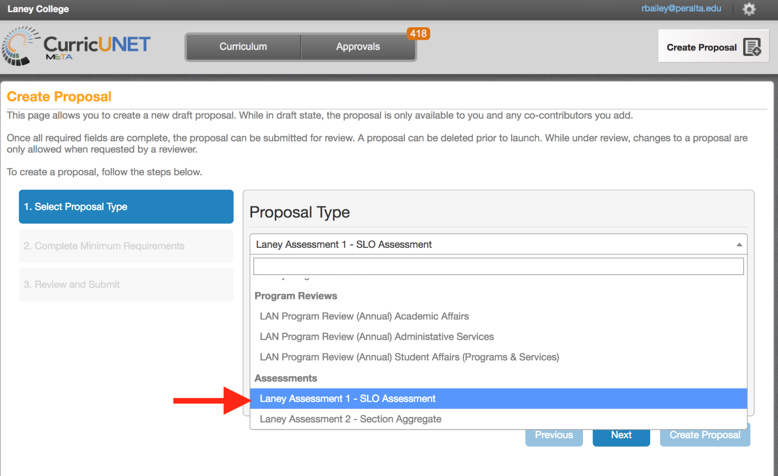

- Choose your Division and Department from dropdown menus. Create a title for your assessment, using the naming conventions in the examples below. If you are one instructor entering data for your course, use example “A,” and you can include just one of your class codes. If you are entering an aggregate of data for multiple sections with multiple instructors, use example “B,” and indicate “AGG” in the title, plus one of the course codes. It is important that titles of assessments are never duplicated, so the codes keep each title unique. If you prefer, you may use your last name in place of the code.

  - Example A: DEPT COURSE CLASSCODE SLO# SEMESTER YEAR, for example:
      - BIOL 2 23456 SLO1 Spring 2017
      - CIS 34 45678 SLO2 Fall 2017
      - MATH 208 32334 SLO3 Summer 2017
      - CHEM 1A Bailey SLO2 Spring 2018
  - Example B: DEPT COURSE AGG CLASSCODE SLO# SEMESTER YEAR, for example:
      - BIOL 4 AGG 23456 SLO3 Fall 2017
      - KIN 150 AGG 54321 SLO2 Spring 2018
      - WELD 53 AGG 34567 SLO1 Fall 2018
      - BIOL 2 AGG Sisneros SLO3 Spring 2018

- Confirm that you want to “Create Proposal” by clicking on button (do not hit enter).

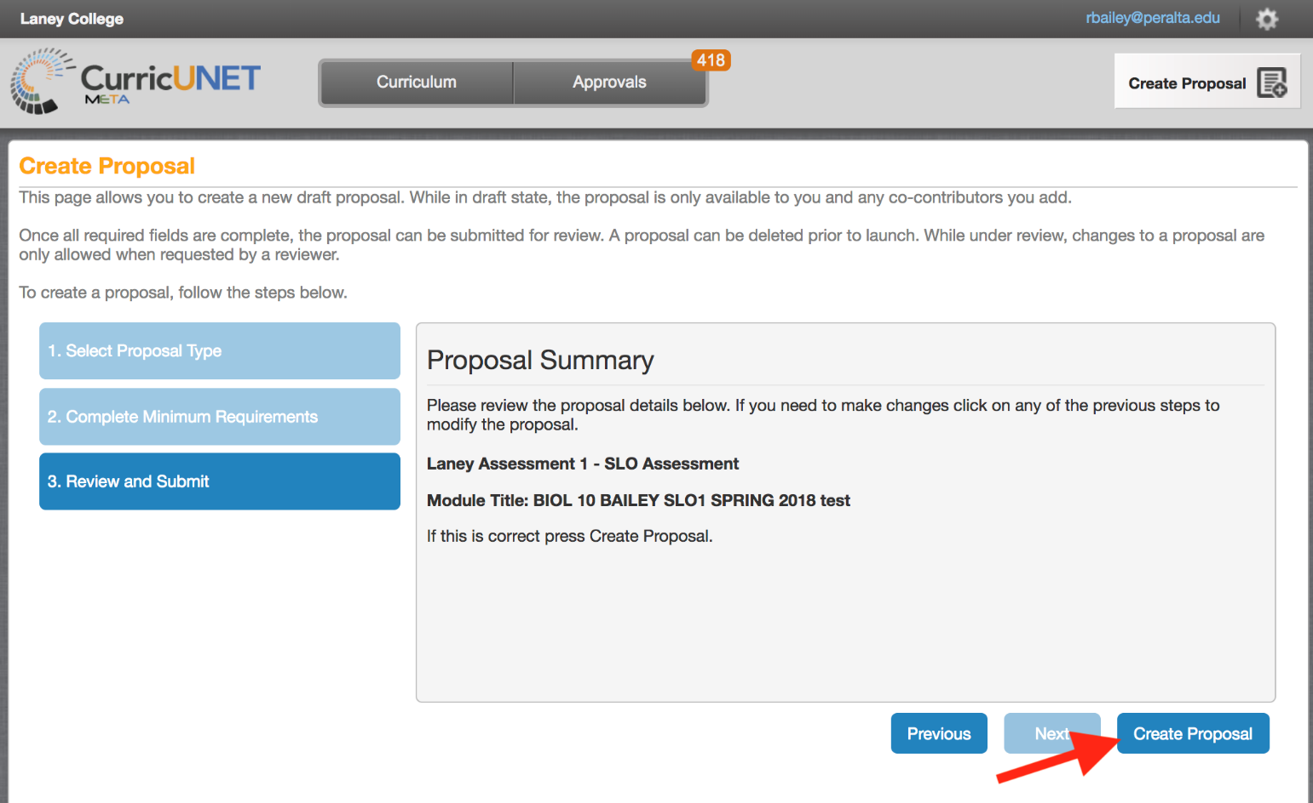

- You will now be on the “Main” tab of your assessment. Complete this tab by choosing pre-populated options from the dropdown menus, or typing in numbers, as appropriate. Number of students assessed, meeting success criteria, and on roster are not technically launch requirements, but Laney faculty should enter these numbers. Choose a “Co-Contributor” if you would like someone else to have access to this assessment. For example, there may be multiple instructors for a course with many sections. Only the originator and co-contributor(s) will be able to see and edit the proposal while it is still in draft form. (note: only faculty with an account will appear in the co-contributors list)

- Once the “Main” tab is completed, click “Save” at the bottom. If you forget to complete this step, or you don’t see the “Save” button, Meta will prompt you before you leave the tab, asking “There are unsaved changes. Do you want to save them?”

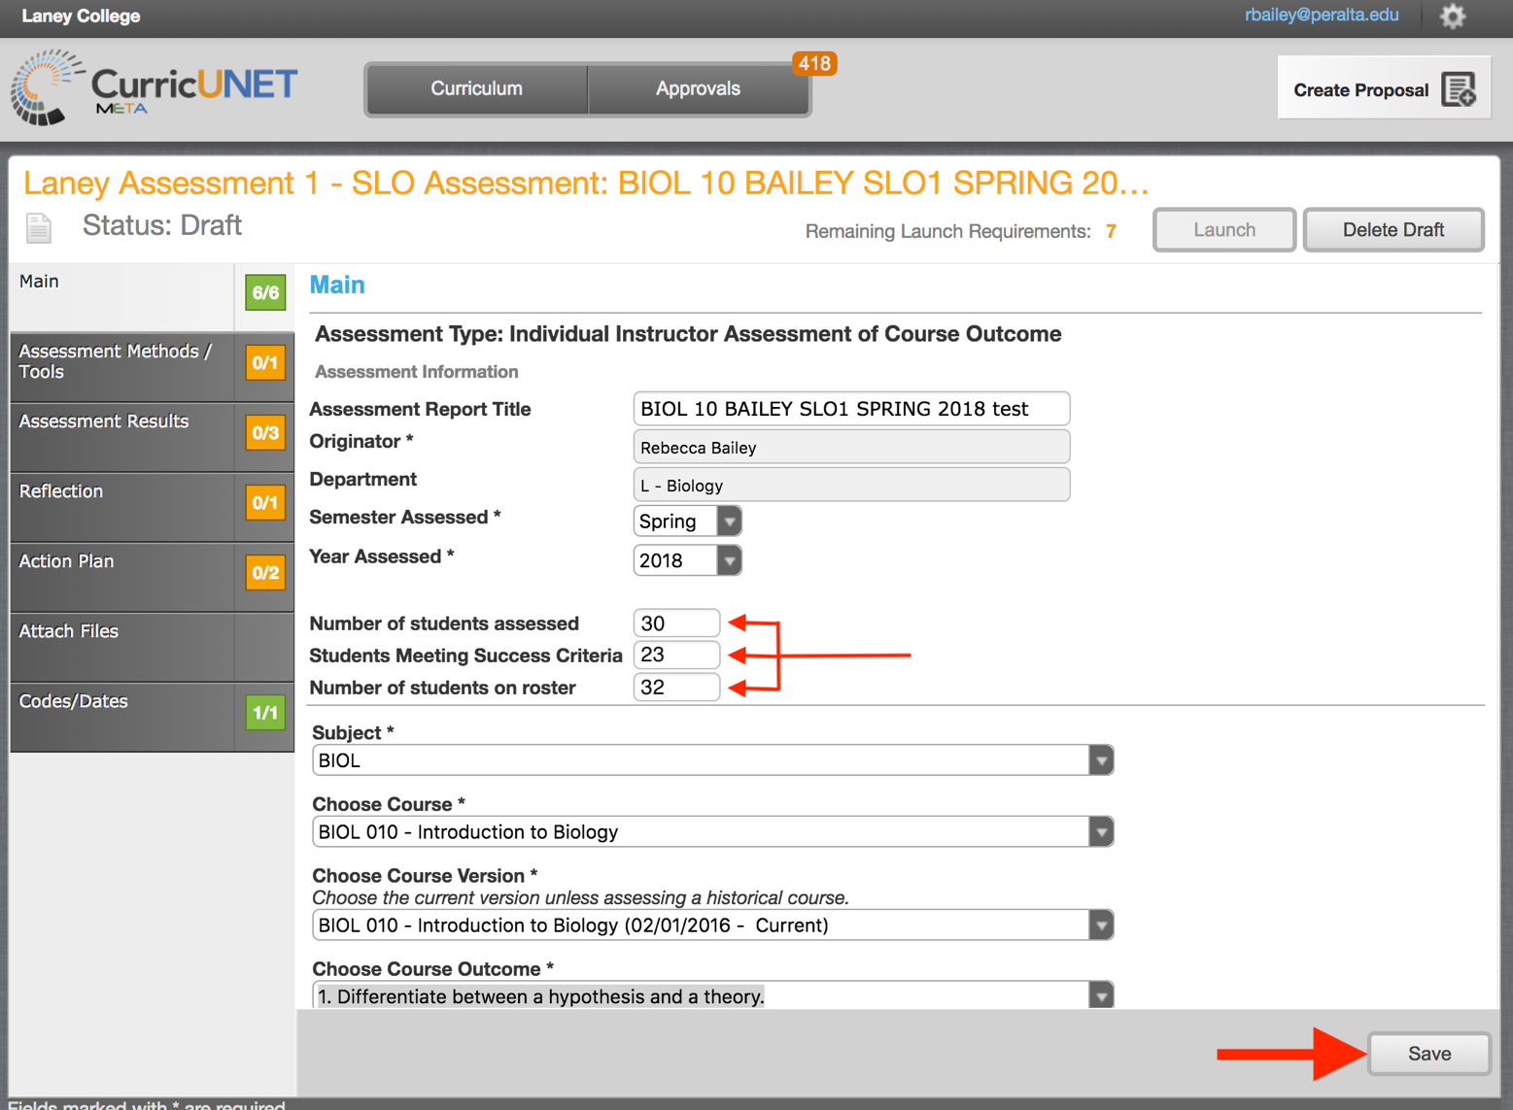

- Click on the tab “Assessment Methods/Tools.” NOTE: If you click a checkbox, and then change your mind, save your work before you unclick a box. Then unclick the box and resave. There is a temporary glitch in the system that makes this necessary.
  - In this section you will identify the method you are using to assess the SLO. Choose from the pre-populated list, or choose “other.” When you click a checkbox, a text box appears for you to describe the method in detail. You may choose more than one method, but make sure to only choose methods that were actually used to assess this specific SLO in this particular semester.
  - Detail your “Success Criteria.” In this area, describe your measurement criteria. Success criteria should be determined BEFORE analyzing your data. Identify the level of success you hope to see, for the outcome overall, and for students. What percentage of students would you want to perform at what level to consider the class successful with that outcome? For example, “80% of the students must earn at least 70% of the points in order to meet the expectations for this outcome.” The percentages expected can vary widely, depending on level of the course, and how critical success with that outcome is to the course. A laboratory course with strict safety requirements, for example, may aim for 100% of students demonstrating proficiency with a safety-related outcome. Rubrics are an excellent way to evaluate student performance on an SLO, and can be attached just below the text box.
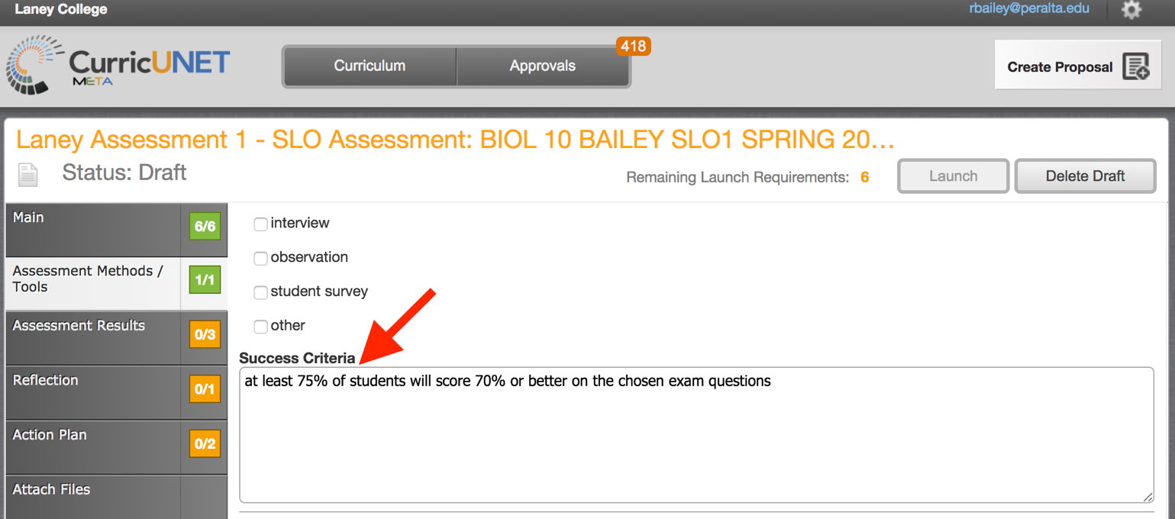
- Click on the tab “Assessment Results.”
- Identify the course delivery method. If the course has day sections and evening sections, these should be entered separately (create one proposal for the day sections, and one for evening). Likewise, online vs. face-to-face should be entered separately, as should dual enrollment sections. Later, in more advanced proposal types, you’ll be able to compare results for the different delivery methods. Disaggregating data in this manner is critical for our service to students, and is essential for accreditation purposes.
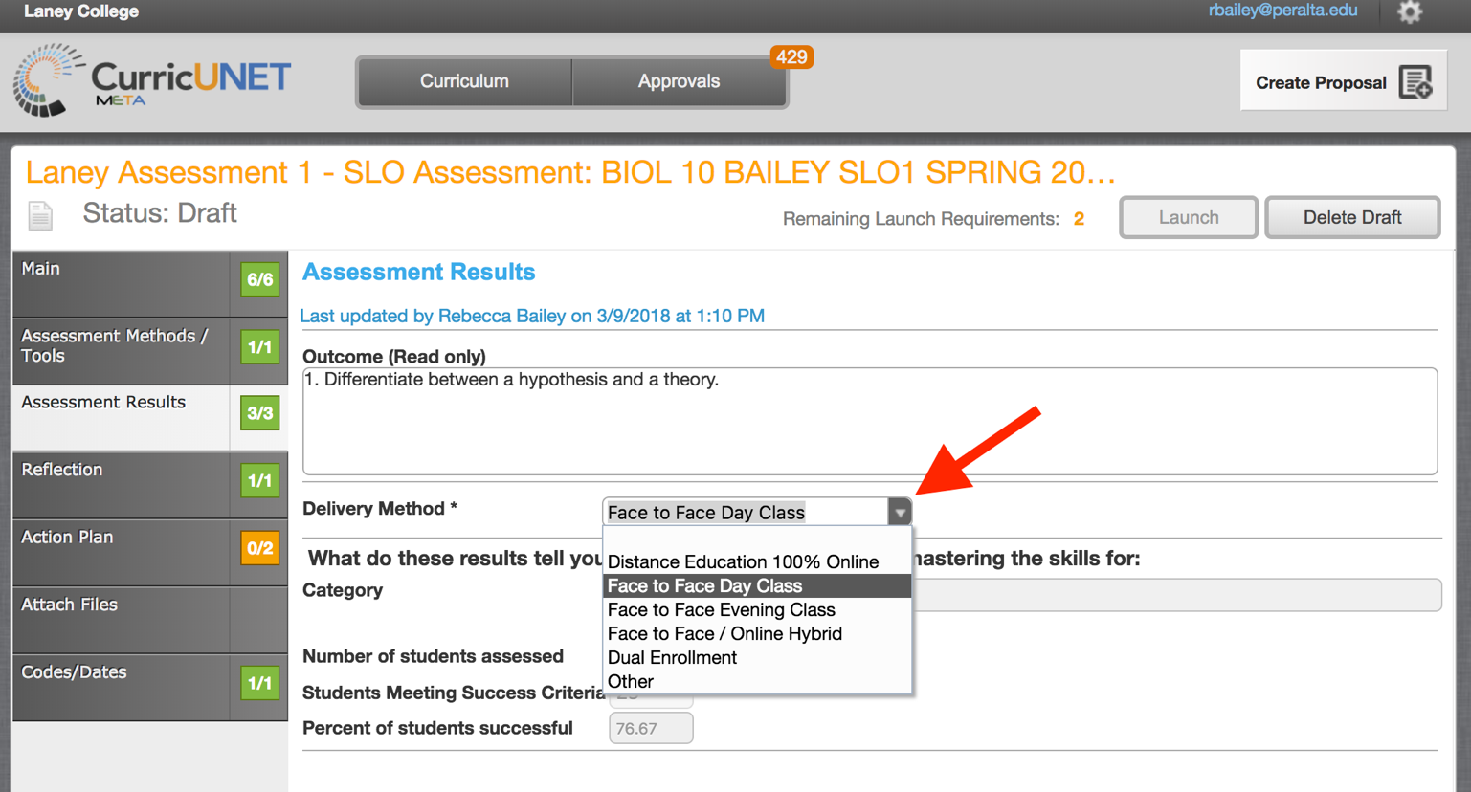

- Complete your Results and Analysis, and Learning Gaps. There may be some overlap in what you include in these text boxes. Generally, results should be numbers, analysis should be a brief narrative, and learning gaps should be the main issues from the analysis that you will address with an action plan.
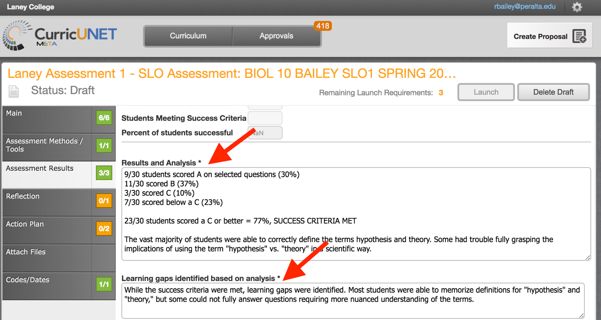
- Click on the tab “Reflection.” Results from previous Action Plans will be populated if data is available, and you will discuss the efficacy of these past action plans. In most cases, until we have more data in the system, you should say n/a.

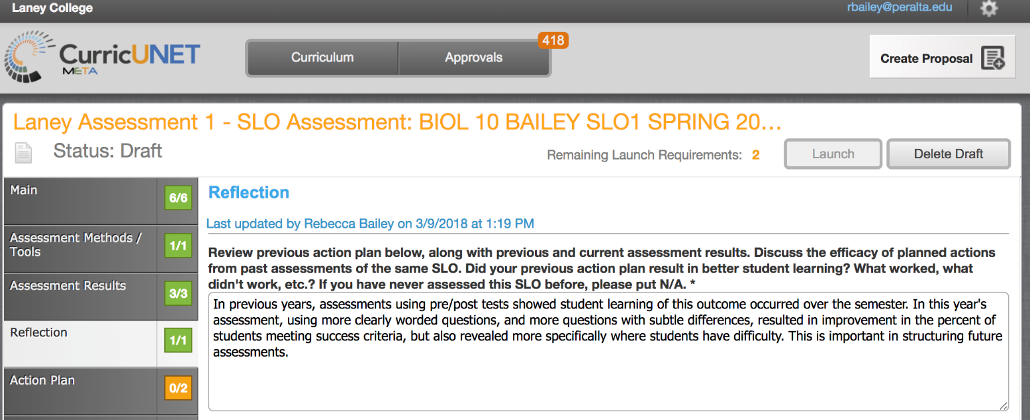

- Click on the tab “Action Plan.” Here you will detail your action plans based on results from the current assessment. You must choose at least one action at the course level. You may also choose actions beyond the course level, but this is not required. Text boxes will request additional detail. At the bottom of the page, identify the next semester/year this SLO will be assessed. You should plan to assess all SLOs for a course within a 3-year cycle, but you may want to assess more often if you feel it is critical to implement your action plan and assess the same SLO again.

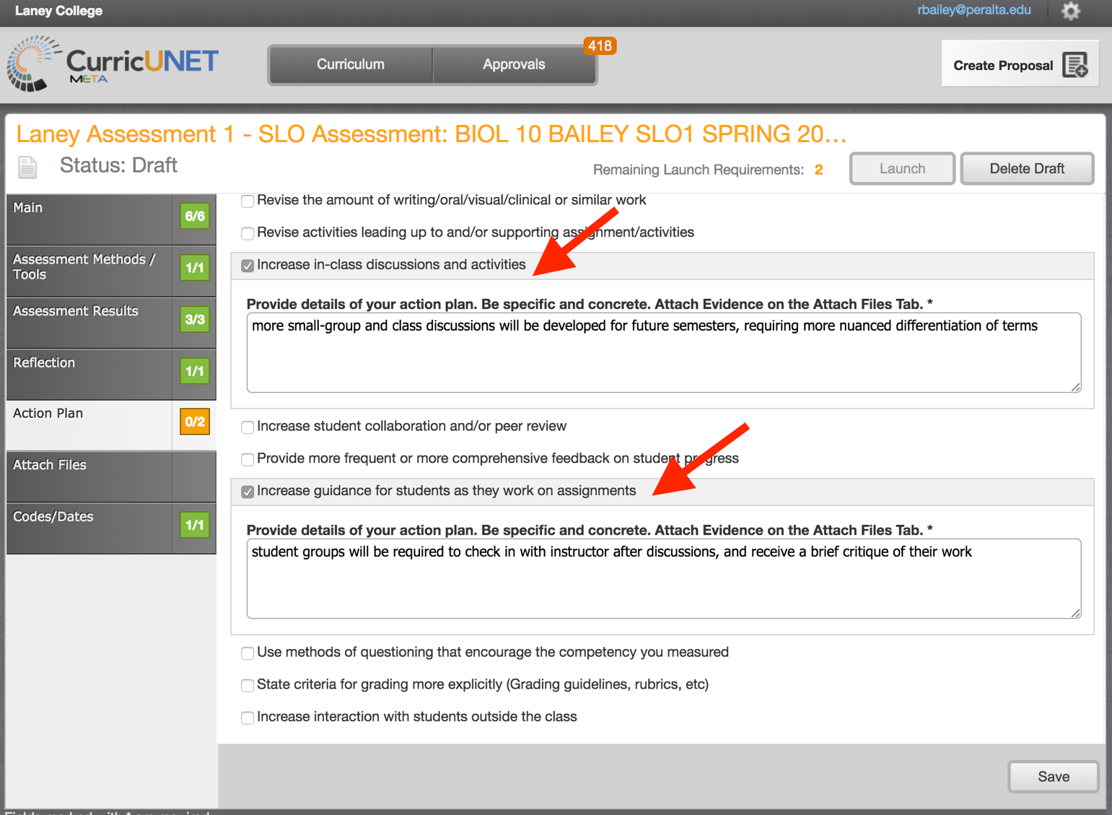

- You can attach supporting documents on the Methods/Tools, Results, and Action Plan tabs. The final tab, “Attach Files,” allows for attachment of any additional supporting files, and anything you’ve attached on any tab should show up here. While attachments are not required by the system, typically you would have a few attachments, including a rubric, exam, etc. When approving your assessments, Assessment Coordinators and/or other Learning Assessment Committee members will generally want to see at least one or two relevant attachments.

- Once all sections are complete, click “Launch” in the upper right hand corner. You will not be able to launch until all launch requirements are complete. Orange boxes indicate the tab is incomplete, while green boxes indicate the tab is completed. If you want to leave it as draft, you can access at another time by logging in, then click on “Curriculum” along the top, scroll down to “Assessment”. Your drafts, in review, and active (approved) proposals will appear. Click on the draft to make changes, or launch once complete. In review or active proposals cannot be modified. You can delete a draft, if necessary, by clicking “Delete Draft” next to the “Launch” button.

