COUNSELING OFFICE IS MOVED

FORMER LOCATION: TOWER BUILDING, ROOM 350/ NEW LOCATION: BEHIND F BUILDING (Counseling # 1)

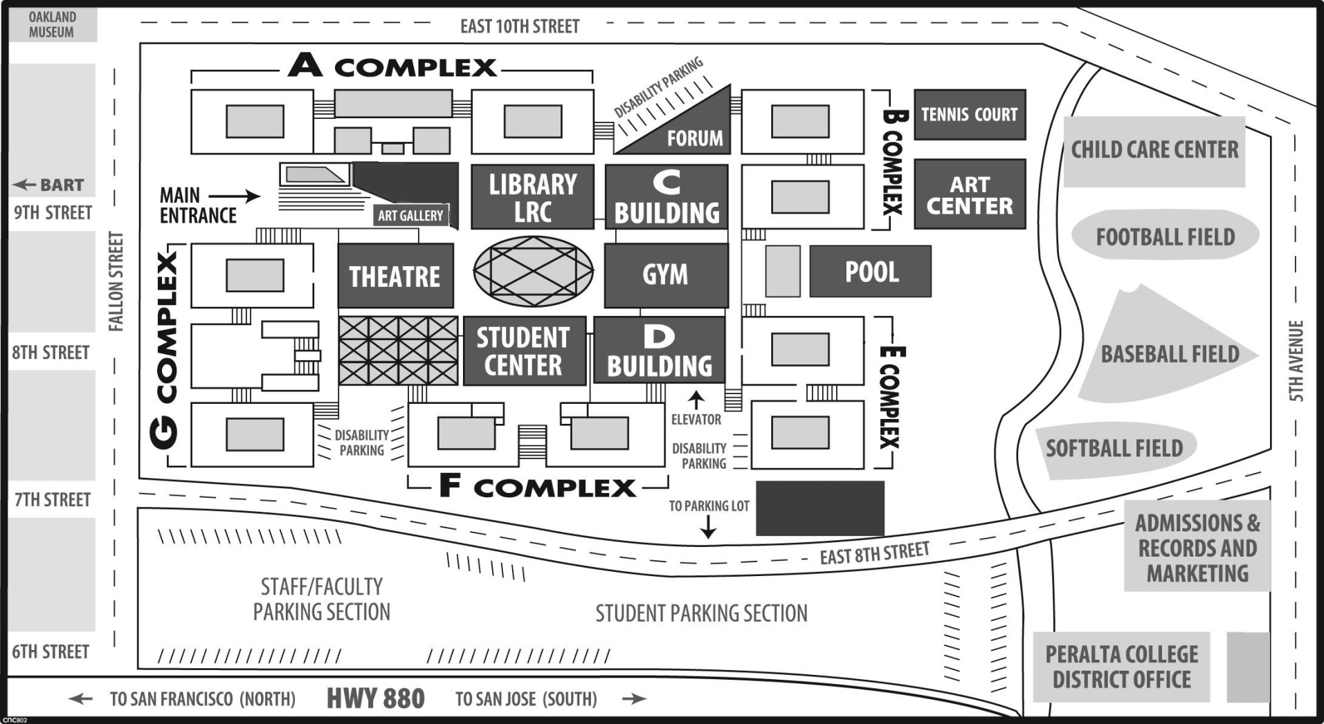
Counseling
Counseling 1

For Appointment and Drop-In please check in at the new location:
BEHIND THE F BUILDING IN PORTABLE COUNSELING 1 OFFICE ONLY
Counseling Department: 464-3152

