Laney College

Distance Education Plan

2018-2020

Building on the Peralta Community College District's Distance Education Plan and also based on guiding principles focused on learners and equity, the Laney College Distance Education Plan outlines the actions it will take to increase a) online student retention and success rates; b) the number and quality of resources and services for student support and learning support; and c) the number of courses that meet guidelines for quality, consistency, equity, and accessibility.

Version 9
February 11, 2019

Table of Contents
Executive Summary 1
Introduction 2
Overview of Distance Education at Laney College 3
Laney Distance Education Committee Charge 3
Online course offerings and enrollment at Laney College 4
Online retention rates at Laney College 5
Online Success rates at Laney College 7
Laney College Distance Education Activities 12
Proposed DE Project Timeline 18
Summary of Resource Needs 19
Laney Distance Education Plan Development Process 20
Appendix A: Additional Data 22

Executive Summary
Building on the district's Distance Education Plan, Laney College has outlined the actions it will take to implement the plan's goals to serve the needs of its online learners.

As the largest of four colleges in the Peralta Community College District (Peralta CCD), Laney College serves over one-third of total district enrollment (37.6% over the last four academic years), and almost one-third of total district online enrollment (31.3% over the last four academic years). Online students at Laney College have improved retention and success rates consistently over the last four years, but there are still large opportunity gaps to address.

This Distance Education (DE) Plan is directly aligned with Peralta CCD strategic goals and ACCJC standards, while taking into account the changing educational landscape and the nature of students in Peralta's service area. Among the district's guiding principles and values, this DE Plan and Program will be focused on learners and equity.

In support of both Peralta CCD and Laney College goals, this Plan outlines projects that Laney College will complete (numbers refer to activity details in plan below):
- Set up and implement early alert initiative for online learners (1.1a, 1.2a);
- Prepare Laney College students for online courses and online learning activities (1.1b, 1.2b);
- Identify and address gaps in support for online learners (2.1a, 2.2a, 2.1b, 2.2b);
- Confirm and adopt guidelines for online course review (3.1a, 3.2a);
- Create and facilitate professional development to address disparate success rates (1.1c, 1.2c), student support (2.1c, 2.2c), and course redesign (3.1b, 3.2b);
- Work with Peralta staff and committees to avoid duplicating efforts (4.1a) and share Laney data collection results (4.3a);
- Develop distance education policies and procedures (4.2a, 4.2b); and
- Provide additional resources to support distance education initiatives at Laney College (4.4a).

Introduction
In 2017-18, the Peralta Community College District (Peralta CCD) created and adopted a Distance Education Plan that is aligned with a) the district's strategic goals; b) district-wide values—learners and equity; c) the needs of students in Peralta's service area; and d) accreditation standards set by the Accrediting Commission for Community and Junior Colleges (ACCJC).

The Peralta CCD Distance Education (DE) Plan outlines ten projects, numbered 1.1 through 4.4, in support of the following goals:
- Peralta DE Goal 1: To close achievement gaps, Peralta CCD will increase online student retention and success rates each year from AY2017-18 to AY2019-20, through research-based success strategies.
- Peralta DE Goal 2: To support students in achieving success in distance education courses, Peralta CCD will provide resources, support, and services that are specific to online students, are necessary to close achievement gaps and meet regulatory requirements.
- Peralta DE Goal 3: To support both student and faculty success throughout their online course experiences, all Peralta CCD online courses will meet guidelines for quality, consistency, and accessibility in their design and facilitation.

Further, while most institutions value diversity and equity, they often struggle to institutionalize practices that support inclusion and equity in online environments. When Peralta's DE team could not find a rubric to support online course equity, they created the Peralta Equity Rubric to foster an expanded understanding and appreciation for student populations, particularly for disproportionately impacted students, and their experiences in online courses. Online teachers in the district may now use the rubric to redesign online course structure, materials, activities, assessments, and modules to align with equity criteria. To help faculty with course redesign, the district provides professional development and support.

Stemming from the district's efforts, Laney College has created its own Distance Education Plan that aligns with the college's vision, mission, and values (https://laney.edu/about), as well as several of its recently revised strategic plan goals and objectives (https://laney.edu/college-strategic-plan/):
- Laney College Vision: Dream. Flourish. Succeed.
- Laney College Mission: Laney College educates, supports, and inspires students to excel in an inclusive and diverse learning environment rooted in social justice.
- Laney College Values: Respect, Diversity, Appreciation, Competence, Integrity, Accountability, Innovation, and Collaboration.
- Laney College Strategic Plan Goals: Promote equity (Goal 1), offer students the highest quality curriculum and services (Goal 3), and increase awareness and access to disproportionately impacted communities (Goal 5).
- Laney College Strategic Plan Objectives: Increase degree completion (3.3), increase course completion (3.4), increase completion of career education (3.5), restructure current professional development activities (4.2), and design and deliver purposeful and seamless student support (4.5).

Overview of Distance Education at Laney College
The Laney College Distance Education initiative is designed to:
- Support excellence in online teaching and learning;
- Reduce education gaps in student achievement; and
- Ensure that all online and hybrid classes meet federal, state, and accreditation standards.

Laney Distance Education Committee Charge
The Laney College Distance Education Committee will serve as the college’s primary recommending body on matters related to distance education – specifically, focusing on supporting excellence in distance education teaching and learning; recommending policies, procedures, and resources to support effective, innovative, and equitable distance education at Laney College; and ensuring that Laney College distance education classes meet federal, state, and accreditation standards.

Online course offerings and enrollment at Laney College
Over four academic years—AY2014-15 through AY2017-18—total enrollment in online courses at Laney College comprised less than ten percent of total enrollment overall (see Table 1, below). In part, total enrollment in online courses has been controlled by the small number of online course sections offered at Laney College (also see Table 1, below). Those sections served between twenty-six and thirty students each, on average. For leaders at Laney to plan distance education program growth mindfully, the college should a) collect data beyond what is analyzed in this plan and b) consider increasing the number of online course sections.

 | # of Online Course Sections Offered | # of Enrollments in Online Courses | # of Hybrid Course Sections Offered | # of Enrollments in Hybrid Courses | % of Total enrollment Online & Hybrid
Fall 2016 | 49 | 1791 | 23 | 631 | 10.52%
Spring 2017 | 57 | 1994 | 29 | 845 | 11.37%
Fall 2017 | 57 | 1922 | 28 | 821 | 11.01%
Spring 2018 | 53 | 1800 | 25 | 804 | 11.10%
Fall 2018 | 59 | 1926 | 31 | 860 | 12.29%
Table 1. Online Course Sections Offered at Laney College and Average Number of Students per Course Section – Fall 2016 through Fall 2018

Online retention rates at Laney College

Overview of Laney College Retention Data
Overall, online student retention rates—i.e., the percentage of students completing an online course—increased over the past four academic years for all Laney students as well as the four largest ethnicity groups—Asian, Black/African American, Hispanic/Latinx, and White (see Figure 1).

Figure 1. Laney College – Online Student Retention Rates by Ethnicity – AY14-15 through AY17-18
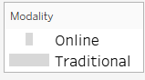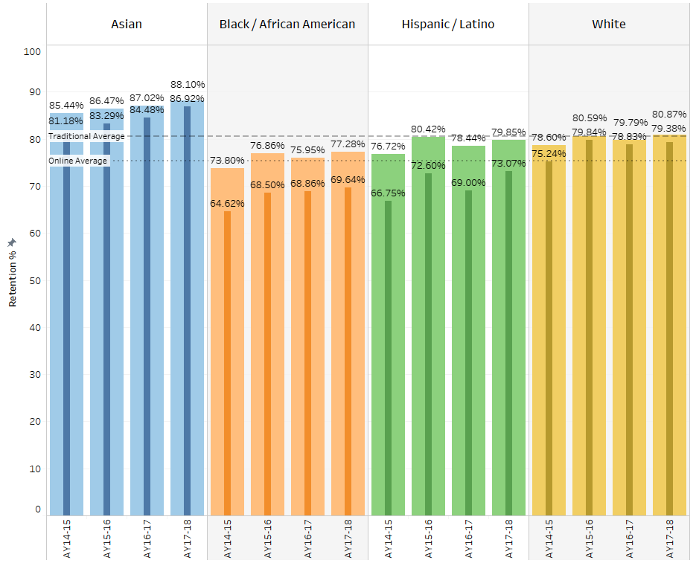

Figure 2 and Table 2 below compare retention rates in online and traditional classes for all groups over this four-year period. The online retention rates for two different student groups have almost reached traditional retention rates; for Asian and white students the difference in retention rates is less than 1.5%. While they improved over four years, online retention rates for the other two groups still trail significantly behind traditional retention rates; African-American and Latinx students face a difference of over 6.5%.

Figure 2. Comparing Online and Traditional Student Retention Rates at Laney College – AY14-15 through AY17-18
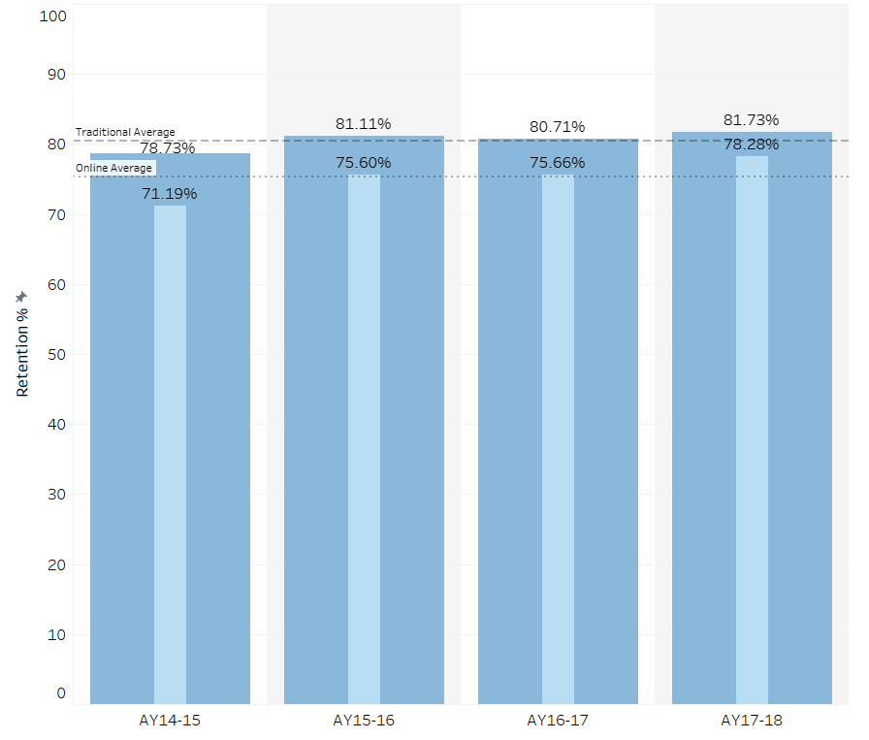

Table 2. Comparing the Differences Between Online and Traditional Student Retention Rates by Ethnicity Group at Laney College – AY14-15 and AY17-18
Ethnicity group | Retention rate difference between online and traditional classes in AY14-15 | Retention rate difference between online and traditional classes in AY17-18
All ethnicities | 7.54% Δ  78.73% (t)-71.19% (o) | 3.45% Δ  81.73% (t)-78.28% (o)
Asian | 4.26% Δ  85.44% (t)-81.18% (o) | 1.18% Δ  88.10% (t)-86.92% (o)
African-American | 9.18% Δ  73.80% (t)-64.62% (o) | 7.64% Δ  77.28% (t)-69.64% (o)
Latinx | 9.97% Δ  76.72% (t)-66.75% (o) | 6.78% Δ  79.85% (t)-73.07% (o)
White | 3.36% Δ  78.6% (t)-75.24% (o) | 1.49% Δ  80.87% (t)-79.38% (o)
t=traditional, o=online, Δ=difference

Analysis of Laney College Retention Data

Results and significance
- While online learner retention rates improved for Laney College students overall, as well as for the four largest ethnicity groups, not all improvements can be viewed equally.
- The difference between online and traditional student retention rates improved modestly for all major ethnicity groups at Laney College—between 1.5% and 3.2% over four years (Asian +3.08%, African-American +1.54%, Latinx +3.19%, White +1.87%). Since African-American and Latinx students had a larger difference between online and traditional retention rates four years ago, those groups still have a retention gap larger than 6.5%.

Proposed next steps to increase online student retention at Laney College
The Distance Education Committee proposes that Laney College complete specific activities to increase online student retention, including the following:
- Set up and implement early alert initiative for online learners (see Activities 1.1a and 1.2a below);
- Prepare students for online courses and/or online learning activities at Laney College (see Activities 1.1b and 1.2b below); and
- Identify and address gaps in support for online learners at Laney College (see Activities 2.1a, 2.2a, 2.1b, and 2.2b below).

Online Success rates at Laney College

Overview of Laney College Success Data
Overall, online student success rates—i.e., the percentage of students earning a passing grade—has risen at Laney College over the past four academic years for all Laney students as well as the four largest ethnicity groups—Asian, Black/African American, Hispanic/Latinx, and White (see Figure 3).
Figure 3. Laney College – Online Student Success Rates by Ethnicity – AY14-15 through AY17-18
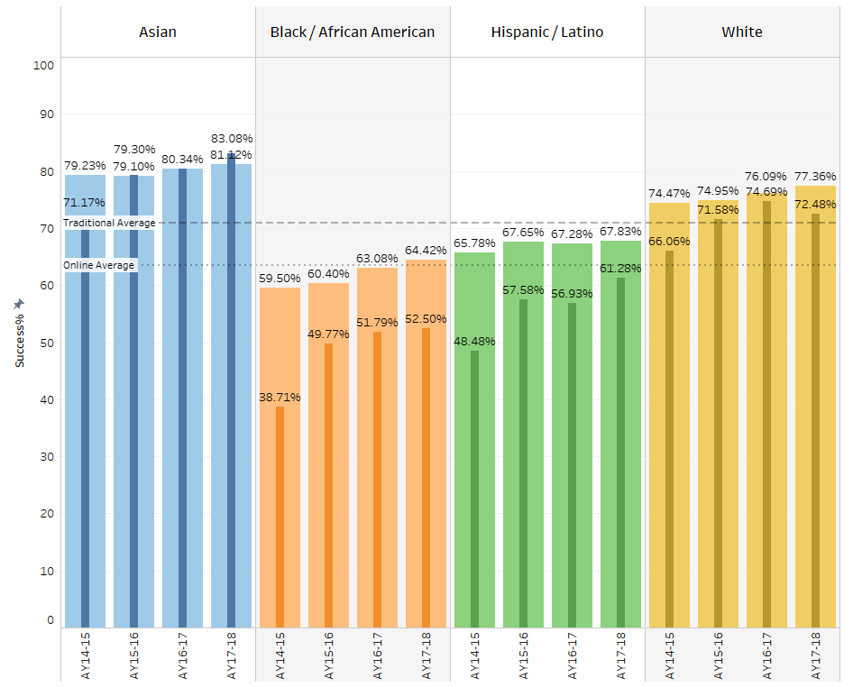

While African-American and Latinx students at Laney College made the biggest improvements in passing online courses over the last four years, they still have significantly lower online success rates (see Table 3 below).

Table 3. Comparing Online Student Success Rates by Ethnicity Group at Laney College – AY14-15 and AY17-18
 | Online student success rate AY14-15 | Online student success rate AY15-16 | Online student success rate AY16-17 | Online student success rate AY17-18 | Net percentage gained over four years
All ethnicities | 54.41%  (of 4402 enrollments) | 64.04%  (of 5770 enrollments) | 65.79%  (of 5107 enrollments) | 68.41%  (of 5103 enrollments) | +14.00%
Asian | 71.17% | 79.30% | 80.34% | 83.08% | +11.91%
African-American | 38.71% | 49.77% | 51.79% | 52.50% | +13.79%
Latinx | 48.48% | 57.58% | 56.93% | 61.28% | +12.80%
White | 66.06% | 71.58% | 74.69% | 72.48% | +6.42%

Figure 4 and Table 4 below compare success rates in online and traditional classes for all groups over this four-year period.
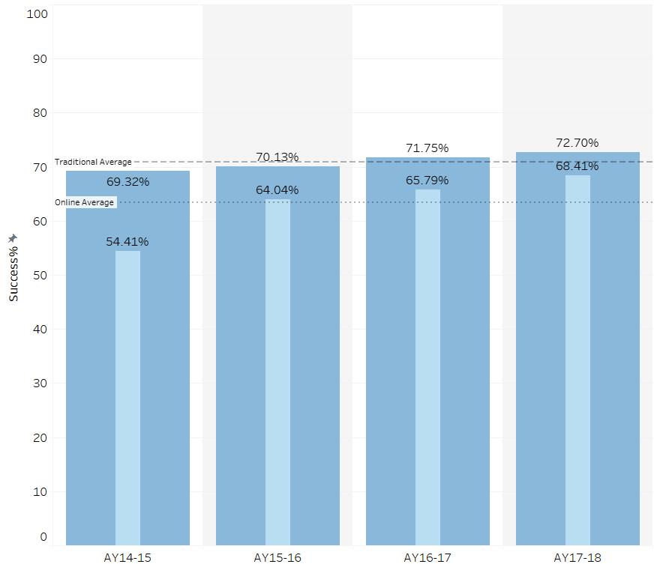
Figure 4. Comparing Online and Traditional Student Success Rates at Laney College – AY14-15 through AY17-18

Table 4. Comparing the Differences Between Online and Traditional Student Success Rates by Ethnicity Group at Laney College – AY14-15 and AY17-18
Ethnicity group | Success rate difference between online and traditional classes in AY14-15 | Success rate difference between online and traditional classes in AY17-18
All ethnicities | 14.91% Δ  69.32% (t) -54.41% (o) | 4.29% Δ  72.70% (t)-68.41% (o)
Asian | 8.06% Δ  79.23% (t) -71.17% (o) | -1.96% Δ  81.12% (t)-83.08% (o)
African-American | 16.79% Δ  55.50% (t) -38.71% (o) | 11.92% Δ  64.42% (t)-52.50% (o)
Latinx | 17.30% Δ  65.78% (t) -48.48% (o) | 6.55% Δ  67.83% (t)-61.28% (o)
White | 8.41% Δ  74.47% (t) -66.06% (o) | 4.88% Δ  77.36% (t)-72.48% (o)
t=traditional, o=online, Δ=difference

Analysis of Laney College Success Data

Results and significance
- The overall online student success rate at Laney College (all ethnicities) improved by 14 percent over four years (from 54.41% in AY14-15 to 68.41% in AY17-18).
- The online success rate for Asian students at Laney has surpassed success rates for traditional classes by almost two percent (83.08% online success compared to 81.12% traditional success in AY17-18).
- Latinx students at Laney reduced the success rate gap the most between online and traditional classes (from a 17.30% difference in AY14-15 to a 6.55% difference in AY17-18).
- As a group, African-American students at Laney increased their success rate in online courses the most (from 38.71% in AY14-15 to 52.50% successful in AY17-18), but still have a) the lowest success rate and b) the largest difference in success rates between online and traditional students.
- An increased awareness of disparities among success rates will allow Laney College to make thoughtful decisions about growing its distance education program.

Proposed next steps to increase online student success at Laney College
The Distance Education Committee proposes that Laney College complete specific activities to increase online student success, including the following:
- Confirm and adopt guidelines for online course review (see Activities 3.1a and 3.2a below); and
- Create and facilitate professional development to address disparate success rates (see Activities 1.1c and 1.2c), student support (see Activities 2.1c and 2.2c), and course redesign (see Activities 3.1b and 3.2b).

Laney College Distance Education Activities
To put the Peralta CCD Distance Education Plan into action locally, Laney College intends to complete the following Distance Education Activities.

In support of Peralta DE Goal 1— increase online student retention and success rates, and reduce achievement gaps

Peralta DE Project 1.1:  Develop recommendations for early interventions and other actions | Peralta DE Project 1.2:  Implement recommendations for early interventions and other actions
Laney DE Activity 1.1a: Set up early alert for online learners  Identify early alert specifications focused on or relevant to online learners at Laney College:  - Identify factors that contribute to putting online learners at risk (DFW)  - Identify tools (e.g., Starfish, Canvas) that can be used to collect data | Laney DE Activity 1.2a: Implement early alert for online learners  Implement an early alert initiative with online instructors at Laney College:  - Collect weekly online learner data from both Starfish and Canvas  - Collect more comprehensive, disaggregated data (e.g., students who are homeless or housing insecure, first-generation, veterans; greater variation of ethnicities)  - Disseminate information related to early alert for online learners  - Provide training and intervention resources for faculty  - Educate students about early alert for online learners
Laney DE Activity 1.1b: Prepare resources to increase retention rates for online learners  Based on Laney data:  - Review and/or revise recommendations from district DE Plan  - Research existing online learning readiness orientations and resources used at other institutions  - Identify appropriate self-assessment tools  - Identify counselor and assessment center support  - Identify directed support for stop-out points | Laney DE Activity 1.2b: Prepare students for online courses and/or online learning activities at Laney  - Create or revise the district's DE orientation module to provide training for all students to succeed with any online activities for online, hybrid or web-enhanced courses  - Offer a non-credit course to prepare students for successful online learning  - Identify potential intervention timeline with most likely stop-out or drop-out points (use data from Starfish and Canvas)  - Provide directed support for stop-out points, including specific intervention strategies and resources for faculty, counselors and staff; and resources to share with students  - Collect feedback from online learners and instructors, counselors, and student support staff
Laney DE Activity 1.1c: Prepare professional development materials to address disparate success rates for disproportionately impacted students in online courses  - Research increasing multicultural awareness in the online environment | Laney DE Activity 1.2c: Create and facilitate professional development opportunities to address disparate success rates for disproportionately impacted students in online courses  - Create and facilitate face-to-face and online workshops on how to support online learners from disproportionately impacted groups (ie: using the Peralta Equity Rubric).  - Create and maintain a community of practice for Laney faculty and staff to share their experiences

In support of Peralta DE Goal 2—provide resources, support, and services that are specific to online students

Peralta DE Project 2.1: Conduct a district-wide needs assessment of student support and learning support services available to online students | Peralta DE Project 2.2: Introduce new and make improvements to existing student support and learning support services for online students
Laney DE Activity 2.1a: Conduct a needs assessment for Laney College  - Document a baseline of existing student support and learning support services available to online students at Laney College (and share results with the district)  - Identify goals for the types and levels of academic, technical and organizational support for online students at Laney (e.g., orientations, library services, tutoring, tech help desk, registration, financial aid)  - Collect data to inform DE growth planning at Laney College (e.g., number of online courses or sections offered) | Laney DE Activity 2.2a: Address gaps in support identified during the needs assessment  - Provide face-to-face and online support for DE students at Laney College (e.g., librarians, welcome center, computer labs, peer-to-peer counseling) that is consistent with an equitable level of support at all four Peralta Colleges  - Create a designated space on campus for students to receive support for online learning and educational technology and for streamlining training resources (ie: Online/Hybrid Help Center)
Laney DE Activity 2.1b: Conduct an environmental scan of additional support structures for online learners  - Identify additional support structures that would help online students (e.g., supplemental instruction, library services, embedded tutors, peer mentors) | Laney DE Activity 2.2b: Institutionalize additional support structures for online learners  - Establish programs to implement recommendations, such as supplemental instruction, embedded tutors, peer mentors, ensuring that support services linked to retention are equitable and relevant for Laney's student population
Laney DE Activity 2.1c: Identify professional development needs related to student support  - Presentation and accessibility of all resources (design tech, courses and support services for ALL students) | Laney DE Activity 2.2c: Create and facilitate professional development opportunities related to student support  - Increase faculty and staff awareness about online students' support needs  - Train faculty to support online learners

In support of Peralta DE Goal 3—increase the number of online courses that meet guidelines for equity, quality, consistency, and accessibility

Peralta DE Project 3.1: Prepare and adopt course design and facilitation guidelines | Peralta DE Project 3.2: Implement recommendations related to online course and instructor preparation
Laney DE Activity 3.1a: Confirm guidelines for reviewing online courses for equity, quality, accessibility according to District standards to increase retention and success  - Define time investment for online instructors and online learners  - Establish course review process using the OEI Course Design Rubric  - Develop concrete strategies to support online instructors and learners, including  - Timeframes  - Rubrics  - Planning guides and information for students | Laney DE Activity 3.2a: Get faculty and administrative buy-in to adopt guidelines as requirements for Laney online courses  - Clarify expectations about online course development  - Provide support for departments in developing pilot online and hybrid pathways, such as  - Instructional designer and accessibility expert  - Load release for online course (re)design  - Stipends and summer institutes with faculty
Laney DE Activity 3.1b: Identify professional development needs related to preparing faculty to design and teach online according to guidelines  - Examine online teacher training opportunities already offered through Peralta to ensure alignment with course design guidelines | Laney DE Activity 3.2b: Create and facilitate professional development opportunities related to preparing faculty to design and teach online according to guidelines  - Create infrastructure to support faculty in course redesign (OEI Course Exchange, Local Peer Online Course Review process, @ONE Workshops, Peralta Online Equity Program, peer summer institutes, communities of practice with peer mentors, extensive workshops led by DE Coordinator, EDT courses)

In support of all three Peralta DE Goals
Peralta DE Project 4.1: Delineate college and district roles and responsibilities related to distance education.
- Laney DE Activity 4.1a: Work with Peralta CCD staff and DE Committee to avoid duplicating efforts and support district-sponsored activities.
  - Assess efficacy of delineation plan
  - Review and make recommendations to current district delineation of functions plan
  - As part of its assessment activities, conduct a formal, annual review of the delineation of roles and responsibilities at college and district levels.

Peralta DE Project 4.2: Develop recommendations for and/or revisions to policies and procedures to address distance education issues.
- Laney DE Activity 4.2a: Create an institutional knowledge transfer process to bridge gaps created by committee members and staff changes each academic year.
  - Create a knowledge base for new committee members to quickly learn key aspects of ongoing projects
  - Make its knowledge base available to the district and other Peralta Colleges to make sure they are all kept apprised of its efforts.
- Laney DE Activity 4.2b: Adopt recommended guidelines as requirements for all Laney online courses (see Laney DE Activity 3.2a above)

Peralta DE Project 4.3: Improve information and communication related to distance education across the district.
- Laney DE Activity 4.3a: Share the results of Laney's needs assessment, environmental scan, and other data collection activities with the district to inform its larger efforts (see Laney DE Activities 1.1b, 1.1c, 2.1a, and 2.1b above)
  - Share results with Laney and then with the district.

Peralta DE Project 4.4: Develop resource recommendations to support the goals and projects above (e.g. fiscal, human resource, tech, etc.).
- Laney DE Activity 4.4a: Hire support staff and/or release faculty
- Laney DE Activity 4.4b: Dedicate staff and/or faculty time to assess the impact of all Laney College's Distance Education Activities outlined in this plan

Proposed DE Project Timeline
Term | Projects supporting  Peralta  DE Goal 1 | Projects supporting  Peralta  DE Goal 2 | Projects supporting  Peralta  DE Goal 3 | Projects supporting  All Peralta  DE Goals
Fall 2018 |  |  |  | 4.1a
Spring 2019 | 1.1a, 1.1b, 1.1c | 2.1a, 2.1b | 3.1a, 3.1b, 3.2a | 4.1a, 4.2a, 4.2b, 4.4a (release)
Summer 2019 | 1.2a, 1.2b | 2.1c | 3.2b | 4.1a, 4.4a (hire)
Fall 2019 | 1.2c | 2.1b, 2.2b, 2.2c | 3.2b | 4.1a, 4.3a
Spring 2020 | 1.2c | 2.2b, 2.2c | 3.2b | 4.1a, 4.3a
Summer 2020 | 1.1c | 2.1c | 3.1b | 4.1a,
Fall 2020 | 1.2c | 2.2b, 2.2c | 3.2b | 4.1a, 4.3a
Spring 2021 | 1.2c | 2.2b, 2.2c | 3.2b | 4.1a, 4.3a
Summer 2021 | 1.2c | 2.2b, 2.2c | 3.2b | 4.1a

Summary of Resource Needs
Proposed DE Activity | Resource description | Estimated cost
1.1, 1.2, 2.1, 2.2 | Assess and purchase integrated software for student orientation and support (ie: tutoring, counseling) | $25,000
1.1, 1.2, 2.1, 2.2 | Third Party LTIs: Notebowl, Namecoach, Respondus, Proctorio, Turnitin, VoiceThread, Upswing | $91,500
2.2 | Two sets of Chromebooks for student online learning support. Laptop and projector for DE Coordinator. | $18,000
2.1, 2.2 | Permanent location for student online learning center. | ?
2.1, 2.2 | Tech Tutors to provide student support for using Canvas, related technologies, and online pedagogy. | $15,000
1.1, 1.2, 2.1, 2.2 | Full time DE program specialist to support students in their online learning, train online learners and faculty, develop online learning resources for students. | $95,000
1.1, 1.2, 2.1, 2.2, 3.1, 3.2, | Full time faculty instructional designer and equity/accessibility expert to ensure quality course design and alignment with statewide standards to better meet the needs of the diverse community of Laney students. | $115,000
3.1/3.2, 4.1, 4.2, 4.3, 4.4 | Faculty reassigned position for DE coordinating. Given that the District is projecting to only pay .4 for DE Coordinators and given that the tasks, projects, and responsibilities of the DE Coordinator have grown exponentially additional faculty reassignment to lead and support distance education is required. | $70,000
3.1/3.2 | Professional development such as face-to-face and online workshops about how to support online learners from disproportionately impacted groups (ie: using the Peralta Equity Rubric); developing pilot and hybrid pathways; course redesign through summer institutes, workshops, online courses and communities of practice. | $10,000
1.1, 1.2, 2.1, 2.2, 3.1, 3.2 4.2, 4.4 | Third party consultant to conduct needs assessment and suggest and implement improvements to existing DE program. | $25,000
 | Total cost estimate* | $464,500

Summary of District Paid Resources | Estimated cost
PCCD Canvas Training Subscription (district wide) | $5,000
Canvas Helpdesk/Tech Support (district wide)  24/7 Phone Support | $57,000  $11,000
DE Coordinator at .5 release | $60,000
Total cost estimate* | $133,000

Laney Distance Education Plan Development Process
Date | Distance Education Plan Development Activity
 | Development and Feedback
9/11/2018 | Distance Education Committee began Plan Development
9/12/2018 through 12/11/2018 | Laney DE Committee members and Consultant developed and reviewed DE Plan drafts
2/11/2019 | Draft revision finalized by DE Committee
2/12/2019 | DE Committee approves and makes public Draft Laney College Distance Education Plan
 | Community Engagement, Shared Governance, and Approval
Spring semester 2019 | Laney College Distance Education Committee shares Draft DE Plan virtually
February 2019 | Submitted to Laney Academic Senate for approval
March 2019 | Submitted to _____ for approval
April 2019 | Submitted to _____ for approval

Appendix A: Additional Data
The following figures represent retention and success rate comparisons between Laney College and the entire Peralta Community College District. Online retention rates for Asian and white students at Laney College were higher than or equal to online retention rates for those same student groups across the Peralta CCD. Online retention rates for African-American and Latinx students were lower than or equal to the rates for those same student groups across the district (see Figure A1). In AY17-18, Laney College students—all ethnicities together and individually—succeeded online at slightly higher rates than district-wide rates that include all four colleges (see Figure A2).

Figure A1. Comparing Online Student Retention Rates for Laney College and Peralta CCD – AY14-15 through AY17-18
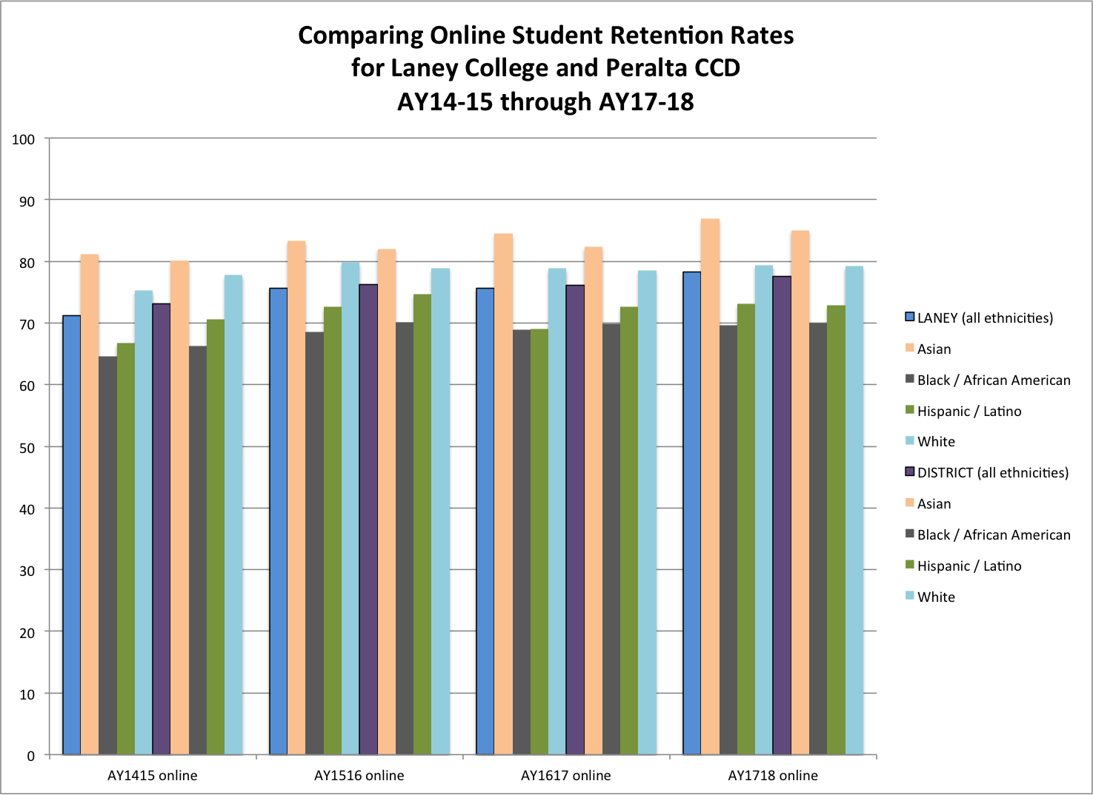
Figure A2. Comparing Online Student Success Rates for Laney College and Peralta CCD – AY14-15 through AY17-18
