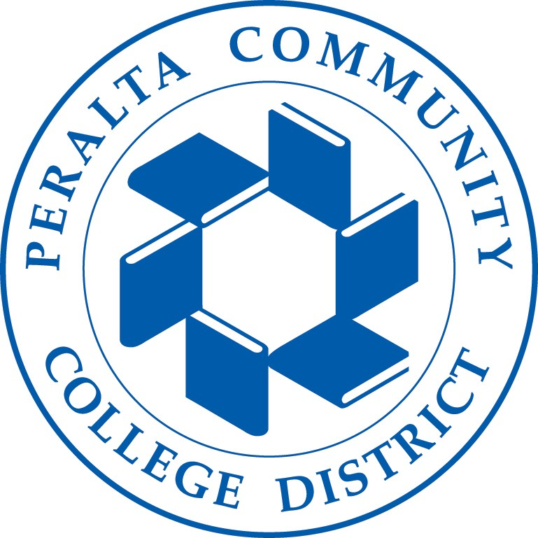
2022-2023 Unaccompanied

Homeless Youth Verification Form
Student Name: ID:

You reported on your 2022-2023 Free Application for Federal Student Aid (FAFSA) that at any time on or after July 1, 2020 you are/were an unaccompanied youth who is homeless or are a self-supporting unaccompanied youth at risk of being homeless. Please have this form completed by the authorizing individual, student signature on back and submit it, along with any required documentation, to the Financial Aid office. Include your student ID number on all documentation submitted. You must renew your status every academic year.

I am providing this letter of verification as (check one):

A McKinney-Vento School District Liaison
☐

A director or designee of a Housing and Urban Development funded shelter:
☐
(Agency Name)
☐
A director or designee of a Runaway or Homeless Youth basic center or transitional living program
(Agency Name) A financial aid professional:
☐
As per the College Cost Reduction and Access Act (Public Law 110-84), I am authorized to verify this student’s living situation. No further verification by the Financial Aid Administrator is necessary. Please contact me at the number listed below to verify or to request additional information regarding this student.

(To be completed by appropriate authorizing person)

This letter is to confirm that is/ was:
(name of student)
Check one:
an unaccompanied homeless youth after July 1, 2021.
☐
This means that, after July 1, 2021, (name of student) was living in a homeless situation, as defined by Section 725 of the McKinney-Vento Act, and was not in the physical custody of a parent or guardian.

an unaccompanied, self-supporting youth at risk of homelessness after July 1, 2021.
☐
This means that, after July 1, 2021, (name of student) was not in the physical custody of a parent or guardian, provides for his/her own living expenses entirely on his/her own, and is at risk of losing his/her housing.

Authorized Signature | Date
Print Name | Telephone Number
Title
Agency

Berkeley City College 2050 Center Street Berkeley, CA
510.981.2805
College of Alameda
555 Ralph Appezzato Mem.Pkwy Alameda, CA 94501
510.748.2228
Laney College 900 Fallon Street
Oakland, CA 94607
510.464.3314
Merritt College 12500 Campus Drive
Oakland, CA 94619
510.436.2465

Rev. 3/15/2019

