Summary of Findings from Surveys, Focus Groups and Data Analysis Performed Under The Basic Skills and Student Outcomes Transformation Grant

Recommendations
Based on findings from extensive evaluation of strategies engaged by the BSSOT grant, the evaluation team has identified the following recommendations:

- Make regular visitation by college counselors a standard component of introductory transfer level courses in math and English. Doing so will increase access to services for students with needs beyond those addressed by academic supports and make it more likely for students to establish a connection to a counselor and make an education plan.
- Make in-class peer tutoring a standard component of introductory transfer level courses in math and English, which has been shown to increase the likelihood of completing with a ‘C’ or better (and thereby increasing the probability that they will complete math and English requirements in their first year).
- Foster communities of practice around the integration of tutors and counselors into the classroom. Doing so will strengthen the impact these strategies have on student outcomes and enable the college to provide support at the scale needed to reach the population of students identified in the student equity plan.
- Provide the opportunity for students to take short-term preparatory courses during intersessions tied to courses for which they are enrolled. Doing so will increase participants outcomes in subsequent and later terms.

Following is a brief summary of findings gleaned from the evaluation efforts. Detailed reports of findings can be found on the college website (https://laney.edu/foundation-skills/).

BSSOT Background
The Basic Skills and Student Outcomes Transformation Grant (BSSOT) defined goals of reducing the time it takes a student to complete transfer level classes in math and English, increases in course success, and increased access to academic counseling. Innovations funded by BSSOT were implementation of accelerated curriculum, in-class tutors and counselors in pre-transfer English and math classes, and Math Camp. It also supported research into the effectiveness of these strategies at achieving the goals of the grant. In Spring 2018 students in these classes were surveyed to find out which aspects of the tutoring and counseling they found most helpful. In Fall 2018 a series of focus groups were conducted which explored in greater detail student experiences in these classes. In Spring 2019, a statistical analysis was conducted which estimated the impact these services have had on student outcomes.

Quantitative and Qualitative Results:
Embedded Tutoring
Results from all three phases indicate that the embedded services had positive impacts on student outcomes. In English 269, tutors were considered a necessary component of the class by 77% of students (surveyed at end of term) and credited with helping organize ideas and provide critical feedback on assignments by over half of respondents. In Math 230/240, tutors were counted as a necessary component by 85% of students and credited with providing encouragement and explaining material by over 70% of respondents. These findings were corroborated by the results of several focus group interviews (comprised of different students than those surveyed), who reported overwhelmingly positive reviews of the tutors and credited improvement in individual outcomes to guidance they provided. When academic outcomes of these students were compared to others of similar background in equivalent courses, different patterns were observed in math versus English. For students in math 230/240 classes, the relative odds of completion with a ‘C’ or better was improved by 80%. Students in English 264, the accelerated course, also showed improved chances of completing with a ‘C’ or better. In contrast, sections of 269 with embedded tutors/counselors did not show improvement on successful completion, but rather showed lower withdrawal rates relative to those in the comparison group. However, note that the composition of students in 269, a basic skills course which included students starting as far as four levels below transfer, was substantially different than those in 264, and used a comparison group drawn entirely from cohorts prior to fall 2017. This is important because trends in placement assessment scores and cumulative high school GPA for 269 suggest that in recent years these classes have seen an increasing concentration of students with lower levels of preparedness.

Integrated Counseling
In all sections incorporating regular visits by college counselors, the likelihood that a student would make a comprehensive educational plan was greatly increased. In sections of math 230 and 240, 52% and 35%, respectively, completed the term with a comprehensive plan in place, while those in sections of English 264 and 269 saw rates of 30% and 34%. Compare this to the average rates in the comparison groups, both of which were around 15%. Student feedback also revealed a high proportion faced difficulties with life situations at the same time as they were working toward academic goals. Among the most commonly cited concerns were income, housing, family matters and transportation. Increase contact with counselors made it more likely that these students shared their challenges and received appropriate supports.

Math Camp
Another innovation, Math Camp, was also found to raise student achievement substantially. Comparison to non-participants in the same classes and having matching academic backgrounds in math show that participants received higher grades (0.7 grade points, on average), were more likely to complete with a ‘C’ or better (a 3-fold increase in odds), and were more likely to be enrolled in math in the second term following Math Camp (a 3-fold increase in odds).

The chart below shows the percentages of students (enrolled at census) who go on to enroll in a transfer level class in the same subject area within a year from the start of the pre-transfer level class. Gold columns include sections with in-class tutors and counselors. Sections of English 201 and Math 201/203 were part of a learning community (Gateway or Umoja/Ubaka). English 264 and Math 230/240 had the same prerequisites as courses two levels below transfer and were accelerated (designed to prepare students for taking transfer level in one term). Blue columns show figures for sections without in-class tutors and counselors. English 269 and math 201 are both more that one level below transfer level. Therefore, students starting in these classes and progressing to the next level course each subsequent typically take longer than one year to reach transfer level. Rates shown for English 269 and Math 201 reflect the longer sequence of classes needed to reach transfer level classes.

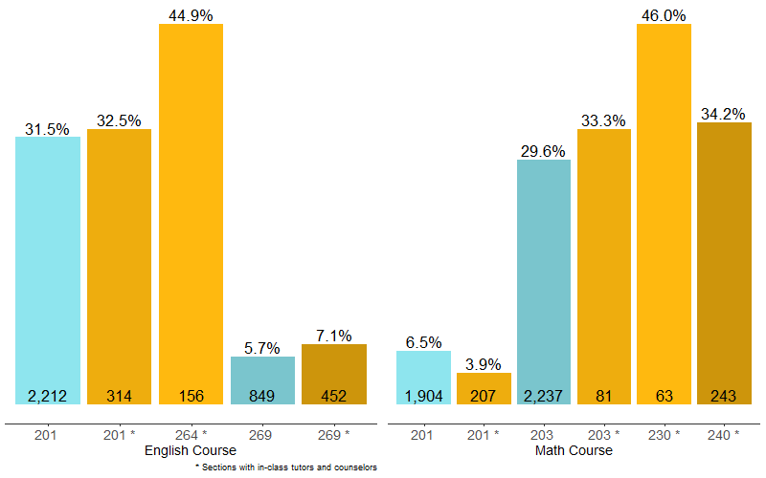
Figure 1. Percentage of students enrolling in transfer level within one year from start of term taking indicated class for sections with in-class tutors and counselors (gold) and comparison (blue).

Evaluation team members include Elizabeth Maher (Laney College), Kip Tellez (Center for Research on Equity and Collaborative Evaluation Division of Social Sciences, University of California at Santa Cruz), and Nathan Pellegrin (independent contractor). Heeju Jang (independent contractor) provided support and feedback on student surveys.

