Taking an online class?

Need help with Canvas?

Get Free Tutoring
To help you learn how to be more successful in online classes

From a REAL, LIVE Tutor
at the TRC (Eagle Village 1)
(by the parking lot)

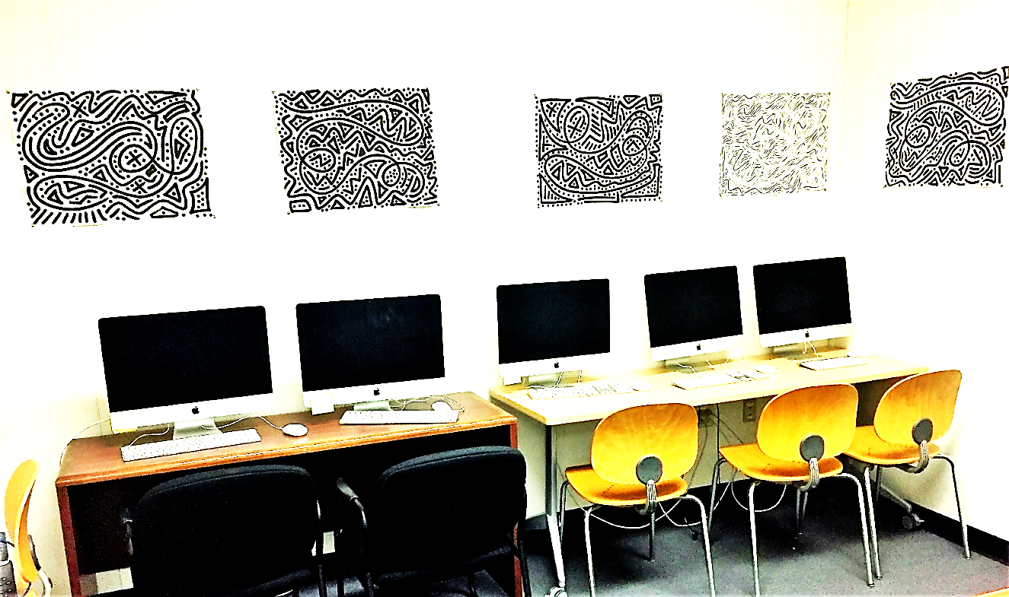

Spring ’19 Schedule:
MONDAYS AND WEDNESDAYS 9am-5pm

Tuesdays and Thursdays (Schedule forthcoming—check TRC website)
For questions, email tutor coordinator Ian Latta (ilatta@peralta.edu)

