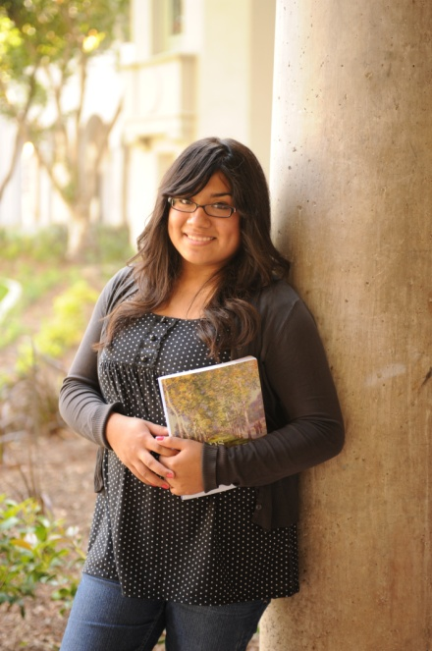

CONTACT US TODAY   
to attend an information session!

**Phone:** (510) 986-6941

 Email: gateway@peralta.edu

FB: www.facebook.com/GTCLaney

Website: www.laney.edu/wp/gateway/

Address: 900 Fallon Street   
 Oakland, CA (Bldg A, Rm 203)

CONTACT US TODAY   
to attend an information session!

**Phone:** (510) 986-6941

 Email: gateway@peralta.edu

FB: www.facebook.com/GTCLaney

Website: www.laney.edu/wp/gateway/

Address: 900 Fallon Street   
 Oakland, CA (Bldg A, Rm 203)

Information   
Session Dates

**April 23rd @ 5 pm**

**May 28th @ 5 pm**

**June 4th @ 5 pm**

**June 11th @ 5 pm**

**June 18th @ 5 pm**

**June 25th @ 5 pm**

**July 2nd @ 5 pm**

**July 9th @ 5 pm**

EARN YOUR **HIGH SCHOOL DIPLOMA**   
*AND* WORK TOWARDS **A**

**COLLEGE DEGREE**!

**TAKE CONTROL OF YOUR DESTINY.**

**You are eligible to apply if you:**

**※** Are between the ages of 16-20

**※** Reside in Alameda County

**※** Have dropped out of high school or are behind in credits and at risk of dropping out

**※** Read at an 8th grade level or above

**※** Take risks, work hard, and are committed to changing your life

**※** Have a desire to get back on track to earn a high school diploma and beyond!

Information   
Session Dates

**April 23rd @ 5 pm**

**May 28th @ 5 pm**

**June 4th @ 5 pm**

**June 11th @ 5 pm**

**June 18th @ 5 pm**

**June 25th @ 5 pm**

**July 2nd @ 5 pm**

**July 9th @ 5 pm**

.

EARN YOUR **HIGH SCHOOL DIPLOMA**   
*AND* WORK TOWARDS **A**

**COLLEGE DEGREE**!

**TAKE CONTROL OF YOUR DESTINY.**

**You are eligible to apply if you:**

**※** Are between the ages of 16-20

**※** Reside in Alameda County

**※** Have dropped out of high school or are behind in credits and at risk of dropping out

**※** Read at an 8th grade level or above

**※** Take risks, work hard, and are committed to changing your life

**※** Have a desire to get back on track to earn a high school diploma and beyond!