Cultural Politics and Mental Health
Guest Speaker: Dr. Shawan M. Worsley
October 24, 2019: 12 PM - 1PM
Laney College Umoja Village EV-2
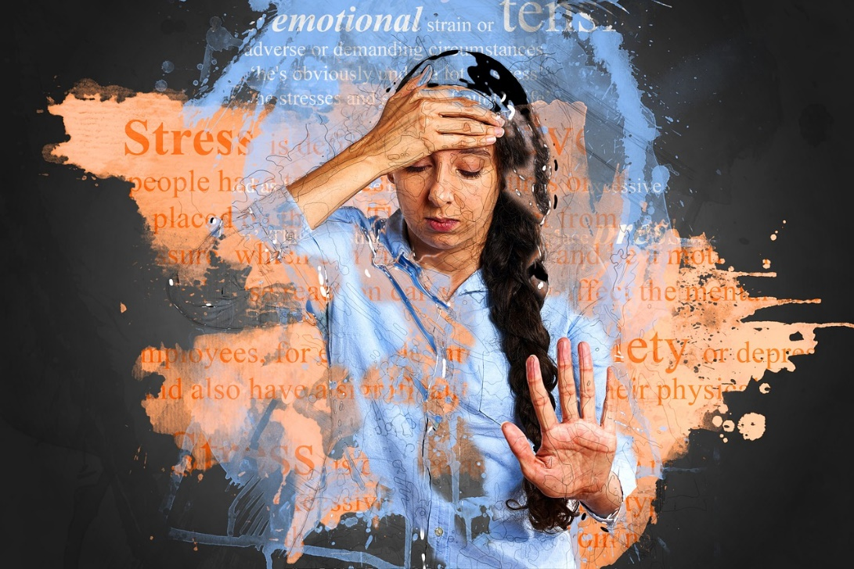

We live in a time of unprecedented anxiety and stress. As a nation, we face horrific acts of violence, terrorism, growing white nationalism, anti-immigration policies and unrestrained expressions of racism and sexism at the highest levels of distinction in our society. As diverse groups are targeted, based on their cultural and social identities, rates of anxiety, depression and trauma steadily rise. Join us as we discuss the impact of contemporary cultural politics on mental health and share strategies for building resilience and well-being.

Lunch will be provided!
Co-Sponsored by Health Services and UMOJA-UBAKA
For more information, contact Lisa Sawadogo at lisasawadogo@peralta.edu or 510-464-3535

