Handout #12 - Another Histogram Example - SOULTIONS
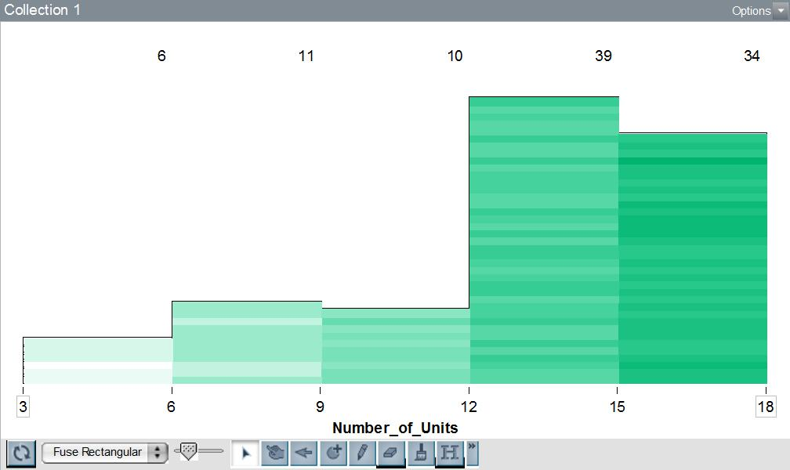
This histogram above contains information about the number of units for CCSF students during the Fall semester. The numbers at the top of each bar tell us how high the bar is. Each bar includes the left endpoint of the data.

1. How many students are represented in the sample?
100
2. How many students represented are taking 9 units or more?
83
3. How many students represented are taking less than 15 units?
66
4. How many students represented are taking at least 6 units but less than 12 units?
21
5. How many students are taking exactly 6 units?
We cannot determine a solution to this question, based on the graph given
6. What percentage of students are full-time (at least 12 units)?
73%
7. Estimate the median number of units a typical student takes.

I accepted answers between 12 and 15. On the quiz, I would like you to give ONE number as an answer and show (or explain) how you got it. We are looking for the 50th and 51st piece of data. Both are in the group between 12 and 15.
8. Estimate the mean number of units a typical student takes.
I was looking for work, like what we did on the board in class. Something like this:
6(5) + 11(7) + 10(10) + 39(13) + 34(16)
100
Which is about 12.52

