***Handout #20 — Practice with Distributions - SOLUTIONS***

For the dot plots below:

1. Find the mean
2. Find the median
3. Is the distribution skewed?
4. Which measure of center do you think would be most appropriate?

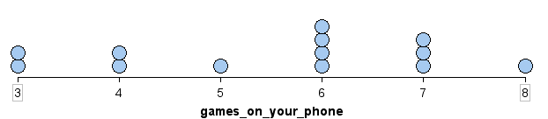

A. Mean = 

The average number of games on the phones of these people is about 6 games.

B. The data in order: 3, 3, 4, 4, 5, 6, 6, 6, 6, 7, 7, 7, 8. So the Median = 6

The median number of games on these people’s phones is 6.

C. No, the distribution is mostly symmetric.

D. The mean is better to use if our data isn’t skewed

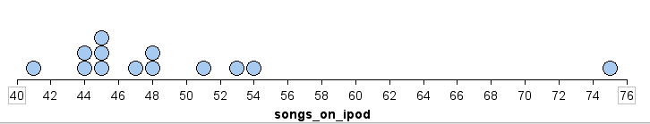

A. Mean = 

The average number of songs on the iPods of the people surveyed is about 49.

B. Median = 47 (find the 7th number)

The median number of songs on the iPods of the people surveyed is 47. About half of the data is above 47 and about half is below.

C. Yes, the distribution is skewed.

D. The median is better to use since our data is skewed.

***Handout #20 — Practice with Distributions***

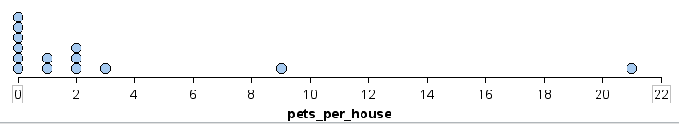

A. mean = 

The average number of pets per house for the people surveyed is about 3.

B. Average the 7th and 8th numbers to get the median, which is 1

The median number of pets per house for these people is 1. About half of the people surveyed have more than 1 pet in their household and about half have 0.

C. Yes, it is skewed.

D. Median (since the distribution is skewed)

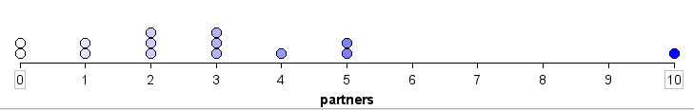

A. mean = 

The average number of partners the people surveyed have had is about 3.

B. To find the median, average the 7th and 8th numbers 

The median number of partners the people surveyed have had is 2.5.

C. Yes, the distribution is skewed.

D. Median