***Handout #21 — More Practice with Distributions***

For the dot plots below:

1. Find the mean
2. Find the median
3. Is the distribution skewed?
4. Which measure of center do you think would be most appropriate?

#1

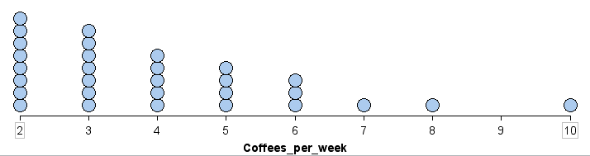

A. The mean = 

B. The median is  (The average of the 15th and 16th numbers)

C. The distribution is skewed to the right

D. We should use the median, since it is skewed.

#2

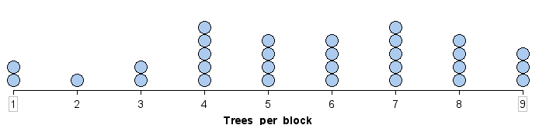

A. The mean = 

B. The median is 6 (average the 15th and 16th numbers)

C. The distribution is mostly symmetric.

D. We should use the mean, since it is mostly symmetric.

***Handout #21 — More Practice with Distributions***

#3

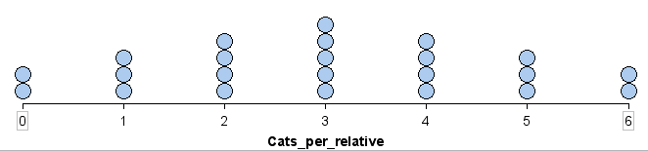

A. The mean = 

#4

