Name: ________________________________ Name: _________________________________
Math 45 Quiz #1 (Topic 2.1 and part of Topic 2.2) - SOLUTIONS
- The following graph displays data from 75 movies on Rotten Tomatoes. Rotten Tomatoes is a website that critiques movies on a scale from 0% to 100%. Answer the following questions using the given histogram.
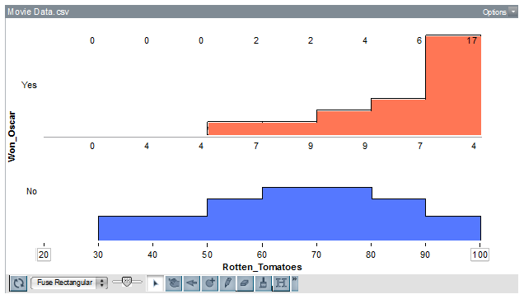
- (4 pts.) Describe the shape of the distributions above.
For the films that won Oscars, the distribution is skewed to the left. For the films that did not win Oscars, the distribution is symmetric.
- (4 pts.) Estimate the center of each distribution. Use a complete sentence for each distribution.
For films that won Oscars, a typical rating on Rotten Tomatoes would be about 90%, while for the films that did not win Oscars, a typical rating is about 70%.
- (10 pts.) Describe the spread of the distributions above, including both overall range and typical range. Use complete sentences to describe these.
The overall range of ratings on Rotten Tomatoes for films that won Oscars is 50% to 100% (range is 100%-50% = 50%), with most movies receiving ratings between 90 and 100. For films that did not win Oscars, the overall range of ratings is between 30% and 100% (the range is 70%), with most movies receiving ratings between 60% and 80%.
- (3 pts.) What percent of movies that won at least one Oscar rated 80% or more? Show the fraction you are using and write the percentage out in a complete sentence.
For movies that won an Oscar, 6+17 = 23 of them rated 80% or more on Rotten Tomatoes, out of 2 + 2 + 4 + 6 + 17 = 31. 23 out of 31 is 23/31 or 0.74193548 or about 74%. So, about 74% of movies that won an Oscar rated 80% or better on Rotten Tomatoes.
- (3 pts.) What percent of movies that did not win any Oscars rated above 80%? Show the fraction you are using and write the percentage out in a complete sentence.
For movies that did not win an Oscar, 7 + 4 = 11 of them rated 80% or more on Rotten Tomatoes, our of a total of 4 + 4 + 7 + 9 + 9 + 7 + 4 = 44 movies. This makes 11 out of 44 or 11/44 or 0.25 or 25%. 25% of the movies that did not win Oscars rated 80% or better on Rotten Tomatoes.
- (6 pts.) Use all parts above to answer the question: Do movies that win Oscars seem to be rated higher on Rotten Tomatoes than those that do not win Oscars? Explain your answer and STRESS what information (from above) you are using to make your decision. Use complete sentences.
Yes, Oscar winning movies tend to be rated higher on Rotten Tomatoes than movies that did not win Oscars. The distribution of Oscar winning movies’ ratings on Rotten Tomatoes is skewed to the left, indicating that more Oscar winning movies are rated higher than lower, while for non-Oscar winning movies, their ratings are symmetrically distributed about a center of about 70%. A typical Rotten Tomatoes rating for an Oscar winning movie is 90%, which it is only 70% for non-Oscar winning movies. Additionally, Oscar winning movies typically rate between 90% and 100%, while non-Oscar winning movies generally have ratings between 60% and 80%. There is no overlap between these two typical ranges, indicating that Oscar winning movies really tend to be rated higher than non-Oscar winning movies. Looking at the percentage of movies that rate 80% or better on Rotten Tomatoes, we can find even further evidence to support our argument; about 74% of Oscar winning movies score 80% or better on Rotten Tomatoes, while only 25% of non-Oscar winning movies rate 80% or better on Rotten Tomatoes. Based on this information, it is clear to see that Oscar winning movies rate higher on Rotten Tomatoes than non-Oscar winning movies.
- (2 pts. each) Which distributions match best? Match each of the following descriptions with I-V. Also, write a sentence about WHY you answer the way you did.
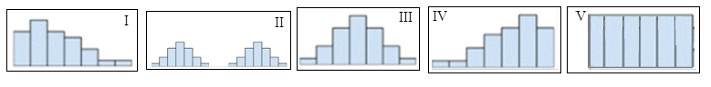
  - The ages of people at a little league game
II – There are two groups of people at these games – adults and kids. There should be a gap between their ages, since most of the adults are parents of the kids (so the two groups should NOT connect)
  - Roll a die 1000 times and record the number of times you got a 1, 2, 3, 4, 5, or 6
V – No value should occur more than another value. You should get approximately the same number of 1’s, 2’s , 3’s, 4’s, 5’s and 6’s.
  - How many cigarettes everyone in class smokes per day
I – This distribution should be skewed to the right since there will be some number o f students who do not smoke (they will all have 0’s) and for the ones who do, there will be less that smoke A LOT of cigarettes per day.
  - The age of death in a large sample of women from the US
IV – This distribution should be skewed to the left, since most women in the US die at an older age (rather than a very young age)
  - Scores on an easy exam
IV – This distribution should also be skewed to the left, since most of the students should score high on an easy exam.
3. (10 pts.) Find the mean and the median of the following distribution. Show ALL work or receive NO CREDIT!
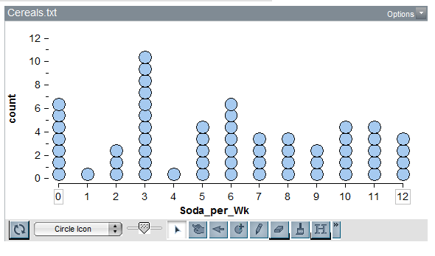
Mean :
Median:
Since there are 60 data points, we need to find the 30th and 31st. If we count on the graph, we can see that both of those numbers will have a value of 6, so the median is 6.

