Quiz #2 Review – Topics 3.1 and 3.2

1. On the axes below, sketch a scatterplot describing…

a. a strong negative b. a strong association, c. a weak but positive

association but *r* is near 0 association

|  |  |  |
| --- | --- | --- |
|  |  |  |
|  |  |  |
|  |  |  |
|  |  |  |
|  |  |  |
|  |  |  |
|  |  |  |

|  |  |  |
| --- | --- | --- |
|  |  |  |
|  |  |  |
|  |  |  |
|  |  |  |
|  |  |  |
|  |  |  |
|  |  |  |

|  |  |  |
| --- | --- | --- |
|  |  |  |
|  |  |  |
|  |  |  |
|  |  |  |
|  |  |  |
|  |  |  |
|  |  |  |

1. A school board study found a moderately strong negative association between the number of hours high school seniors worked at part-time jobs after school and the students’ grade point averages. Explain in this context what “negative association” means
2. After conducting a survey at a local community college to see what impact having a computer had on student performance, a news reporter stated “There appears to be a strong correlation between student performance and whether one owns a computer”. Why would a statistician be upset about this statement?
3. Suppose you were to collect data about Lightening. You record (for various people, at various times) the following two variables: distance from lightening and time delay of thunder.
   1. Which would you consider the explanatory variable and which the response? Why?
   2. What do you think the strength of the association would be?

1. **Brain Size and Intelligence:** A scatterplot of brain sizes (in cubic centimeters) and Wechsler IQ scores of subjects can be found below.

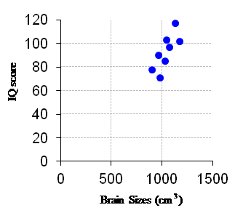

The equation of the regression line for these data is given by:  and .

1. State what the slope of the line is.
2. Explain in words what the slope of the line means, using the context of the problem.
3. State what the y-intercept is
4. Explain in words what the y-intercept means, using the context of the problem. Does the y-intercept make logical sense?
5. Explain what a positive residual would mean using the context of this problem.
6. If someone had a brain size of 1,000 , find that person’s predicted IQ score.
7. If the person who had a brain size of 1,000  actually had an IQ of 105, find the residual. Explain what this means in words, using the context of the problem.