Name: ______________________________________ Name: __________________________________
Quiz #2 (Topics 3.1 and 3.2)
- (5 points each) Suppose you were to collect data for the following pair of variables. You want to make a scatterplot. Which variable would you use as the explanatory variable (predictor) and which as the response variable? Give a brief explanation of why you chose them the way that you did. Additionally, discuss the likely direction of the association and explain why you think the direction would be that way.
  - Distance driven; Cost of a cab ride

  - Apparent brightness; Distance from a streetlamp

- (10 points total) Given the following Scatterplots, answer the questions below:
A. 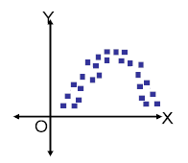B. 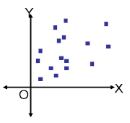C. 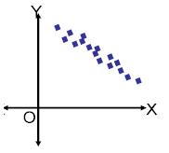D. 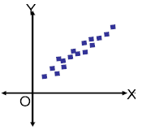
  - Which scatterplot(s) show little to no association?

  - Which scatterplot(s) show a negative association?

  - Which scatterplot(s) show a positive association?

  - Which scatterplot(s) show a strong association?

  - Which scatterplot(s) show a curved association?

  - Which scatterplot(s) show a linear association?
- ( 5 points) For the following scatterplot, make up two variables that could be described by the graph. Explain why you think so (and do NOT use the same variables as from #1 – if you do, you will receive 0 points).

- (10 points) Match the four scatterplots below with their correct correlations: -0.977, -0.021, 0.736 and 0.951
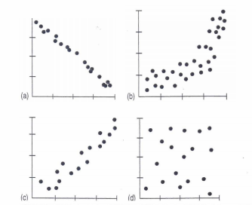

- (5 points) Roller coasters get all of their speed by dropping down a steep initial incline, so it makes sense that the height of the drop must be related to the speed of the roller coaster. Here is a scatterplot of Top Speed and Height of Drop for 75 roller coasters around the world (sorry it’s crooked!).
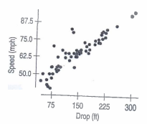
  - Does the scatterplot indicate that it is appropriate to calculate correlation? Explain.

  - In fact, the correlation between Speed and Drop is 0.91. Describe the association (strength, direction and form).

- (10 points) A regression analysis of the initial drop (in feet) of a roller coaster ride and the DURATION (notice this is different from the previous problem) of the ride (in seconds) yields the model: , where Duration is the response variable and the Drop is the explanatory variable.
  - Explain what the slope of the line says about how long a roller coaster may last and the height of the roller coaster.

Problem 6 continues here. Here is the prompt again: A regression analysis of the initial drop (in feet) of a roller coaster ride and the DURATION (notice this is different from the previous problem) of the ride (in seconds) yields the model: , where Duration is the response variable and the Drop is the explanatory variable.
  - A new roller coaster advertises an initial drop of 200 feet. How long would you predict the ride to last?

  - If the coaster with the initial drop of 200 feet actually lasts 2 minutes, calculate the residual and explain what it means using the context of this problem.

  - Identify the y-intercept of the least squares regression line and write what it means using the context of the problem. Does the y-intercept actually make logical sense? (Yes or No?) Why or why not?

