Name _________________________________ Name _________________________________

Math 45 – Quiz #3

1) (3 points) Consider the question: Are students less likely to do well on standardized test if their parents are less educated? To answer this question, we will use data for the two variables "parental education level" and "student standardized test score". Which variable is the explanatory variable? Explain your answer.

Use this table to help answer questions #2 – 4.
 |  | Parental Education Level
 |  | Less than high school | High school | Some college or more | Row Total
Student standardized test score | Basic | 5,556,230 | 3,949,710 | 4,461,409 | 13,967,349
 | Proficient | 2,971,820 | 10,798,368 | 6,015,841 | 19,786,029
 | Advanced | 1,063,009 | 4,124,123 | 9,056,499 | 14,243,631
 | Column Total | 9,591,059 | 18,872,201 | 19,533,749 | 47,997,009

2) (2 points) Explain the following percent in a sentence:

3) (3 points) Are students less likely to do well on standardized test if their parents are less educated?
Which fractions should be compared to answer this question? (Of course we would convert these fractions to percentages to do the actual comparison, but just write down the fractions needed to compare.)

4) (2 points) What percent of students in the study scored “basic”? Write the fraction and the percent.

 |  | Medicine Taken
 |  | No | Yes | Total
Cold Length | 1-3 days | 86 | 19 | 105
 | 4-7 days | 16 | 79 | 95
 | Total | 102 | 98 | 200
5)
This data is from a study on whether taking medication while one has a cold decreases the length of the cold. Here the variable Medicine Taken indicates whether the subject took medicine or not. The variable Cold Length indicates the duration of the subject’s cold.

- (3 points) Suppose that a nurse is conducting interviews for a random sample of people in this study. What is the chance that the woman selected had a low weight baby? Write marginal, conditional or joint probability. Write your answer using probability notation and give both the fraction and the percentage.

- (3 points) If a nurse randomly selects a person from this study who did not take any medicine, what is the probability that the person selected had a cold that lasted 1-3 days? Write marginal, conditional or joint probability. Write your answer using probability notation and give both the fraction and the percentage.

- (3 points) If a nurse randomly selects a person from this study, what is the chance that the person selected had a cold that lasted 1-3 days and did take medicine? Write marginal, conditional or joint probability. Write your answer using probability notation and give both the fraction and the percentage.

- (6 points) Is there an association between taking medicine and the length of a cold? (You will need two percentages here.) Write whether these are marginal, conditional or joint probabilities. Write your answers using probability notation and give both the fraction and the percentage. Additionally, answer the question with a complete sentence.

- This table summarizes the real results for a survey of firefighters and other crisis responders (such as police, EMT, etc.) in the New York area.

 | No alcohol problems | Moderate to severe alcohol problems | Totals
Participated in 9/11 rescue | 793 | 309 | 1,102
Did not participate in 9/11 rescue | 441 | 110 | 551
Totals | 1,234 | 419 | 1,653

- (6 points) Do the firefighters and other “first responders” at the 9/11 crisis at the World Trade Center have a higher risk of alcohol-related problems? Support your answer with appropriate percentages. (Remember that the explanatory variable gives the denominators of your fractions.) Communicate your results in complete sentences.

- (3 points) How much greater is the risk of moderate to severe alcohol problems for those who participated in the 9/11 rescues? Communicate the meaning of your answer in a sentence.

- (3 points) What is the relative risk of alcohol-related problems? Communicate the meaning of your answer in a sentence.

- (3 points) What is the percent increase in risk of alcohol-related problems if someone was involved in the rescue efforts? Communicate the meaning of your answer in a sentence.

- Here we have measurements from 252 men. Body Fat is the percentage of a man’s weight that comes from fat, as opposed to muscle. Weight is measured in pounds. Abdomen is a measurement (cm) around the body at the stomach.
- (7 points) Which measurement, weight or abdomen, is a better predictor of the percent of body fat? Support your answer using the scatterplot, s_{e} and r². (Use all 3 or you will NOT get full credit!)
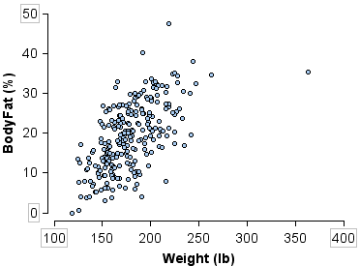
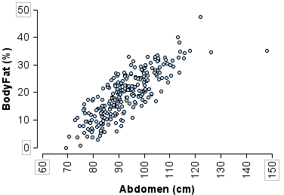
Simple linear regression results:
Dependent Variable: BodyFat
Independent Variable: Weight
BodyFat = -12.052 + 0.1744 Weight
Sample size: 252
R (correlation coefficient) = 0.6124
Estimate of error standard deviation: 6.6290
Simple linear regression results:
Dependent Variable: BodyFat Independent Variable: Abdomen
BodyFat = -39.023 + 0.6282 Abdomen
Sample size: 252
R (correlation coefficient) = 0.8148
Estimate of error standard deviation: 4.8610

- (4 points) Calculate two predictions for the percentage of body fat of a man who weighs 175 pounds and has an abdomen measurement of 100 cm. Show your work. Which prediction do you think is more accurate? Why?

- (4 points) What percentage of the total variation in body fat is explained by weight? By abdomen measurement? What other variables could explain the variation we see in men’s body fat percentages?

