Chapter 23 (part I): Estimating the Population Mean
First write what the Central Limit Theorem says here:
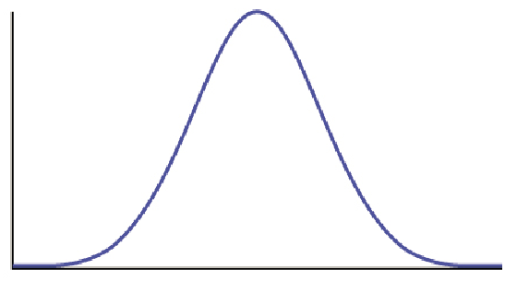
Assumptions and Conditions:

- Using the t tables, estimate:
  - The value of t for a 95% confidence interval with df = 33
  - The value of t for a 99% confidence interval with a sample size of 150.

- Is smoking during pregnancy associated with premature births? To investigate this question, researchers selected a random sample of 114 pregnant women who were smokers. The average pregnancy length for this sample of smokers was 260 days. From a large body of research, it is known that length of human pregnancy has a standard deviation of 16 days. The researchers assume that smoking does not affect the variability in pregnancy length (they use the same standard deviation).

  - Verify that the conditions are met for use of the confidence interval formula for estimating µ.

  - Based on this study, find a 95% confidence interval for μ, the mean pregnancy length of women who smoke during their pregnancy, and interpret your interval in context.

  - What does “95% confidence” mean in the context of this problem?

- The engineers take a random sample of 45 cables and apply weights to each of them until they break. The mean breaking weight for the 45 cables is 768.2 lb. The standard deviation of the breaking weight for the sample is s = 15.1 lb.

  - What should the engineers report as the mean amount of weight held by this type of cable?

  - Let’s use these sample statistics to construct a 98% confidence interval for the mean breaking weight of this type of cable.

- What happens when the sample size increases? Redo problem #2 assuming that we instead had a sample size of 101 cables. What changes do you notice? List all parts of the problem that change.

- What happens if we use a z-score instead? Redo problem #2 using z instead of t. Is it greatly different?

- According to the website www.collegedrinkingprevention.gov, “About 25% of college students report academic consequences of their drinking including missing class, falling behind, doing poorly on exams or papers, and receiving lower grades overall.” A statistics student is curious about drinking habits of students at his college. He wants to estimate the mean number of alcoholic drinks consumed each week by students at his college. He plans to use a 90% confidence interval. He surveys a random sample of 71 students. The sample mean is 3.93 alcoholic drinks per week. The sample standard deviation is 3.78 drinks.

  - Have the conditions for constructing a confidence interval been met?

  - Find the margin of error for this 90% confidence interval.

  - Find the 90% confidence interval the statistics student is looking for.

  - Write out the confidence interval in words.

  - Would the confidence interval be more narrow or wider if we used a confidence level of 95%?

