Unit 3: Distributions for Quantitative Data and Measures of Center (Modules 7 & 8)

- Use the case-value graph below to answer each of the following questions.

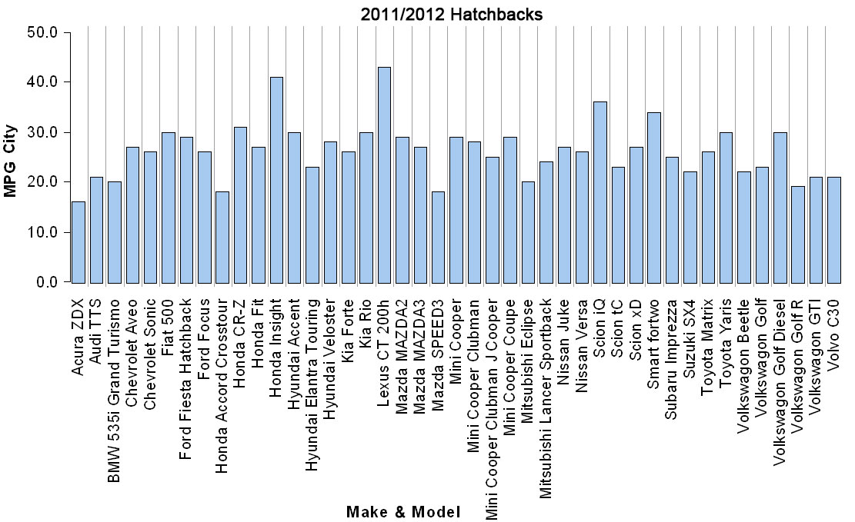
- How many hatchbacks get 23 mpg in the city?

- What are the mpg rates that occur most frequently?

- Which mpg rate is the middle rate?

- In question #1, were you asked to examine the individuals cases and their values? Or were you asked to describe patterns in data and/or to create summaries about the group?

- Was it awkward to work with the case-value graph in #1? Why or why not?

- Let's answer the same questions using a dotplot to represent the same data for the variable MPGCity.
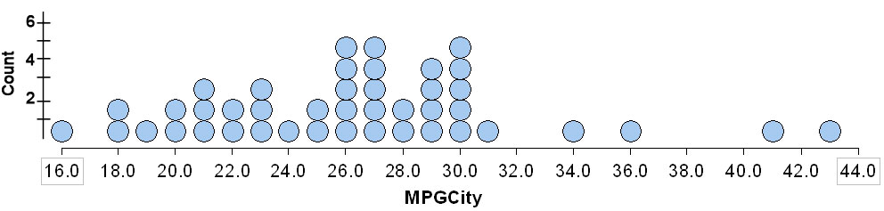

- How many hatchbacks get 23 mpg in the city?

- What are the mpg rates that occur most frequently?

- Which mpg rate is the middle rate? What did you do to find this "middle"?

- Which graph gives a more immediate summary of the distribution for the MPGCity variable (the case-value graph on the first page of this activity or the dotplot on the second page)? Explain.

- Use the dotplot to summarize the data even further.
- What is the overall range for the mpg values?

- What is a typical range (the main clump of data) for the mpg values?

- What is the average mpg?

- What are the outlier mpg rates?
- For each of the following dotplots, draw a smooth curve outlining the distribution, and then describe the shape of the distribution.
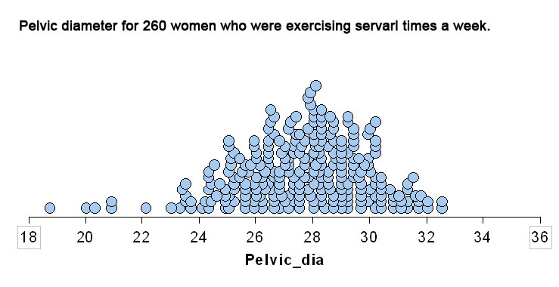

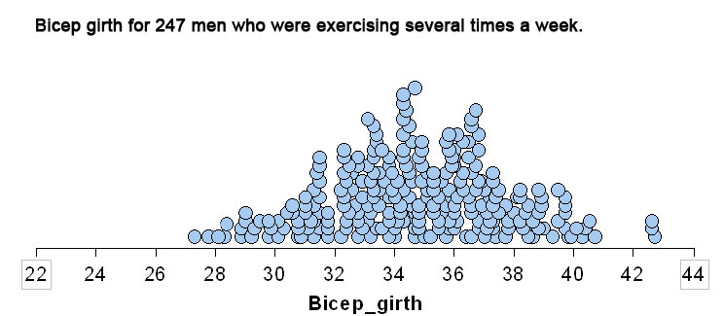

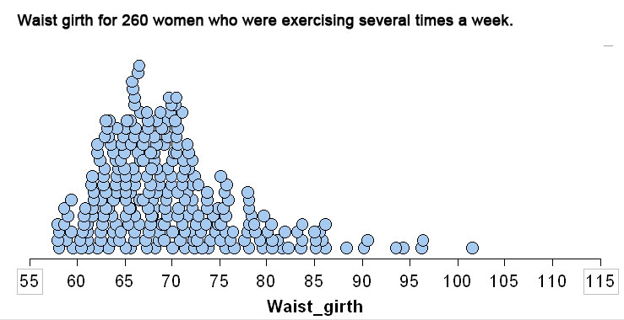

- The following is a histogram indicating the distribution of scores on the Spring 2012 Module 1 Checkpoint for an instructor’s combined classes.
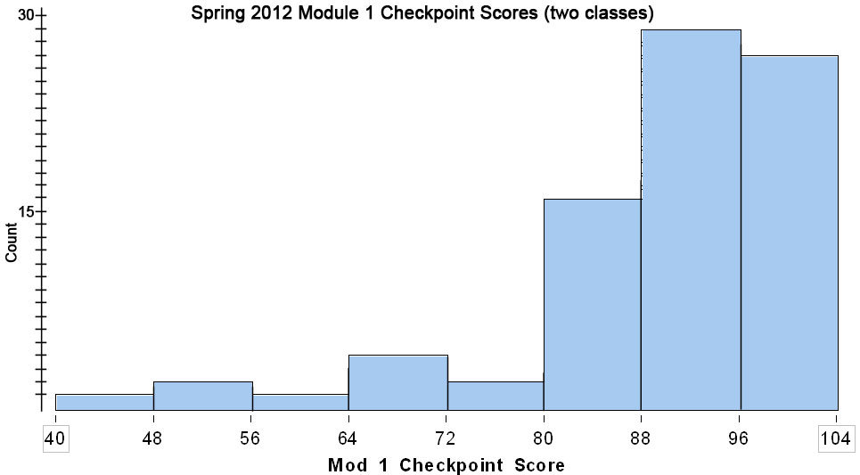
What percentage of students scored below 80% (assume left-hand endpoints are included in each bin)?

- For each of the following questions, give an exact answer if possible. If the histogram in #8 doesn’t provide enough information to answer exactly, give a range of possible answers.
- What percentage of the students who took the exam scored at least 88 but less than 96 points?

- What is the lowest grade on the Module 1 Checkpoint?

- What percentage of students scored less than 90?

- How many students did not pass the exam, if "not passing" is a score of 70 or less?

- Describe the shape of the distribution of the Module 1 Checkpoint Scores in the histogram in #8 (try to write your response like a statistician).

- Describe where the center appears to be in this distribution (again … try to write like a statistician).

- Describe the range for this data (you should come up with a single number).

- Describe any apparent outliers.

- Here are data from adults (247 men and 260 women) who were exercising several hours a week. Indicate whether you think the following statements are valid or invalid (and try to explain why using evidence from the histograms).
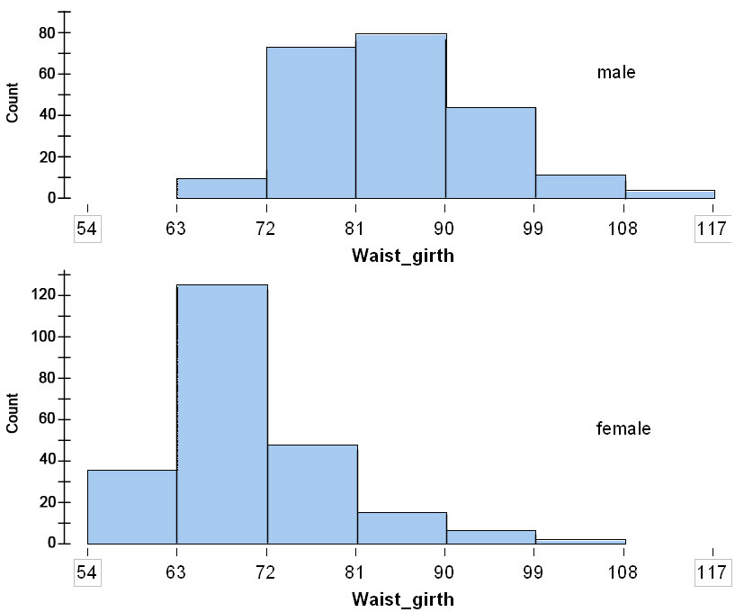
- Typical females have a smaller waist girth than typical males.

- The overall range in waist girth is smaller for females than for males.

- A medium size pair of pants will fit a woman with a waist girth between 72 and 76 centimeters, so a medium size pair of pants with fit about 20% of the women in this sample.

