Examples of 5 Number Summaries and Box Plots:
1. The following are exam scores for a statistics course. Find the 5 Number Summary for the data and create a Box Plot under the Dot Plot Shown (using the same axes).
50, 62, 65, 68, 70, 72, 72, 73, 73, 73, 75, 75, 75, 75, 75, 78, 78, 78, 78, 78, 78, 78, 80, 80, 80, 80, 80, 80, 80, 80, 80, 80
Min | 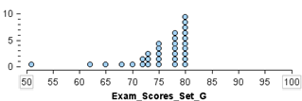
Q1
Median
Q3
Max

2. The following are exam scores for another statistics course. Find the 5 Number Summary for the data and create a Box Plot under the Dot Plot Shown (using the same axes).
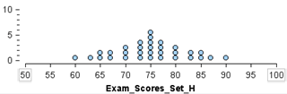
60, 64, 65, 65, 66, 66, 70, 70, 70, 74, 74, 74, 74, 75, 75, 75, 75, 75, 75, 76, 76, 76, 76, 80, 80, 80, 84, 84, 85, 85, 86, 90
Min
Q1
Median
Q3
Max

