Module 15, part 3!
1. Researchers in the Physicians’ Health Study (1989) designed a randomized clinical trial to determine whether aspirin reduces the risk of heart attack. Researchers randomly assigned a large sample of healthy male physicians (22,071) to one of two groups. One group took a low dose of aspirin (325 mg every other day). The other group took a placebo. This was a double-blind experiment. Here are the final results.
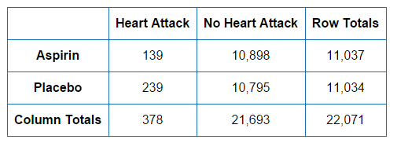
Question: Does aspirin lower the risk of having a heart attack?
- Compare appropriate percentages to answer the question (show what fractions you used).
- What kind of probabilities did you find (joint, marginal or conditional)? Write the probabilities you found using the appropriate notation.
- Calculate the percentage change and explain what it means for this problem (We calculate the difference - how much the risk changed - and divide by the risk for the placebo group.)

2. The table below is based on a 1988 study of accident records conducted by the Florida State Department of Highway Safety.
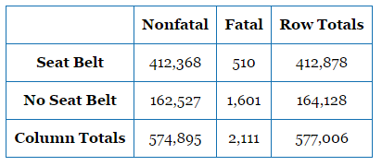
Question: Does wearing a seat belt lower the risk of an accident resulting in a fatality?
- What fractions will you compare in order to answer the question? Show the fractions and explain the answer to the question.
- Write the probabilities you found using the correct notation.
- Calculate the percentage change and explain what it means for this problem.

(continued on back)
Complex Probability Problems
Learning goal: Create a hypothetical two-way table to answer complex probability questions.
Example #1: Suppose that Walmart has a mandatory drug test for all employees. The test attempts to identify users of illegal drugs, such as cocaine. Let’s assume that the test is 95% accurate. This means that 95% of time a positive test result will accurately identify a drug user. Similarly, 95% of the time a negative test result will accurately identify a non-drug user. Let’s assume that 4% of the employees are drug users.
If the drug test is positive, what is the probability that the test is wrong and the employee is not using drugs?
We want to find a conditional probability, P(drug user no | positive test). To find this probability we will construct a two-way table for a hypothetical sample of 10,000 employees. (10,000 is a large enough number to ensure that all calculations result in whole numbers.)

 | Drug User Yes | Drug User No | Totals
Drug Test: Positive
Drug Test: Negative
Totals

Which two cells in the table will we use to calculate P(drug user no | positive test)?
Take notes as we complete the table together.

P(drug user no | positive test) = _________________________________

Example #2: During pregnancy, women often have an ultrasound to identify the sex of the baby in utero. Suppose that the ultrasound correctly identifies 92% of the girls and 80% of the boys. Suppose also that 49% of babies are girls.

Construct a two-way table for 10,000 random babies to answer the following questions. Show enough work that you can retrace your thinking when asked.

- If the ultrasound predicts a girl, what is the probability that the baby is a girl?
- If the ultrasound predicts a boy, what is the probability that the baby is a boy?
 | Baby is a girl | Baby is a boy | Totals
Test predicts a girl
Test predicts a boy
Totals

