Unit 3, Module 10: Measuring Variability Relative to the Mean
(The Standard Deviation)

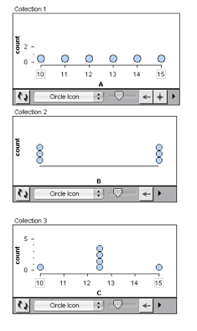
- Each dot plot shown varies from 10 to 15 with a mean of 12.5.

- Which dot plot has the least variability about the mean?

- Which has the most variability about the mean?

- Find the standard deviation from the mean (SD) by using Excel or Google Spreadsheets

- Which set of data will have a larger Standard Deviation? Why do you think so?
- The ages of children at a local elementary school
- The ages of people living in Pittsburg

We will use technology to find the standard deviation of a data set, instead of calculating it by hand. So here we will practice problems that focus on the concept, instead of the mechanics.

- If we calculate the Standard Deviation for City A and City B using the average high temperatures, we get 4.4 and 16.6. Which is the Standard Deviation for City A? If one of the cities is San Francisco and the other is New York City, which is which? How do you know?
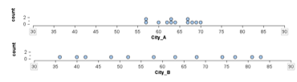

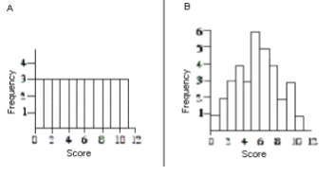
- Which distribution has the smaller standard deviation? Explain how you made your decision.

- If the standard deviation of quiz scores on the Checkpoint 2.4 is zero, what do we know?

- everyone made a 100% on the quiz b. everyone failed the quiz
- everyone made the same score on the quiz d. it is impossible to tell

- Here is a dot plot of elbow girth measurements for 507 adults. In Tinkerplots (computer software like Excel), we can graph a standard deviation hat plot. The standard deviation hat plot consists of a box around the mean that captures all of the data that is within one standard deviation of the mean. In other words, the left edge of the box is Mean – SD; the right edge of the box is Mean + SD.
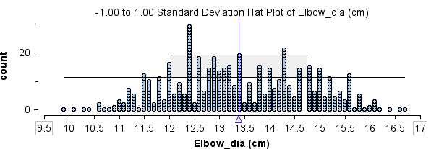

The mean elbow diameter is about 13.4 cm. Which of the following choices is the most reasonable estimate for the standard deviation? Why?

a. about 2.8cm b. about 1.4cm c. about 7cm

- The people in this sample are 18 to 67 years old. Here is a summary of the distribution of ages: Mean = 30, SD = 9.6; 5-number summary: 18, 23, 27, 36, 67

- Give an interval of typical ages for this sample using quartiles.

- Give an interval of typical ages for this sample using mean and SD.

- Here is a boxplot and a standard deviation hat plot for this age distribution. In the boxplot label the median and other quartiles. In the standard deviation hat plot label the mean and SD.
