Unit 11, Module 27: Distribution of Sample Means

**First write what the Central Limit Theorem says here:**

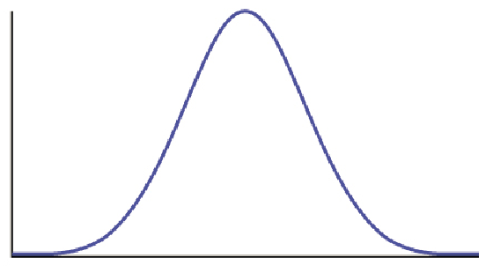

**Assumptions and Conditions:**

1. The annual salary for teachers in a certain state has a mean of  and a standard deviation of 
   1. What is the probability that the mean annual salary of a random sample of 5 teachers from this state is more than $60,000? Find this probability or explain why you cannot.
   2. What is the probability that the mean annual salary of a random sample of 64 teachers from this state is less than $52,000?
   3. What is the probability that a randomly selected teacher from this state has an annual salary of $55,500 or more.