Unit 4, Module 13: Assessing the Fit of a Line

Learning Goal: Use residuals, standard error and r² to assess the fit of a linear model.

In this activity you will practice pulling together what you have learned in Topic 3.3. You will use residuals, s_{e} and r² to analyze how well the regression line fits the data.

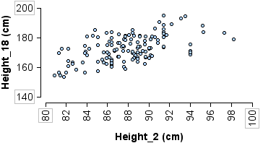
- Researchers took body measurements for 136 children at ages 2, 9, and 18. The children were born in 1928-29 in Berkeley CA. Here we investigate the relationship between height at age 2 and height at age 18.
Simple linear regression results:
Dependent Variable: Height_18
Independent Variable: Height_2
Height_18 = 45.797 + 1.444 Height_2
Sample size: 136
R (correlation coefficient) = 0.5486734
R-sq = 0.3010425
Estimate of error standard deviation: 7.4216731

- In this analysis, what is the explanatory variable? Why does this make sense?

- Do taller 2-year-olds also tend to be taller 18-year-olds? Support your answer.

- Is the association between heights at age 2 and age 18 strong or weak? Support your answer.

- Use the context of the problem to describe what the standard error tells us in this situation.

- Use the context of the problem to describe what the R-sq value tells us in this situation.

- In the data set there is a boy who was 92 cm tall at age 2 and 189 cm tall at age 18. What is the residual for this boy? What does the residual tell us?

- Here we have measurements from 252 men. Body Fat is the percentage of a man’s weight that comes from fat, as opposed to muscle. Weight is measured in pounds. Abdomen is a measurement (cm) around the body at the stomach.
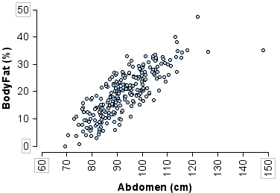
- Which measurement, weight or abdomen, is a better predictor of the percent of body fat? Support your answer using the scatterplot, s_{e} and r².
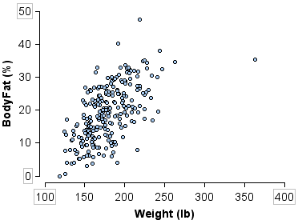
Simple linear regression results:
Dependent Variable: BodyFat
Independent Variable: Weight
BodyFat = -12.052 + 0.1744 Weight
Sample size: 252
R (correlation coefficient) = 0.612414
R-sq = 0.37505091
Estimate of error standard deviation: 6.6290191
Simple linear regression results:
Dependent Variable: BodyFat Independent Variable: Abdomen
BodyFat = -39.023 + 0.6282 Abdomen
Sample size: 252
R (correlation coefficient) = 0.81483224
R-sq = 0.66395158
Estimate of error standard deviation: 4.8610253

- Calculate two predictions for the percentage of body fat of a man who weighs 175 pounds and has an abdomen measurement of 100 cm. Show your work. Which prediction do you think is more accurate? Why?

- What percentage of the total variation in body fat is explained by weight? By abdomen measurement? What other variables could explain the variation we see in men’s body fat percentages?

- In general do we want a large or small R-sq value? Why?

- In general do we want a large or small s_{e} value? Why?

