Name: _____________________________
Unit 8, Module 20: Introduction to Statistical Inference
First, Review the Distribution of Sample Proportions:
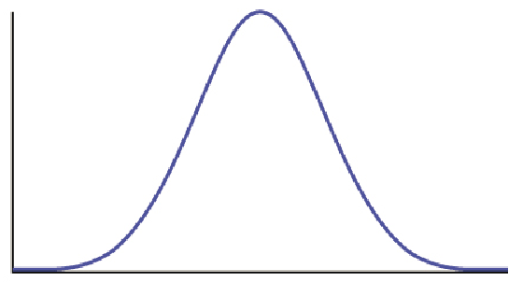

Assumptions and Conditions:

What does this mean about Sample Proportions??
About ________ % of samples should have a ____________________ within _________ standard deviations from
____________

About ________ % of samples should have a ____________________ within _________ standard deviations from
____________

About ________ % of samples should have a ____________________ within _________ standard deviations from
____________

About ________ % of samples should have a ____________________ within _________ standard deviations from
____________

About ________ % of samples should have a ____________________ within _________ standard deviations from
____________

Confidence Intervals:
1. The National Vital Statistics Reports for November 2011 states that U.S. preterm birth rate for 2010 was about 12%. Preterm birth means premature birth. Suppose that this year a random sample of 500 births has 52 that are preterm. Using the estimate from the NVS Report for 2011 and the result from this year’s random sample, estimate the percent of preterm births this year with 95% confidence interval. (Be sure to check that a normal model is appropriate.)

2. The National Vital Statistics Reports for November 2011 states that U.S. preterm birth rate for 2010 was about 12%. Preterm birth means premature birth. Suppose that this year a random sample of 500 births has 52 that are preterm. Using the estimate from the NVS Report for 2011 and the result from this year’s random sample, estimate the percent of preterm births this year with 95% confidence interval. (Be sure to check that a normal model is appropriate.)

3. The National Vital Statistics Reports for November 2011 states that U.S. Cesarean delivery rate for 2010 was about 32.8%. Cesarean delivery is also called a “C-section.” It means the baby is not delivered in the normal way. The baby is surgically removed through an incision in the mother’s abdomen and uterus. Suppose this year a random sample of 100 births has 41 that are preterm.
Use the estimate from the NVS Report for 2011 and the result from this year’s random sample to estimate the U.S. Cesarean delivery rate for this year with 95% confidence. (Be sure to check that a normal model is appropriate.)

Hypothesis Testing:
4. With data from the 2010 National Health Interview Survey, the Centers for Disease Control and Prevention (CDC) estimates that 22% of U.S. adults (age 18–64) did not have health insurance in 2010. Is the percentage higher this year? In a hypothesis test, we translate the research question into a claim about the population.
Claim: The percentage of U.S. adults (ages 18–64) who do not have health insurance is higher than 22% this year.

To test the claim, we assume that the percentage is 22% this year. Then we gather a random sample from the population to test the claim. Suppose 25% of a random sample of 600 U.S. adults (age 18–64) do not have health insurance this year. What can we conclude? Obviously, this sample has more than 22% uninsured adults. But does this data suggest the percentage of the U.S. adult population(age 18–24) who are uninsured is greater than 22%?
5. Now we retest the same claim using different data.
Claim: The percentage of U.S. adults (ages 18–64) who do not have health insurance is higher than 22% this year.
Suppose 26% of a random sample of 50 U.S. adults (age 18–64) do not have health insurance this year. What can we conclude?

