**Module 27: Distribution of Sample Means**

1. What was the distribution of Sample Proportions? Describe it in words, along with what the center and spread of the distribution was.

2. What did we use the distribution of Sample Proportions for? List as many uses as you remember.

3. What do you think the Distribution of Sample Means is? What do you think it will look like? Any guesses to the center and spread?

4. What do you think we will use the Distribution of Sample Means for? List as many as you think possible.

**When we talk about the Distribution of Sample Means, write down the relevant important information:**

**How is the Sampling Distribution of Sample Means Created?**

**Center:**

**Spread:**

**Shape: (If parent population is Normal and if it’s not Normal, what’s the difference?)**

**IF THE PARENT POPULATION IS NOT NORMAL…like the ages of students in our class wan’t…**

13. If we roll a die 10,000 times, what do you think our results would look like in a histogram?

**Here are the results of a simulation of 10,000 die rolls:**

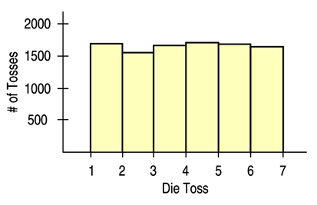

14. What is the Sample size in this case?

15. Describe the distribution above (shape, center, spread).

**We will think of the above distribution as our “Parent Population”. In it, the population mean is about 3.5 or **

**Now, we roll TWO dice 10,000 times, find the average of the 2 dice roll and get the following results:**

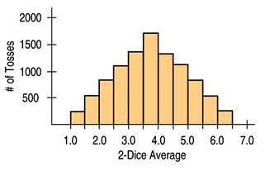

16. What is the sample size now?

17. Describe the distribution above (shape, center, spread).

18. How does this distribution relate to the “parent population”?

19. What do you think will happen if we roll even more dice?

**This is what happens when we roll THREE dice 10,000 times and plot the averages of each 3-die roll:**

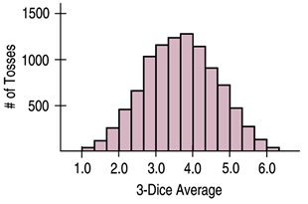

**And here are some more results:**

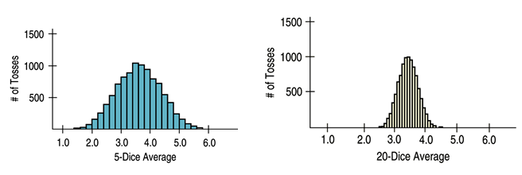

20. What is happening to the sample size?

21. As the sample size increases, what is changing in the distributions?

22. As the sample size increases, what is staying the same in the distributions?

**Important things to note (that I hope you can see):**

* **As the sample size increases, each sample average is more likely to be closer to the population ()**
* **As the sample size increases, the distribution becomes Normal (even though the parent population is UNIFORM!)**
* **The Sampling distribution of Sample Means is more Normal as n increases, REGARDLESS of what the parent distribution’s shape!**

**This is what we call the CLT or Central Limit Theorem for Sampling Means. Previously we learned about the CLT for Sample Proportions and they have similarities. In general, we can state the CLT as follows:**

**The mean of a Random Sample has a sampling distribution whose shape can be approximated by a Normal Model. The larger the sample, the better the approximation will be.**

* The mean of this model will be equal to the population mean: 
* The standard deviation of this model will be equal to the population standard deviation, divided by the sample size: 

**PRACTICE PROBLEMS:**

1. A waiter believes the distribution of his tips has a model that is slightly skewed to the right, with a mean of $9.60 and a standard deviation of $5.40.
   1. Explain why you cannot determine the probability that a given party will tip him at least $20.
   2. Can you estimate the probability that the next 4 parties will tip an average of at least $15? Explain.
   3. Is it likely that his 10 parties today will tip an average of at least $15? Explain.
2. The waiter in the previous problem usually waits on about 40 parties over a weekend of work.
   1. Estimate the probability that he will earn at least $500 in tips.
   2. How much does he earn on the best 10% of such weekends?