**Class Work for Module 28: Confidence Intervals for Population Means**

**Previously, we created Confidence Intervals for *p*, the population proportion. We used the Sampling Distribution for Sample Proportions:**

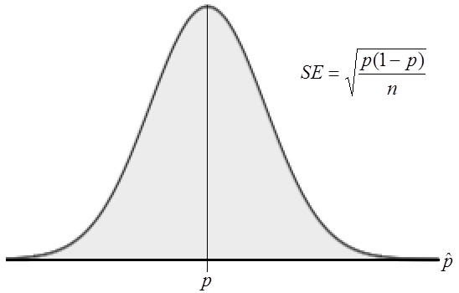

We started with the point estimate of , since  is what we use to estimate. So long as we have a Normal Model, we knew that about 95% of the time, would be within 1.96 standard deviations of the true population proportion, . We used this to create a formula for a 95% confidence interval: . We had to use in the calculation of the standard error since we generally do NOT know what  is. We then generalized this formula for ANY level of confidence by taking out 1.96 and using the corresponding z-score for the level of confidence we wanted:



**NOW, we want to create confidence intervals for , the population mean. We also need to use the Sampling Distribution, but this time, we use the Sampling Distribution for Sample Means:**

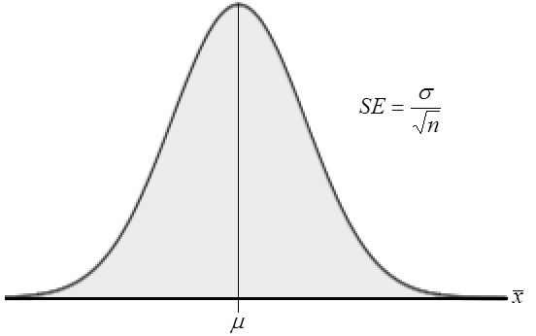

**Building a Confidence Interval for :**

1. Instead of using  as the point estimate, what will we use as the point estimate for ?

2. What standard error will we use?

3. So long as we have a Normal Model, we know that about 95% of the time, ______ will be within 1.96 standard deviations of _______________________ (write this in terms of MEANS).

4. Create a formula for a 95% confidence interval for .

5. Create a formula for ANY confidence level.

6. In the formula you found in #5, what value(s) do we usually NOT know?

**In General…we don’t know what  is. What should we do?**

7. What do you think we can use to estimate ?

8. Write out the new confidence interval for , using your answer in #7.

**We do use the sample standard deviation, *s*, to estimate** **, BUT, when we do, our distribution is no longer Normal…which is a problem. BUT, we are lucky. Since we MUST use *s* to estimate** , **a new distribution is created that is VERY, VERY *similar* to a Normal Distribution. It is called the “t-distribution”.**

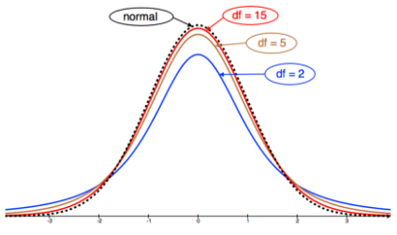

**Things to Note about the t-Distribution:**

* **Unimodal, Symmetric and Bell Shaped (just like the Normal Model!)**
* **They have “fatter tails”, meaning that it isn’t so odd to have a value that is 2 standard errors from the mean**
* **It uses “t-scores” rather than “z-scores”, but they function in the *exact* same way,** 
* **It also uses “degrees of freedom”, which is equal to the sample size minus 1 ()**
* **As the degrees of freedom increase, the shape gets closer and closer to a Normal Model.**

**We use the t-distribution if we are looking at creating confidence intervals or running hypothesis tests that involve . It is OK to use the t-distribution IF:**

* **We don’t know **
* **If our sample data LOOKS Normal when plotted**
* **If we have a small sample, but the data values are closely packed**
* **If our sample size is larger than 30 ()**
* **Our sample is randomly chosen**

**To find the value of t or to find p-values involving t, we need to use an online calculator.**

Example: Using the online calculator, find the following:

* 1. The value of *t* for a 95% confidence interval with df = 7
  2. The value of *t* for a 99% confidence interval with df = 102.
  3. The percent below , with df=45
  4. The percent above , with df=30

**The confidence interval for , when we do not know is given by:**



**OR**



**PRACTICE PROBLEMS:**

1. According to the website www.collegedrinkingprevention.gov, “About 25 percent of college students report academic consequences of their drinking including missing class, falling behind, doing poorly on exams or papers, and receiving lower grades overall.” A statistics student is curious about drinking habits of students at his college. He wants to estimate the mean number of alcoholic drinks consumed each week by students at his college. He plans to use a 95% confidence interval. He surveys a random sample of 71 students. The sample mean is 3.93 alcoholic drinks per week. The sample standard deviation is 3.78 drinks.

1. Have the conditions for creating a confidence interval been met by this sample? Explain.
2. Find the margin of error at 95% confidence.
3. Find the 95% confidence interval.
4. Interpret your confidence interval in context.
5. If we increased the sample size, what would happen to the resulting confidence interval (if everything else remained the same)?
6. Hoping to lure more shoppers downtown, a city builds a new public parking garage in the central business district. The city plans to pay for the structure through parking fees. During a two-month period (44 weekdays), daily fees collected averaged $126, with a standard deviation of $15.
   1. What assumptions must you make in order to use these statistics for inference?
   2. Write a 90% confidence interval for the mean daily income this parking garage will generate.
   3. Explain in context what this confidence interval means.
   4. Explain what “90% confidence” means in this context
   5. The consultant who advised the city on this project predicted that parking revenues would average $130 per day. Based on your confidence interval, do you think the consultant could have been correct? Why?