Class Work for Module 29: Hypothesis Testing for Population Means

1. Monarch’s Magnetic Fields

It is believed that some animals travel over great distances guided by the magnetic field of the earth. It is not clear how animals detect the earth’s magnetic field, as is the case with the monarch butterfly. Monarchs cannot survive a long cold winter, so they migrate far distances south in the fall. They fly to the same winter roosts, often to the same trees year after year. It is not known how they locate their winter homes. One possibility is that they possess some magnetic material that could be utilized in a magnetic field.

A biologist wished to determine whether monarchs have some magnetic material in their bodies, using extremely sensitive magnetometers. Unfortunately the magnetometer itself creates some background magnetism, about 200 pico-emus of magnetic intensity. (A pico-emu is 10−12 electromagnetic units.) In order to demonstrate that monarchs have some magnetic material in their bodies, it must be shown that their mean magnetic intensity exceeds 200 pico-emus naturally.

For this test we will use a 5% level of significance.

a) Determine the Hypotheses. Write the parameter in words.
b) A random sample of 16 butterflies were examined. The measured magnetic intensity of each butterfly were: 486, 328, 532, 323, 173, 122, 366, 298, 124, 219, 264, 490, 145, 75, 402, 290 pico-emus.
c) Determine the sample mean, sample standard deviation and sample size.
d) Is the sample size large enough for approximate normality?
e) Based on the histogram of the data, are the criteria for approximate normality satisfied?
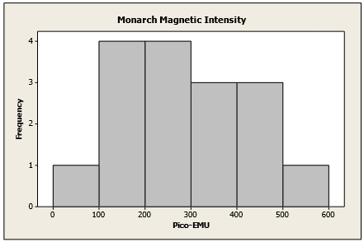
f) Calculate the p-value and draw a picture of it
g) Explain what the p-value means using the context of the problem
h) Is there enough evidence to reject the Null Hypothesis?
i) State your conclusion using the context of the problem.

2. Mean Life Span of Batteries

A company provides portable walkie-talkie radios to construction crews. Their batteries last, on average, 55 hours. The purchasing manager receives a brochure advertising a new brand of batteries with a lower price, but suspects that the average battery life for this new battery is shorter than the brand they currently use. He wants to perform statistical test at the 1% level of significance to determine if the cheaper batteries have a shorter average lifespan.

To test this, the manager installs 40 randomly selected batteries of the new brand in the same walkie-talkie radios. He finds that the mean lifetime for the sample is 52 hours with a standard deviation of 10 hours.

a) Determine the Hypotheses. Write the parameter in words.
b) Is the sample size large enough for approximate normality?
c) Calculate the p-value and draw a picture of it
d) Explain what the p-value means using the context of the problem
e) State your conclusion using the context of the problem.
f) It is possible that the conclusion was incorrect. The new, cheaper batteries may indeed have a shorter lifespan that the old batteries. If this is the case, what type of error was made?

