Quiz #2 (Modules 7, 8 and 9)

1. (8 pts.) The following data show the heart rates for 65 men and 65 women, along with a chart of the summary statistics for the data:

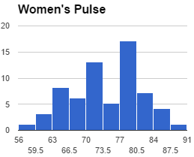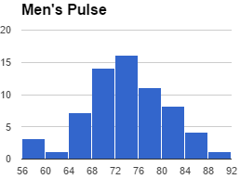

Women |  |  | Men
Min | 59 |  | min | 57
Q1 | 69 |  | Q1 | 69
median | 74 |  | median | 73
Q3 | 79 |  | Q3 | 78
max | 89 |  | max | 89

- (4 pts.) Calculate an interval of typical measurements using the given statistics for the females and the males.

- (4 pts.) Write in words what the typical range means for JUST the WOMEN. (I’m looking for a sentence that describes the numerical range you found in part a)

2. (12 pts.)Use the following distribution to answer the questions below:

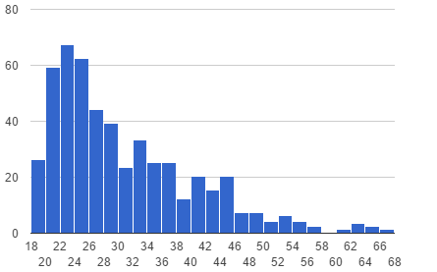

a) (3) Which will be larger for this set of data: the mean or the median? Explain why.

b) (4) Describe the shape of the histogram.

c) (3) Which measure of center (mean or median) would best describe the distribution? Explain briefly.

d) (2) Which measure of spread (IQR or standard deviation) would best describe the distribution? Explain briefly.

