Quiz #3 (Unit 4, modules 11, 12 and 13)

**Please Show Work, when possible! (If you don’t, I can’t give you partial credit!)**

**1. (15 pts.)** Researchers at the University of Denver Infant Study Center investigated whether babies take longer to learn to crawl in cold months (when they are often bundled in clothes that restrict their movement) than in warmer months. The study sought an association between babies’ first crawling age (in weeks) and the average temperature during the month when the baby is 6 months old. Parents reported the birth month and age at which their child was first able to crawl a distance of 4 feet in one minute. The graph below plots average crawling ages (in weeks) against the mean temperatures when the babies were 6 months old. The accompanying chart describes the data.

|  |  |  |
| --- | --- | --- |
|  | Temperature | Age |
| Mean | 48 | 32 |
| Standard Deviation | 17.42 | 1.93 |
| Correlation | -0.72 | |

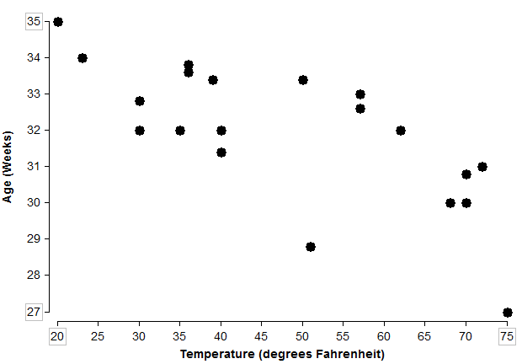

* 1. **(3 pts.)** Describe the association.
  2. **(5 pts.)** Find the equation of the regression line. **Keep AT LEAST 4 decimals in your approximations!!!** Your final answer should be approximately: . Since I’m giving you the answer, I expect to see your work. No work = no credit.
  3. **(4 pts.)** Explain (in context) what the slope of the line means.
  4. **(3 pts.)** Use the regression line to predict the average crawling age if the average temperature was  when a baby was 6 months old.

1. **(15 pts.)** Here we have measurements from 507 men and women. Weight is measured in kilograms. Height is measured in centimeters. The waist girth (narrowest part of torso below the rib cage, average of contracted and relaxed positions) is measured in centimeters. Which measurement, height or waist girth, is a better predictor of a person’s weight? Answer the following questions below to answer that question completely.

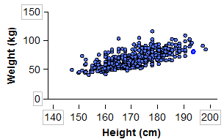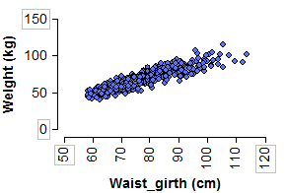

**Simple linear regression results:**

Dependent Variable: Waist Girth

Independent Variable: Weight

Weight = -15.2 + 1.0955 Waist Girth

Sample size: 507

r = 0.9040

Estimate of error standard deviation: 5.71

**Simple linear regression results:**

Dependent Variable: Height

Independent Variable: Weight

Weight = -105 + 1.0176 Height

Sample size: 507

r = 0.7173

Estimate of error standard deviation: 9.31

a) (5 pts.)Using the correlation, explain which variable is a better predictor of Weight. Be sure to explain why (what about the correlation indicates to you that the variable you chose is a better predictor?) **In your description, to get full credit, you need to make it clear to me that you know what r measures.**

b) (5 pts.) Calculate  for each scatterplot. Explain what it means about the relationship between the explanatory variable and response variable. Use this to explain which variable is a better predictor. **In your description, to get full credit, you need to make it clear to me that you know what**  **measures.**

c) (5 pts.)Using the standard error, explain which variable is a better predictor of Weight. Be sure to explain why (what about the standard error indicates to you that the variable you chose is a better predictor?) **In your description, to get full credit, you need to make it clear to me that you know what the standard error measures.**