Unit 4, Module 13: Assessing the Fit of a Line

Learning Goal: Use residuals, standard error and r² to assess the fit of a linear model.

In this activity you will practice pulling together what you have learned in Topic 3.3. You will use residuals, s_{e} and r² to analyze how well the regression line fits the data.

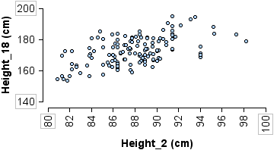
- Researchers took body measurements for 136 children at ages 2, 9, and 18. The children were born in 1928-29 in Berkeley CA. Here we investigate the relationship between height at age 2 and height at age 18.
Simple linear regression results:
Dependent Variable: Height_18
Independent Variable: Height_2
Height_18 = 45.797 + 1.444 Height_2
Sample size: 136
R (correlation coefficient) = 0.5486734
R-sq = 0.3010425
Estimate of error standard deviation: 7.4216731

- In this analysis, what is the explanatory variable? Why does this make sense?

- Do taller 2-year-olds also tend to be taller 18-year-olds? Support your answer.

- Is the association between heights at age 2 and age 18 strong or weak? Support your answer.

- Use the context of the problem to describe what the standard error tells us in this situation.

- Use the context of the problem to describe what the R-sq value tells us in this situation.

