Creating your OLI course for Math 13

Create an instructor’s account at oli.cmu.edu.

Log into OLI at oli.cmu.edu.

Under My Courses, click Create a new course.

Starting Course Builder: choose Advanced Mode as shown below. Then click Next.
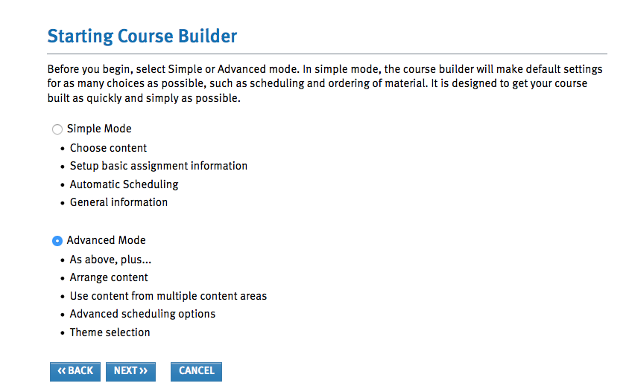

Select a Curriculum: from the pull-down menu labeled Pick One, choose Statistics.
Choose Concepts in Statistics. When the label Instructions appears, from the pull-down menu choose Concepts in Statistics Excel. Click Next.
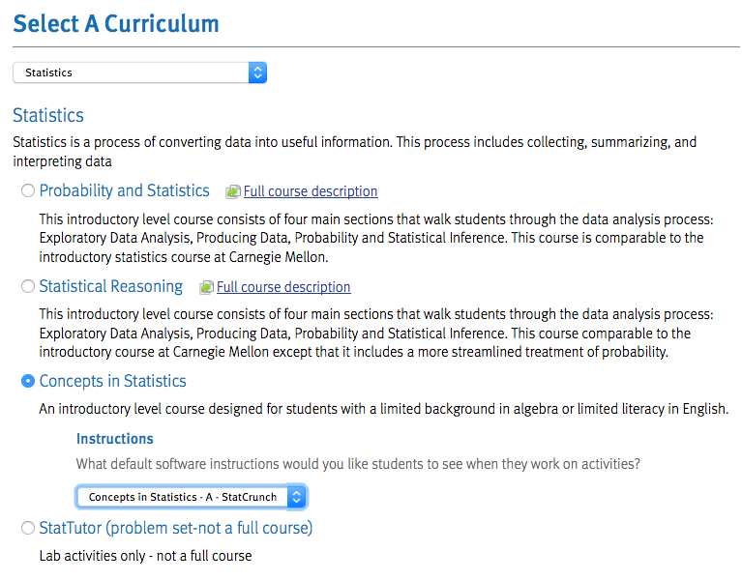

Arrange Content: Now you will need to reorder content and remove some content, in that order.

First use the green down-arrow to move the Unit: Types of Statistical Studies to after the Unit: Relationships in Categorical Data with an Intro to Probability.

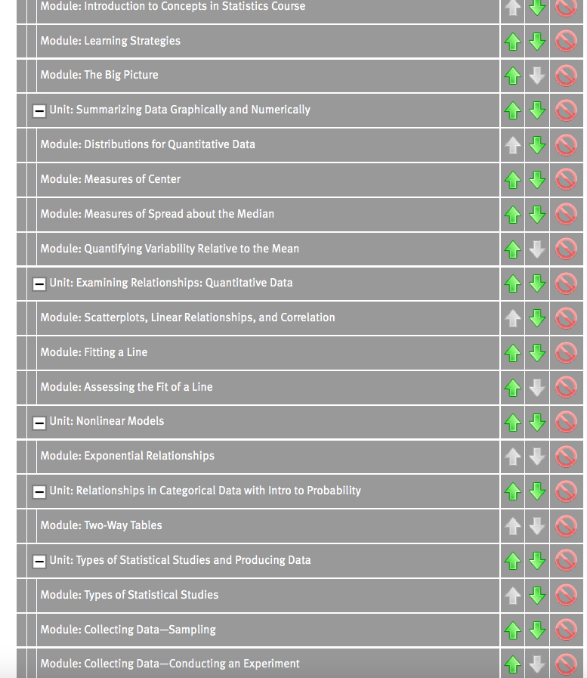

Next, click on the red circle to delete the following:
Under Unit: Examining Relationships: Quantitative Data, delete the Module: Assessing the Fit of a Line (keep the other two modules in this unit);
Now delete the following Units entirely (or move them to the end)
- Unit: Nonlinear Models
- Unit: Linking Probability to Statistical Inference
- Unit: Inference for One Proportion
- Unit: Inference for Two Proportions
- Unit: Inference for Means
- Unit: Chi-Square Tests

Note: We will leave the Unit: Probability and Probability Distributions in the OLI course, but you may not have time to cover it.

Here is a partial snapshot of how the Arrange Content page looks after you click on the red circles to delete content.

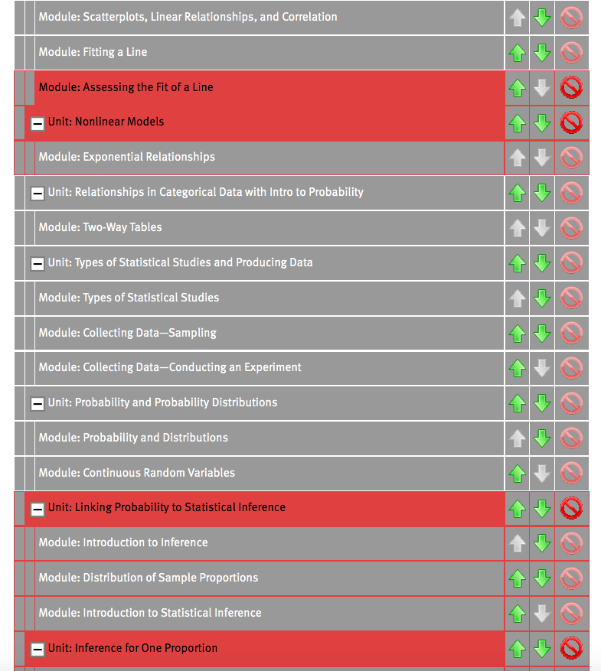

Click NEXT.
Schedule Course
Set the end date (last day students will have access to the course) and the time zone (Pacific Standard Time (America/Los Angeles)

Schedule Assignments
The default None allows you to set due dates as your students work through the course. This option allows for the most flexibility.
Click Next.

Assessment Options
Past Math 13 instructors used the default settings with two exceptions: Attempt(s) is set to Max available, and Scoring Model is set to Maximum Attempt Scores. This allows students to have two or more attempts on Checkpoint quizzes with the highest score recorded.

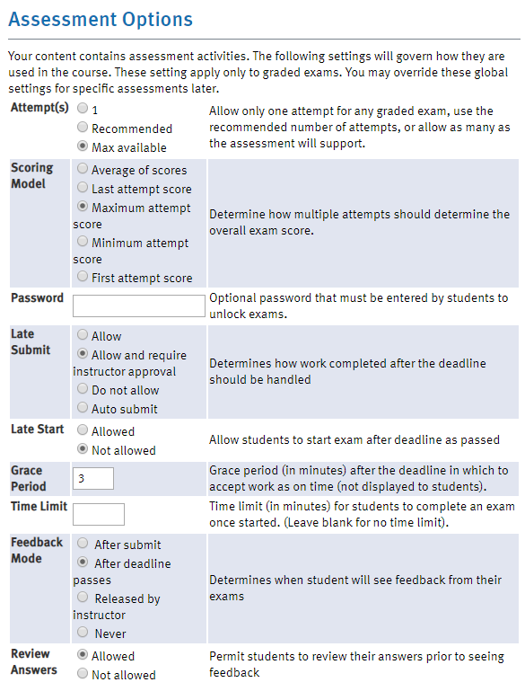
Click Next.

General Information
Title: Choose a title for your course. This is the course title that will appear in the student’s OLI syllabus.
Institution: Merritt College
Course key: We recommend that you include section number and/or semester, e.g. Math13-47522. Students will type the course key into OLI to enroll in your OLI course.
Course Password: Do not set a password.
Auto Admit Students: Yes.

