Window of Tolerance
When you feel of frustrated with problem solving, it is useful to learn about your window of tolerance, the amount of challenge and frustration you can feel without needing to escape or give up. The goal is to remain in your window of tolerance, where learning can take place.
If you are not feeling challenged at all, then you are not learning. If you are feeling too challenged, then you will become frustrated and want to give up. You should then ask for help, take a break, etc.
If you have had negative experiences with math, you will tend to have a small window of tolerance. Over time, the goal is to increase your window of tolerance, in order to develop resilience and grit. This is a process that takes time and requires you to become more comfortable with making mistakes and taking risks as part of the learning process. This also requires a sense of safety, both inside and outside of the classroom. If you feel safe to make mistakes, then you can participate in an authentic way. This allows the instructor to be able to better support your learning, and creates an efficient learning environment.
Questions:
1.) What do you do when you get stuck on a problem? List your approaches, in order.

2.) List at least one thing you can do to increase your window of tolerance. It is helpful to think about a possible challenge or hurdle, and how you would face it.

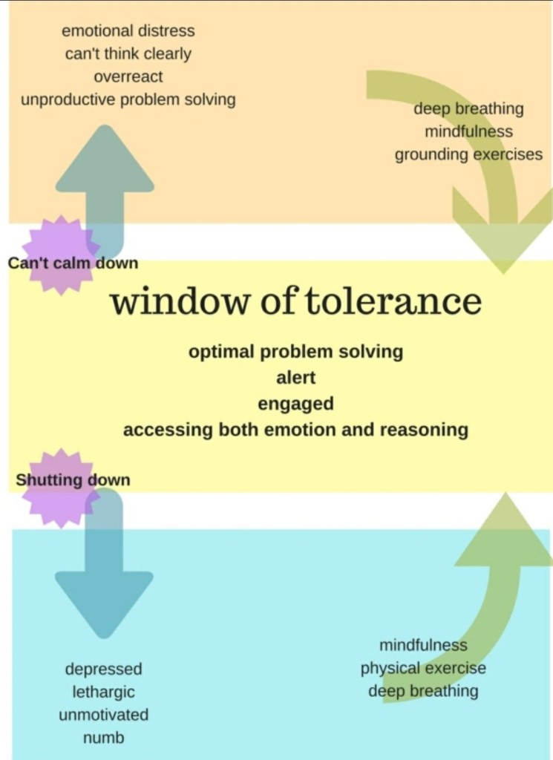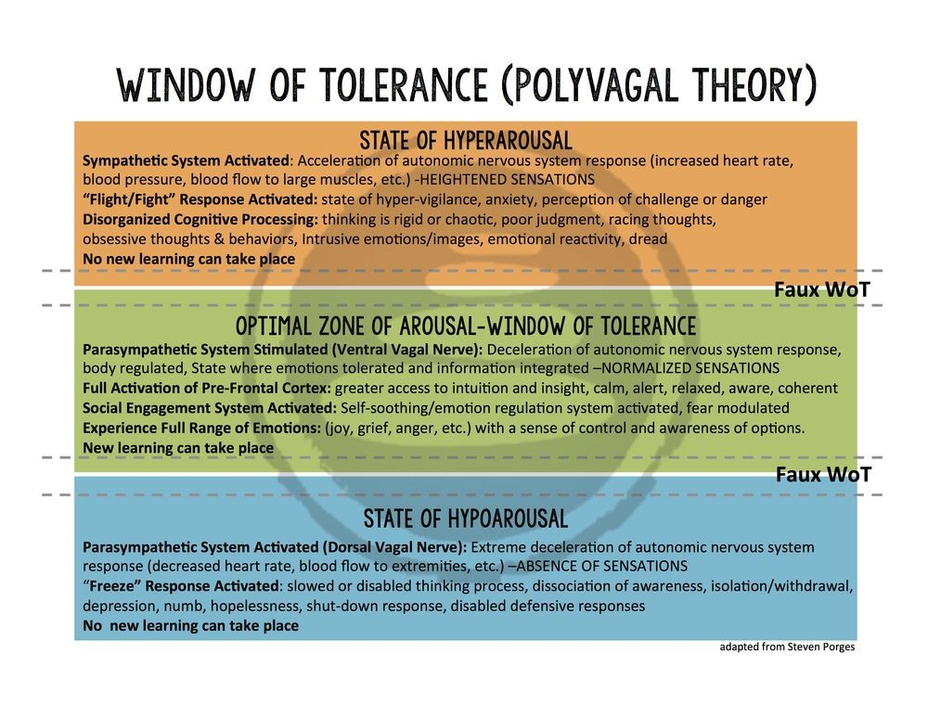

References:
Adapted from Stephen Porges Polyvagal Theory, which refers to hyper and hypoarousal, and how the state a person is in can affect their ability to learn.
https://www.kqed.org/mindshift/34690/whats-the-sweet-spot-of-difficulty-for-learning
https://i.pinimg.com/originals/85/e8/fe/85e8fec6dcaf610bd7f545934dfeea29.jpg
https://i.pinimg.com/originals/a1/ab/bb/a1abbb9f7f868b576e8200519d27cd56.jpg

