Window of Tolerance

When speaking with students about feelings of frustration with problem solving, it is useful to explain that the goal is to remain in their window of tolerance, where learning can take place. If a student is not feeling challenged at all, then they are not learning. If they are feeling too challenged, they become frustrated and want to give up. They should then ask for help, take a break, etc. If they have had negative experiences with math, they will tend to have a small window of tolerance. Over time, the goal is to increase their window of tolerance. I adapted this concept from Stephen Porges Polyvagal Theory, which refers to hyper and hypoarousal, and how the state a person is in can affect their ability to learn. I applied it to Math Anxiety.

From a teacher’s standpoint, you want to challenge your students enough to develop resilience and grit. However, you don’t want them to be so challenged that they give up. It is a process to slowly increase their window of tolerance. Also, it is important to create an environment for students in which they feel that mistakes and risk taking is encouraged and part of the learning process. Normalizing mistakes early in the semester is key to creating an environment that feels safe enough for students to participate in an authentic way. This is vital for instructors to be able to evaluate student understanding and be responsive to student learning in their teaching, which creates an efficient learning environment.

On the other hand, you don’t want to introduce new material in such a way that it creates cognitive overload for students. For example, it’s important to introduce new material by couching it in topics that the students fluent in. Also, you don’t want to introduce too many new topics at once. Check out this link for more detailed info. https://www.kqed.org/mindshift/34690/whats-the-sweet-spot-of-difficulty-for-learning
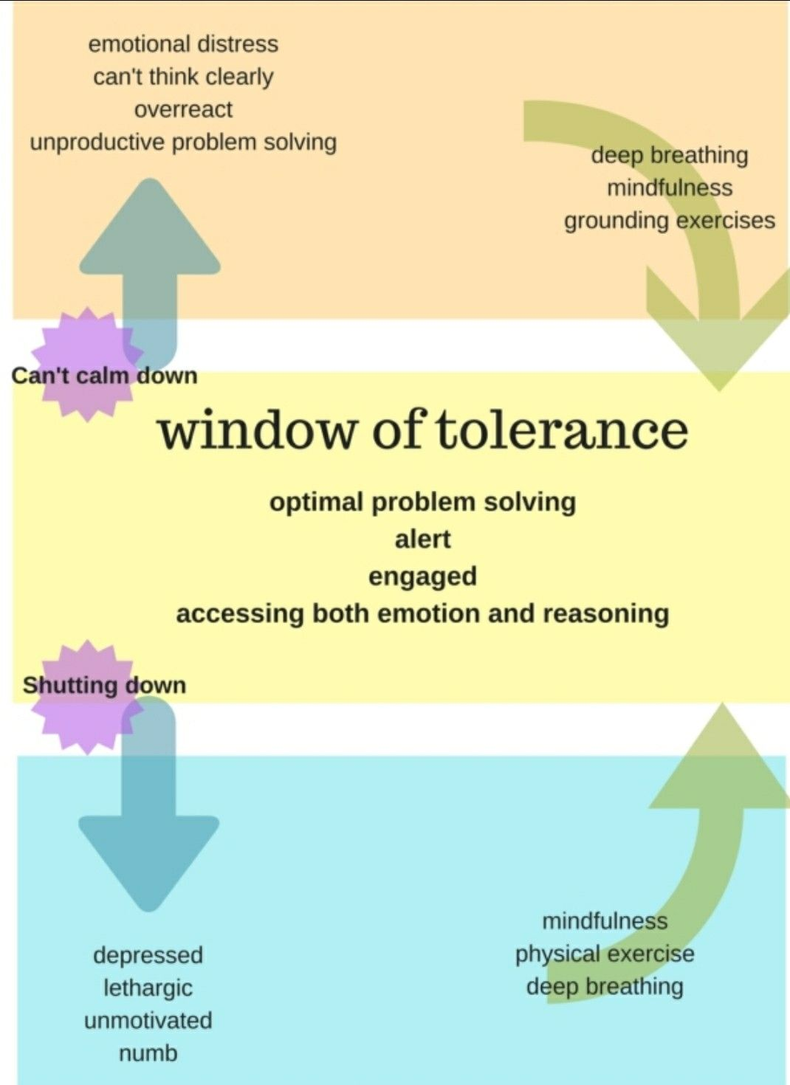https://i.pinimg.com/originals/a1/ab/bb/a1abbb9f7f868b576e8200519d27cd56.jpg
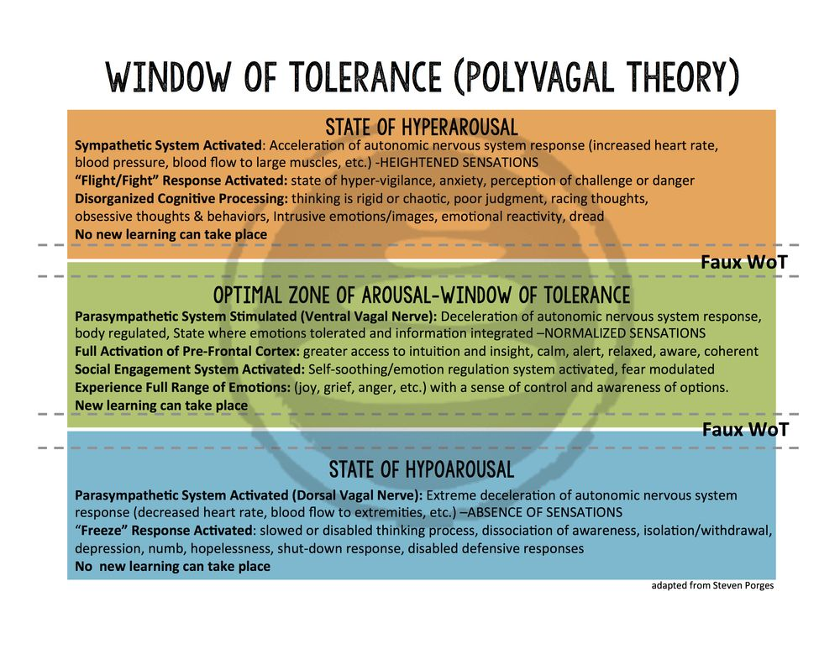
https://i.pinimg.com/originals/85/e8/fe/85e8fec6dcaf610bd7f545934dfeea29.jpg

