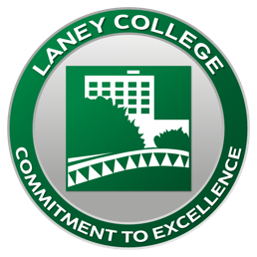
Interview Project Release Form
Laney College

Laney College is conducting an interview project focused on____________________________ __________________. This effort is intended to deepen student learning and overall understanding within the Laney Community. The full interview, or excerpts from it, may be published, incorporated in original writing, or produced into audio/visual productions for educational, informational and marketing purposes.

This may include public presentations, web use, with a broad public audience, and marketing materials. By providing a signature below, you (the student) consent to participate in an audio or video recorded interview and allow the use of the recorded audio/video materials (or transcriptions thereof) in productions, without further consideration.

You (the student) hereby intend to transfer legal title and all intellectual property rights which Laney College possesses in such interview or recording, including copyright. By providing your signature, you understand that photographs, video, audio footage, and testimonials resulting from this recorded interview may be incorporated into public works, broadcast at public events, and/or become accessible online and in blog posts. You consent to any future archive arrangements for this interview and its associated media and materials.

____________________________
SIGNATURE OF INTERVIEWEE

_____________________________
PRINTED NAME

_____________________________
STREET CITY, STATE, ZIP

____________
DATE

____________________________
SIGNATURE OF INTERVIEWER

_______________________
PRINTED NAME

_______________________
STREET CITY, STATE, ZIP

___________
DATE

